Chapter 9: Nuclear Changes

- ____________- the process by which an unstable nucleus
emits one or more particles or energy in the
form of electromagnetic radiation
- _____ ________- process radioactive materials undergo
- radioactive materials have an unstable nucleus
- become stable by undergoing nuclear decay
- results in a different isotope or an entirely different
element
- nuclear ________- the particles that are released from the
nucleus during radioactive decay
- may have effects on other materials

4 Types of Nuclear Radiation

1) ____________ particles (___)
- positively charged
- more massive than any other type of nuclear radiation
- made of 2 protons and 2 neutrons (helium nucleus)
- barely able to pass through a sheet of paper
- it is changed; ionize (remove e⁻) from matter as it
passes through
- causes alpha particle to lose energy and slow down
- ⁴₂He

2) ________ particles (____)
- fast moving electrons
- neutrons in nucleus decays to form a proton and an
electron
- electron is shot from nucleus at high speed
- penetrate a piece of ___________
- stopped by 3 mm aluminum or 10 mm of wood
- not as massive as α particle
- move faster
- ionization prevents further penetration

3) ________ rays (____)
- high energy photon
- not matter
- no charge
- can penetrate 60 cm aluminum or 7 cm lead

4) ___________- emission
- neutron is emitted
- no charge; does not ___________
- penetrating through 15 cm of ___________
- there are other types, these are the main ones
- Ex.- ___________ (↕⁺)
- positively charged electron
- exist for a short period of time
- anti-particles of electrons
- electron and positron meet:
- all mass is converted to _________ in form of
gamma rays
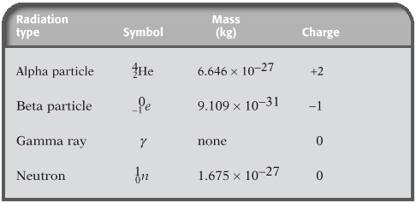

Nuclear Decay
- if an unstable nucleus emits alpha or beta particles, the
number of protons and neutrons changes

- alpha decay (______)
- Ex.- ²²⁶₈₈Ra ²²²₈₆Rn + ⁴₂He
226 = atomic mass 222 + 4 = 226
88 = atomic number 86 + 2 = 88

- beta decay (______)
- Ex.- ¹⁴₆C ¹⁴₇N + ⁰₋₁e
14 = atomic mass 14 + 0 = 14
6 = atomic number 7 - 1 = 6
***proton changes to ________ and an __________***
- proton and neutron have same mass
- atomic mass stays the same, but atomic number
changes

Practice Problems
Identify isotope X and tell if decay is alpha or beta.
1) ²³⁸₉₂U ²³⁴₉₀Th + ^{A}_{Z}X A=__Z=___X=___type___

2) ⁴⁰₁₉K ⁴⁰₂₀Ca + ^{A}_{Z}X A=__Z=___X=___type___

3) ²¹⁹₈₆Rn ^{A}_{Z}X + ⁴₂He A=__Z=___X=___type___

4) ¹²₅B ¹²₆C + ^{A}_{Z}X A=__Z=___X=___type___

5) ²²⁵₈₉Ac ²²¹₈₇Fr + ^{A}_{Z}X A=__Z=___X=___type___

6) ⁶³₂₈Ni ^{A}_{Z}X + ⁰₋₁e A=__Z=___X=___type___

7) ²¹²₈₃Bi ^{A}_{Z}X + ⁴₂He A=__Z=___X=___type___

Decay Rates
- ______ _____- time required for half of a sample of a
radioactive substance to disintegrate by
radioactive decay or by natural processes
- after one half-life has passed, there will be __ of
the original sample left
- after 2 half-lives, there will be ½ of ½ or ¼ of
the sample left
# of half-lives | % left | fraction left
0 | 100 | 1/1
1 | 50 | ½
2 | 25 | ¼
3 | 12.5 | 1/8
4 | 6.25 | 1/16
5 | 3.13 | 1/32
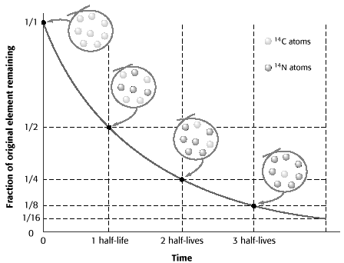

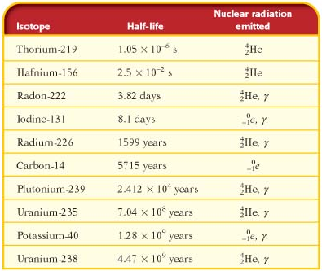

- different isotopes have different ________- ________
- able to tell age of objects based upon amount of ________
- Ex.- Carbon-14
- Carbon-14 is radioactive
- can be used to date things that were once alive
- plants take in ________
- some CO₂ contain C-___ rather than the more
common C-___
- when plant is alive the ratio of both isotopes is
constant
- same for any thing that lives on the plants
- when plant or animal dies, it no longer takes in
C-14
- ratio changes
- C-14 decays, C-12 doesn’t
- measure _______, determine ______
Practice Problems
1) The half-life of iodine-131 is 8.1 days. How long will it
take for ¾ of the sample of iodine-131 to decay?
2) Radon-222 is a radioactive gas with a half-life of 3.82
days. How long would it take for fifteen-sixteenths of a
sample of radon-222 to decay?
3) Uranium-238 decays very slowly, with a half-life of 4.47
billion years. What percentage of a sample of
uranium-238 would remain after 13.4 billion years?
4) A sample of strontium-90 is found to have decayed to
1/8 of its original amount after 87.3 years. What is the
half-life of strontium-90?
5) A sample of francium-212 will decay to 1/16 its original
amount after 80 minutes. What is the half-life of
francium-212?
Answers
1)

2

3)

4)

5)

- whether a nucleus is stable or unstable depends on the
forces in the nucleus, between protons and neutrons
- called “_________ __________ _________”

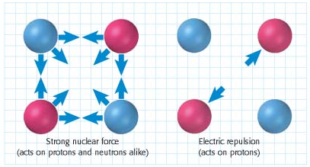

- causes protons and neutrons to attract
- force of attraction is greater than force of _________
between 2 _________
- occurs over a very short distance
3 x 10⁻¹⁵ m (width of _________ protons)

- neutrons are important in producing attractive force
- too many or too few ________ makes the nucleus
unstable…decays
- any nucleus with __ or more protons will be unstable and
undergo radioactive decay
- releases energy and particles resulting in a more stable
___________

Nuclear Fission
- ______- the process by which a nucleus splits into two or
more fragments and releases _______ and _____
- a larger nucleus breaks down into several smaller
ones
- Ex.-
²³⁵₉₂U + ¹₀n ¹³⁷₅₆Ba + ⁸⁴₃₆Kr +15¹₀n + energy

137 + 84 = 221 + 15 = 236
56 + 36 = 92
- releases lots of energy
3.2 x 10 ⁻¹¹ J of energy (per molecule)
- 1 molecule of TNT releases 4.8 x 10 ⁻¹⁸ J
- Hahn and ________ found that the mass after the reaction
had decreased. It had changed into energy.
- Albert __________________
- special theory of relativity
- matter can be converted into ________ and energy into
____________
Energy = mass x (speed of light)²
E = mc²
- c is a constant (3 x 10 ⁸m/s)…very large

- mass equivalent of energy of 1 ____ of matter is
9 x 10¹⁶J
- more energy than 22 million tons of TNT
- one neutron hits a large nucleus
- nucleus breaks into smaller nuclei
- releases more neutrons and energy
- extra neutrons will split more of the original large nuclei
if available
- nuclear ______ _______- a continuous series of nuclear
fission reactions
- start with ___ neutron
- release ___ neutrons
- each neutron starts its own fission reaction
- releases a total of ___ neutrons
- each starts its own fission reaction
- releases ____ new neutrons…etc.
- _____________
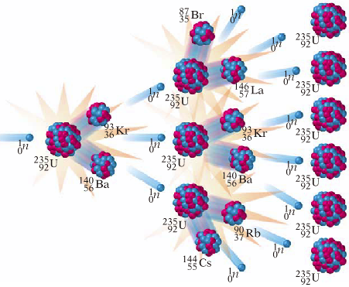
- if it can be controlled, it can be used to produce electricity
- energy given off by each phase of the chain reaction is
used to boil _____________
- water heats other pipes of water to produce ______
- steam turns turbine
- produces electricity
- chain reaction used for nuclear __________
- several masses of uranium-235 in bomb
- explosives surround them
- explode and push ____________ together
- achieve critical _______
- minimum amount of a substance that can
undergo a fission reaction and can also sustain a
chain reaction
- concentrations of uranium-235 in nature are too
___________ to reach critical mass
- neutrons given off are absorbed by
surrounding, stable material
- in a nuclear power plant
- _________ rods are used to absorb excess neutrons

Nuclear Fusion
- _______- process in which light nuclei combine at
extremely high temperatures, forming heavier
nuclei and releasing energy
- occurs naturally on the ___________
- hydrogen nuclei combine or fuse
- takes lots of energy to start
- both particles are positively charged
- must overcome electrical repelling forces until
________ can form strong nuclear force
¹₁H + ¹₁H ²₁H + 2 particles
²₁H + ¹₁H ³₁He + ⁰₀γ
³₂He + ³₂He ⁴₂He + ¹₁H + ¹₁H

- ________ ____________- the nuclear radiation that arises
naturally from cosmic rays and
from radioactive isotopes in the
soil and air
- body tissues adapted to survive
low levels of radiation

- ______- unit of measure for radiation
- 5000 millirems annually plus background exposure
is safe
- higher _______________ receive more radiation
- closer to space (__________ rays)
- areas with rocks tend to have more background than
those areas without rocks
- certain _____________ can affect exposure

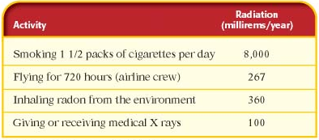

Beneficial Uses of Nuclear Radiation
1) ___________ ________________
- release charged alpha particles to produce an electric
current
- smoke interrupts the current
- sounds alarm

2) ______________ ________________
- Ex.- digital computer, ultrasound, CT scanning, PET,
MRI, and x-rays
- radioactive tracers
- short lived isotopes that tend to concentrate in
affected cells and are used to locate tumors

3) _______________
- radioactive tracers in water
- follow path and rate of absorption into ground and
plants
- locate with sensors

4) ___________ ___________
- Ex.- shooting beams of gamma rays at tumors
- Ex.- kill defective bone marrow with nuclear radiation
and then replace healthy bone marrow from a
donor

5) _________________ of food
- spoiling agents killed by radiation
- longer shelf life

Possible Risks of Nuclear Radiation
1) ______________ atoms
- α, β, γ, and x-rays can ionize living tissues
- produce substances that are harmful to life
- each has a different penetrating power
- risk depends on amount of radiation
- high levels can lead to cancer
- _____________ sickness
- illness resulting from excessive exposure to nuclear
radiation
- may be caused by explosion or repeated exposure to
high levels
- workers must wear protective clothing and shields
- ___________- device for measuring the amount of
nuclear radiation exposure
2) ___________ ___________
- colorless and odorless
- decay of uranium-238 in soil in rocks
- α, β, and γ decay

3) ____________ _____________
advantages:
1) no ____________ pollutants
2) lots more energy in _________ reserves than oil and
coal reserves
disadvantages:
1) radioactive waste
2) ___________ __________
- lots of safety features
- expensive to build
3) storing waste
- safe facilities
- avoid groundwater
- sparsely populated, little water, few earthquakes
- nuclear _____________ being tested
- ____ of hydrogen in a fusion reactor = ___ _____ tons
of burning coal
- very little waste or pollution
- too hot
- experiments run for short periods of time
- ________ ____________
- fusion at room temperature
- VERY abundant reactants
- hydrogen is most abundant element in the universe
- drawbacks
- fast ______________
- highly energetic and dangerous radiation
- must replace shielding material
- expensive
- ___…slows neutrons
- very reactive and ________

