Chapter 17: Magnetism

- magnets- name from region of Greece called
________________

- ________ – naturally occurring magnetic rocks
- found in Magnesia 3,000 years ago
- composed of an iron-based material
called _______________

- __________ magnets – materials that are magnetic all the
time
- any piece of iron can become a
permanent magnet
- stroke with a strong magnet
- set near strong magnet
- magnetism can be weakened or
removed
- _____ or __________

- magnetically hard vs. magnetically soft
- __________: easily magnetized
- loses magnetism easily (iron)
- __________: difficult to magnetize
- difficult to un-magnetize (cobalt and nickel)

- magnetic _______ – force exerted by a magnet
- further distance from magnet
- smaller force
- Ex: magnet in bucket of nails
- some nails attract to magnet
- each nail acts as magnet
- attracts other nails
- eventually magnetic force can’t
overcome gravity and nails no
longer stick together

- _____________– one of two points, such as the ends of a
magnet, that have opposing magnetic
qualities
- 2 poles (N & S)
- like poles _______
- opposite poles ____________

____________________ iron
NS N SN S NS SN NS SN S SN NS N SN NS SN

_____________________ iron
NS NS NS NS NS NS NS NS NS NS NS NS NS NS NS NS

- magnet gets cut in half = ____ magnets

Magnetic Fields
- magnetic _____ – a region where a magnetic force can be
detected
- strength of field depends on:
1. the _________ from which the magnet is
made
2. degree it is magnetized

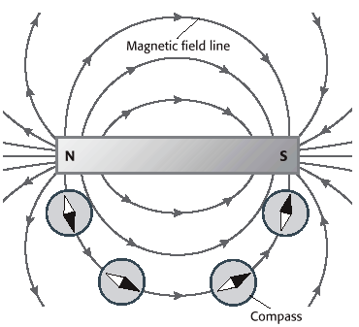

- magnetic________ – lines used to represent the magnetic
field around a magnet
- closed loop
- arrowheads drawn from _______ to
__________ pole
- field gets weaker further from magnet
- field lines close together = _________ field
- field lines further away = ________ field

- ___________ – magnet suspended on top of a pivot
- magnet can spin freely
- aligns with Earth’s ____________ field
- compass follows direction of magnetic field
lines
* 1st compass was lodestone, placed on wood and floated in water *
- sailors watched as wood spun to point to north _____
- useful in day time
- compass tells direction because Earth is like a giant bar
________________
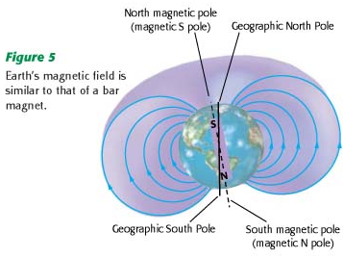

magnetic north vs. geographic north
- magnetic north is in northern _______________
- geographic north is at north pole (axis)
- _________ km apart
- source of Earth’s magnetism is debatable
- some think it results from flowing liquid _________
- some think it is a ____________ of several factors

- Earth’s magnetic field has switched several times
throughout time
- proof is in _________ ___________
- once fired, hold magnetism
- compare with rocks of similar age
- “N” on magnet means ___________________
- north as in geographic north
- “S” on magnet means ____________________
- south as in geographic south
- because of magnetic switching
- pole in Canada is a magnetic ______ pole
- pole in Antarctica is a magnetic ______ pole

Magnetism & Electricity
- 18th century – people noticed lightning caused _______ to
deflect & iron pans sometimes became
magnetized
- knew of relationship between electricity and
magnetism
- 1820 – Hans Christian __________
- teacher
- experimented with electric current and compasses
- found magnetism is produced by _________ electric
charges
- iron fillings around current carrying wire
- from pattern – electric field
- _____________ ____________
- compass needle near wire would point _________ to
iron filling
- current stops flowing
- magnetic field _______________

Right Hand Rule
- If you imagine holding the wire in your right hand with
your thumb pointing in the direction of the positive
current, the direction your fingers would curl is in the
direction of the magnetic field
- thumb = _____________
- fingers = magnetic field
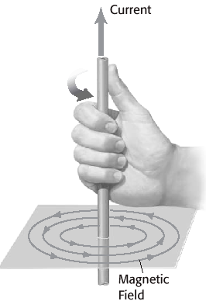
2 ways to increase strength of magnetic field
1. increase current
- dangerous
2. __________ – a coil of wire with an electric current in it
- to increase a solenoid’s magnetic field insert iron rod

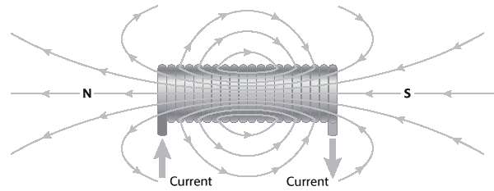

- ______________ – a coil that has a soft iron core and that
acts as a magnet when an electric current
is in the coil
- solenoids magnetic field makes iron core
become a magnet as well
- adds to solenoid’s field
* movement of ________ causes magnetism *
- Ex: electrons moving around nuclei
- Ex: protons move in nucleus
- Ex: electrons have electron spin
- most times fields cancel out
- some materials (iron, cobalt, nickel) do not
cancel
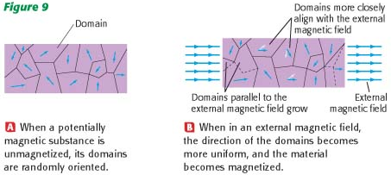
- ______________ line up within a magnetic field

Electromagnetic devices
1. galvanometers
- device that detects, measures, and determines the
direction of a small electric current

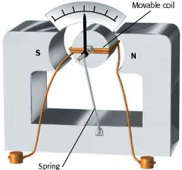

- coil and core act as electromagnet when connected to
a circuit
- core and coil can _____________
- current is sent through coil
- produces magnetic field
- new field reacts with surrounding __________
- turns core
- needle measures it on scale

2. electric __________
- device that converts electrical energy into
_________________ energy
- coil turns when current present
- magnetic field present
- interacts with surrounding magnet
- coil is attached to ____________
- shaft spins, does ________

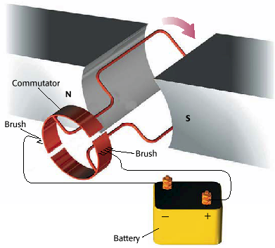

- ______________ – device that makes current change
direction every time the flat coil
makes a _____ revolution
- splits in ring, makes electrons travel
through coil
- as commutator spins
- opposite side touches brush
- current in different direction
- magnetic field __________
- keeps loop spinning in ___ direction
- if magnetic field doesn’t reverse, it
attracts to magnet

3. ___________ ____________
- current in wire
- produces ______________ ___________
- reacts with permanent magnetic field
- causes _______ to move
- current reverses direction, so does magnetic field
- cone accelerates in opposite direction
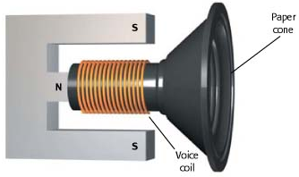

- _____________ _________– process of creating a current
in a circuit by changing a
magnetic field
- discovered by Michael Faraday, 1831
- _________ law – an electric current can be produced in a
circuit by a changing magnetic field
2 ways
1. rotate _____________
2. changing __________ of magnetic field
- energy produced is ____________ to energy used to
move coil through field

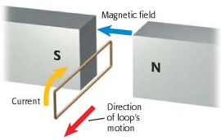

- charged particle in magnetic field will experience a force
due to the magnetic field
- if charge moves opposite or in direction of field;
magnetic force is ___________
- if charge moves perpendicular to field;
____________ force
* as angle between changes direction and direction of
magnetic field decreases, force on change decreases *
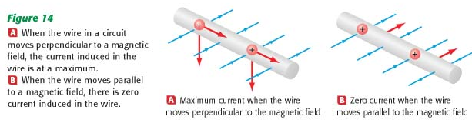

- wire moves perpendicular
– maximum force – ______________
- wire move parallel
– no force – ____ ______

- __________ – a machine that converts mechanical energy
into electrical energy
- opposite of ___________
- convert motion into energy
- Ex: AC generator

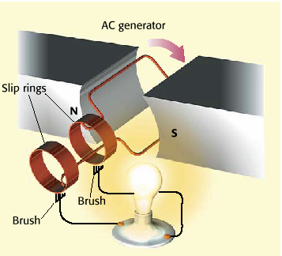

- use energy to turn loop inside magnetic field
- _______________ produced
- every half rotation of loop reverses _________
produced and generator reverses direction
- amount of current depends on orientation of _____ in
field
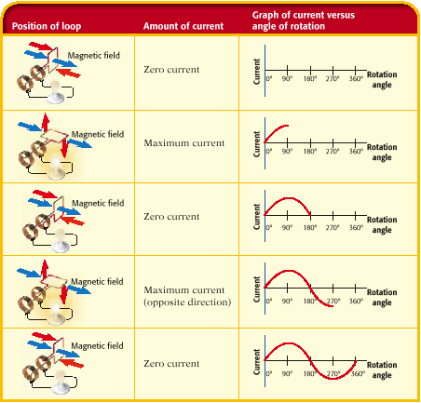

- loop perpendicular; ___ current
- loop turns, current ___________
- loop parallel, ___________ current
- large power plants use natural resources to turn coil
- Ex: dams
- use falling water
- Ex: coal and nuclear power plants
- heat water to steam to turn turbine
- Ex: wind mills
- wind turns turbine

QUICK REVIEW
1. moving _______________ produce a magnetic field
2. changing magnetic field causes an _________ ______ to
move
- resulting energy is called electromagnetic energy
- Ex: light, radio signals, x-rays
- made up of oscillating electric and magnetic
fields __________________ to each other
- both electric and magnetic fields are
perpendicular to direction the _______ travels
- as wave moves changing electric field generates
the magnetic field and changing magnetic field
generates the electric field
- allows wave to travel through _______ _______

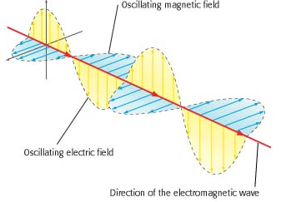

Transformers
- _____________ – a device that increases or decreases the
voltage of alternating current
- current in ___ wire (AC) creates changing magnetic
field
- magnetizes iron core
- changing magnetic field of core induces a current on
_____ coil
- amount of energy on 2º coil depends on the number of
loops of wire
- Ex: equal number of coils
- equal voltage on each coil

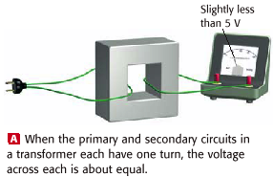
- Ex: 1 turn on 1º, 2 sets of 1 turn on 2º
- both 2º coil voltages = to 1º coil voltage

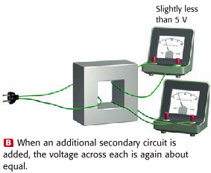

- Ex: 1 turn on 1º coil, 2 turns together on 2º coil
- 2º coil has 2x as much voltage
- ______________ transformer
- step up voltage

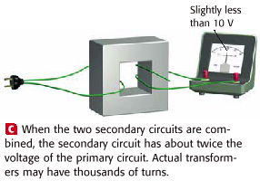

- if 2º coil has fewer loops
- voltage will decrease
- ____________ transformer
- step up transformer used near power plants
- send electricity long distanced with high _____, low
______________
- decrease _______________
- step down transformers used near homes
- decrease __________, increase __________

