Chapter 16 Practice Test #2

Multiple Choice
Identify the letter of the choice that best completes the statement or answers the question.

____ 1. There is a repulsive force between two charged objects when
a. | their charges are of unlike sign.
b. | they have the same number of protons.
c. | their charges are of like sign.
d. | they have the same number of electrons.

____ 2. There is an attractive force between two charged objects when
a. | their charges are of unlike sign.
b. | they have the same number of protons.
c. | their charges are of like sign.
d. | they have the same number of electrons.

____ 3. When there is an equal amount of positive and negative charges on an object, the object is
a. | positively charged. | c. | neutral.
b. | negatively charged. | d. | supercharged.

____ 4. Electric force varies depending on the
a. | charge and distance between charged objects.
b. | charge and mass of charged objects.
c. | height and mass of charged objects.
d. | mass and distance between charged objects.

____ 5. Electric field lines
a. | point toward a negative charge. | c. | never cross one another.
b. | point away from a positive charge. | d. | All of the above

____ 6. Electric field lines indicate
a. | direction only. | c. | both direction and relative strength.
b. | relative strength only. | d. | neither direction nor strength.

____ 7. Potential difference is measured in
a. | amperes. | c. | coulombs.
b. | volts. | d. | joules.

____ 8. Batteries typically have
a. | two positive terminals. | c. | one positive and one negative terminal.
b. | two negative terminals. | d. | no terminals.

____ 9. Current is the rate at which charges move through a(n)
a. | conductor. | c. | voltage.
b. | insulator. | d. | joule.

____ 10. Potential differences cause
a. | electrons to move from the positive terminal to the negative terminal.
b. | electrons to move from the negative terminal to the positive terminal.
c. | protons to move from the positive terminal to the negative terminal.
d. | protons to move from the negative terminal to the positive terminal.

____ 11. The brightness of a light bulb is determined by its filament’s
a. | voltage. | c. | watts.
b. | amperes. | d. | resistance.

____ 12. Resistance is caused by
a. | internal friction. | c. | proton charge.
b. | electron charge. | d. | a heat source.

____ 13. The SI unit of resistance is the
a. | volt. | c. | ohm.
b. | ampere. | d. | joule.

____ 14. Whether or not charges will move in a material depends partly on how tightly _____ are held in the atoms of the material.
a. | electrons | c. | protons
b. | neutrons | d. | resistors

____ 15. Which of the following does not affect a material’s resistance?
a. | length | c. | the type of material
b. | temperature | d. | Ohm’s law

____ 16. A flashlight bulb with a potential difference of 4.5 V across its filament has a power output of 8.0 W. How much current is in the bulb filament?
a. | 3.7 A | c. | 0.23 A
b. | 1.8 A | d. | 0.56 A

____ 17. There is a potential difference of 12 V across a resistor with 0.25 A of current in it. The resistance of the resistor is
a. | 48 Ω. | c. | 12 Ω.
b. | 24 Ω. | d. | 0.021 Ω.

____ 18. A 13 Ω resistor has 0.050 A of current in it. What is the potential difference across the resistor?
a. | 6.5 V | c. | 0.065 V
b. | 0.65 V | d. | 0.0065 V

____ 19. A resistor has a resistance of 280 Ω. How much current is in the resistor if there is a potential difference of 120 V across the resistor?
a. | 160 A | c. | 0.12 A
b. | 0.43 A | d. | 2.3 A

____ 20. A set of electric trains are powered by a 9V battery. What is the resistance of the trains if they draw 3.0 A of current?
a. | 3 Ω | c. | 27 Ω
b. | 0.03 Ω | d. | 2.7 Ω

____ 21. The resistance of an insulator is
a. | absent. | c. | moderate.
b. | very low. | d. | high.

____ 22. Which of the following shows how conductors, insulators, superconductors, and semiconductors rank in order of least resistance to most resistance?
a. | superconductors, conductors, semiconductors, insulators
b. | semiconductors, superconductors, conductors, insulators
c. | insulators, conductors, semiconductors, superconductors
d. | none of the above

____ 23. Appliances connected so that they form a single pathway for charges to flow are connected in a(n)
a. | series circuit. | c. | open circuit.
b. | parallel circuit. | d. | closed circuit.

____ 24. If a lamp is measured to have a resistance of 45 Ω when it operates at a power of 80.0 W, what is the current in the lamp?
a. | 2.10 A | c. | 0.91 A
b. | 1.3 A | d. | 0.83 A

____ 25. An electric toaster has a power rating of 1100 W at 110 V. What is the resistance of the heating coil?
a. | 7.5 Ω | c. | 10 Ω
b. | 9.0 Ω | d. | 11 Ω

____ 26. If a lamp is measured to have a resistance of 120 Ω when it operates at a power of 1.00 × 10² W, what is the potential difference across the lamp?
a. | 110 V | c. | 0.913 V
b. | 120 V | d. | 220 V

____ 27. If a 325 W heater has a current of 6.00 A, what is the resistance of the heating element?
a. | 88.1 Ω | c. | 9.03 Ω
b. | 54.2 Ω | d. | 11.4 Ω

____ 28. A device that protects a circuit from current overload is called a(n)
a. | resistor. | c. | circuit breaker.
b. | capacitor. | d. | closed circuit.

Short Answer

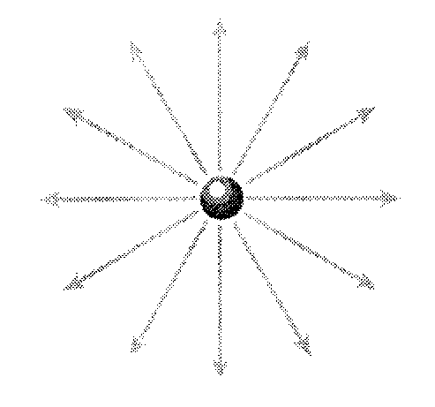

29. Is the charge shown in the figure above positive or negative?

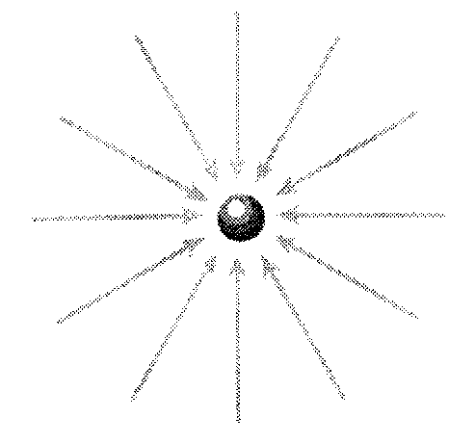

30. Is the charge shown in the figure above positive or negative?

31. What is electrical potential energy?

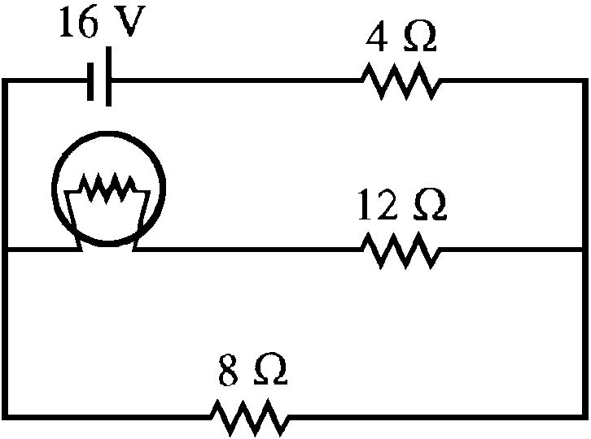

32. Identify the types of elements in the schematic diagram above and the number of each type.

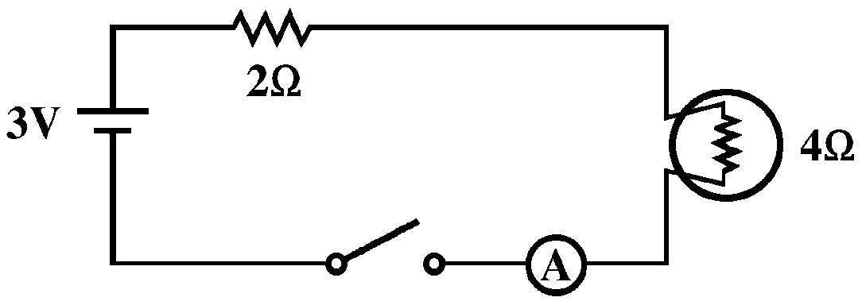

33. Is a current flowing in the schematic diagram above? Explain your answer.

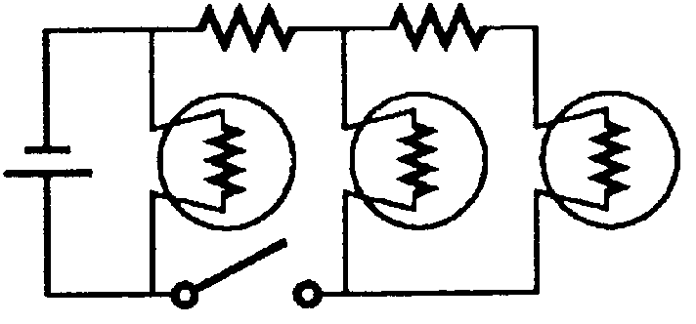

34. Which bulb(s) will have a current in the schematic diagram above?

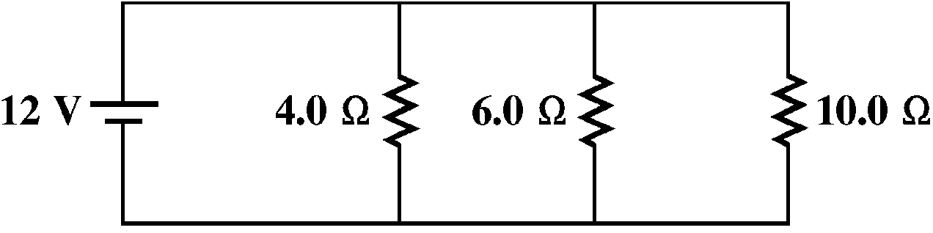

35. Does the schematic diagram above represent a series or parallel circuit?

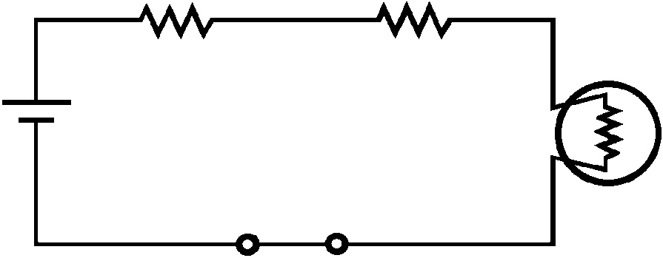

36. Does the schematic diagram above represent a series or parallel circuit?

Essay

37. Does the wiring in your house use series or parallel circuits? Explain.
Chapter 16 Practice Test #2
Answer Section

MULTIPLE CHOICE

1. ANS: C DIF: 1 REF: 1 OBJ: 1

2. ANS: A DIF: 1 REF: 1 OBJ: 1

3. ANS: C DIF: 1 REF: 1 OBJ: 1

4. ANS: A DIF: 1 REF: 1 OBJ: 2

5. ANS: D DIF: 1 REF: 1 OBJ: 3

6. ANS: C DIF: 1 REF: 1 OBJ: 3

7. ANS: B DIF: 1 REF: 2 OBJ: 1

8. ANS: C DIF: 1 REF: 2 OBJ: 1

9. ANS: A DIF: 1 REF: 2 OBJ: 2

10. ANS: B DIF: 1 REF: 2 OBJ: 2

11. ANS: D DIF: 1 REF: 2 OBJ: 3

12. ANS: A DIF: 1 REF: 2 OBJ: 3

13. ANS: C DIF: 1 REF: 2 OBJ: 3

14. ANS: A DIF: 1 REF: 2 OBJ: 3

15. ANS: D DIF: 1 REF: 2 OBJ: 3

16. ANS: B DIF: 2 REF: 2 OBJ: 4

17. ANS: A DIF: 2 REF: 2 OBJ: 4

18. ANS: B DIF: 2 REF: 2 OBJ: 4

19. ANS: B DIF: 2 REF: 2 OBJ: 4

20. ANS: A DIF: 2 REF: 2 OBJ: 4

21. ANS: D DIF: 1 REF: 2 OBJ: 5

22. ANS: A DIF: 1 REF: 2 OBJ: 5

23. ANS: A DIF: 1 REF: 3 OBJ: 2

24. ANS: B DIF: 2 REF: 3 OBJ: 3

25. ANS: D DIF: 2 REF: 3 OBJ: 3

26. ANS: A DIF: 2 REF: 3 OBJ: 3

27. ANS: C DIF: 2 REF: 3 OBJ: 3

28. ANS: C DIF: 1 REF: 3 OBJ: 4

SHORT ANSWER

29. ANS:
positive

DIF: 1 REF: 1 OBJ: 2

30. ANS:
negative

DIF: 1 REF: 1 OBJ: 2

31. ANS:
potential energy associated with a charged object due to its position in an electric field

DIF: 1 REF: 1 OBJ: 3

32. ANS:
three resistors, one light bulb, and one battery

DIF: 1 REF: 3 OBJ: 1

33. ANS:
No, because the switch is open, so there is not a closed-loop path for the electrons to follow.

DIF: 1 REF: 3 OBJ: 1

34. ANS:
Only the first light bulb will light. The other two bulbs are beyond the open switch and, therefore, will not receive current.

DIF: 1 REF: 3 OBJ: 1

35. ANS:
parallel circuit

DIF: 1 REF: 3 OBJ: 2

36. ANS:
series circuit

DIF: 1 REF: 3 OBJ: 2

ESSAY

37. ANS:
Parallel circuits; otherwise everything would have to be on for anything to be on. There may be series circuits within the system, however. For example, lights that can be operated from switches at either entrance to a room or wall sockets that work only when a switch is in the on position use series circuits.

DIF: 3 REF: 3 OBJ: 2

