Chapter 15: Sound and Light

Sound
- _______ ______ – a longitudinal wave that is caused by
vibrations and that travels through a
material medium
- particles of medium vibrate __________ to
direction of wave energy

- drum beating
- drummer hits drum, drum head vibrates up and down
- each time head moves up it ___________ air above it
- each time head moves down it leaves air at lower
pressure
- creates series of compressions and ______________
- sound waves spread out in all directions from source
- compressions cause ear drums to vibrate
- all sounds create vibrations in a medium that ultimately
get passed to ear

Properties of Sound
1. _________
- at room temp. ≈ 346 m/s (760 mi/k)
- depends on medium and temperature
- how well medium particles transmit
compressions and rarefactions
- closer particles are: faster transmission
- exception: rubber-sound proof
- higher temperature; _______ energy;
______ collisions; ________ transmission
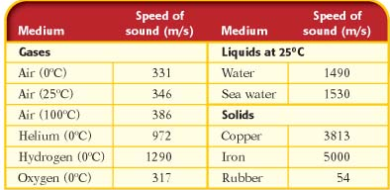

2. __________
- depends on intensity of sound wave
- intensity depends on two factors:
1. _______________________________
2. _____________
- greater intensity, _________ sound
- for humans to hear sound that is twice as loud it
must be ___________ as intense
- measured in _____________ (dB)
- difference of 10dB means a sound is twice as
loud

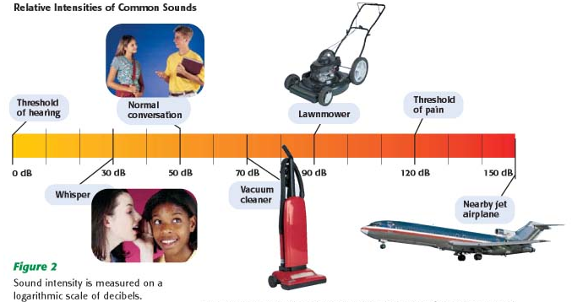

0dB – quietest noise
120dB – pain
- intense exposure to over 120 dB can lead
to deafness
3. __________
– a measure of how high or low a sound is perceived
to be depending on the frequency of the sound wave
- _____ frequency = high pitch
- _____ frequency = low pitch

- ___________ – slow vibrations of frequencies lower than
20 Hz
- ________ – any sound wave with frequencies higher than
20,000 Hz
- humans can hear sound between 20 Hz to 20,000 Hz

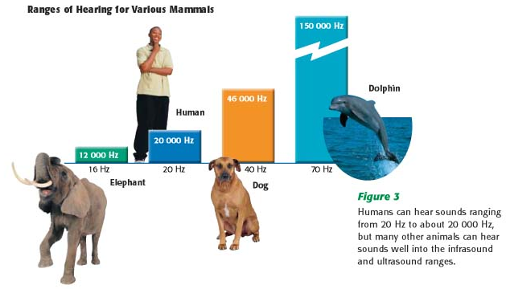

Musical Instruments
- produce sound by vibrating 1 of 3 things:
1. ___________
2. ____ _________
3. _____________
-Ex.: pluck string, its particles vibrate
- reflect at ends and return to middle
- sets up a ____________ wave
- 2 ends are nodes
- middle of string is anti-node
- place finger on string, changes length of string
- shorter string vibrates ____________
- higher frequency, higher pitch

- ___________ ___________ – primary standing wave on a
vibrating string has a
wavelength twice the length of
the string
- flutes and standing waves
- column of ________ instead of string
- change wavelength and frequency by opening and
closing ______________-
- changes length of air column

- ___________ – vibration at natural frequency and certain
whole number multiples of that frequency

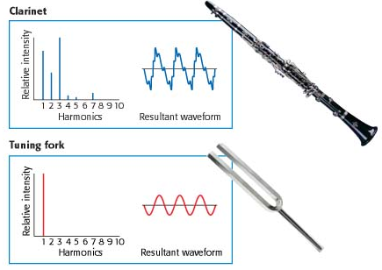

- reason why A from clarinet is not same as A
on tuning fork
- clarinet is combining several ____________
- gives each instrument its characteristic sound
- _________ – a phenomenon that occurs when two objects
naturally vibrate at the same frequency
- __________ sound (more particles vibrating)
- Ex: guitar
- pluck sting
- body of guitar _______ (forced vibrations)
- have certain natural frequencies
- guitar has many natural frequencies
- resonate at several pitches
- electric guitar doesn’t resonate well
- electronic amplification

The Ear (3 regions)
1. ______ _____
- includes:
1. cartilage on side of head
- gather sound waves
2. ___ ___________
- funnels sound into ear
3. ear drum
- piece of tissue
- compressions in sound waves vibrate ear
drum

2. __________ ear
- hammer, anvil, stirrup
- 3 ____________ bones in body
- hammer connected to eardrum
- vibrates with eardrum
- anvil vibrates with hammer
- stirrup amplifies vibrations
3. __________ ear
- stirrup strikes membrane (_____ _____) of inner ear
- sends waves into __________
- cochlear fluid
- make _________ in fluid
- waves strike ___________ membrane
- different parts vibrate at different natural
frequencies
- hair cells near vibrating portion trigger (bend) _____
cells which send impulse to brain
- brain interprets that as sound
Why do you hear ringing in ear after concert?
- large waves in cochlea crash into nerve endings
- damage nerve endings – stay bent over
- constantly send message to brain
- brain interprets as ringing
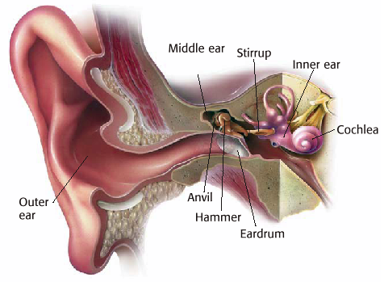
- sound can be reflected
- Ex: sonar
- ________ __________ and ____________
- uses acoustical signals and echo returns to determine
the location of objects or to communicate
- measure time it takes to travel to object and back
- know speed based on medium and temperature
V=d/t
- calculate distance
- _________________
- waves above 20,000 Hz
- can be focused
- sonogram
- computerized images using frequencies of
1 million to 15 million hertz
- view organs and ______ tissues
- doesn’t harm body like x-ray

