Chapter 5: Photosynthesis and
Cellular Respiration

- almost all energy comes from sun
- ________________- process by which light energy is
converted to chemical energy
- ___________- organisms that use energy from sunlight or
from chemical bonds in inorganic substances
to make organic compounds
- most are photosynthetic
- some use chemicals for energy...volcano vent
- ____________- organisms that must get energy from their
food instead of directly from the sun or
inorganic substances
- cellular __________- how heterotrophs get energy from
food
- metabolic process
- releases energy in food to make ATP
- chemical energy stored in food molecules is
released gradually in a series of ______-assisted
chemical reactions

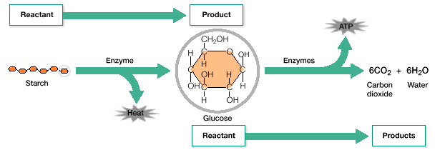
- product of one reaction becomes reactant in the
next
- when food is broken down
- some is lost as heat
- rest is stored as ATP
- ATP delivers energy whenever energy is
needed in cell
- ATP drives most of a cell’s activities
- ATP- _______________________- nucleotide with extra
energy storing phosphate groups
- 3 phosphate groups form a chain that branches
from a 5 carbon sugar called ______________
- phosphate “tail” is unstable
- phosphates are “-“ charged and repel each
other
- energy is released when these bonds between
phosphates are broken
- some energy is required to release energy
***much less than what is released***
- ____ minus a phosphate group becomes _____; adenosine
diphosphate
ATP ADP + P + energy
- occasionally 2 phosphate groups will be released instead
of just one…makes the reaction ___________________
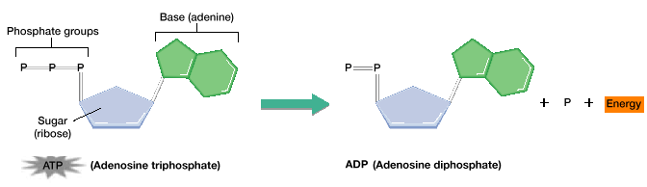

____________________________
3 Stages
1) Energy is captured from sun light
2) Light energy is converted to chemical energy-temporarily stored as ATP and energy carrier molecule ____________
3) Chemical energy stored in ATP and NADPH powers the formation of organic compounds using ______

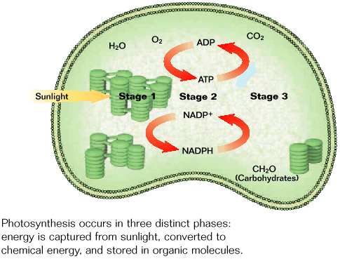

- occurs in chloroplasts of plant cells and algae and in cell
membranes of certain prokaryotes

3 CO₂ + 3 H₂O ^{light} ___________ + 3O₂

STAGE ONE:
Absorption of Light Energy

- “light rxns” or light dependent reactions
- reactions that occur during the first _____ stages of
photosynthesis
- light in the form of radiation is used to make energy
storing compounds
- different types of radiation have different _____________
- we only see visible light (red through violet)
- ________- light absorbing substances
- absorb certain wavelengths and reflect the rest
- _______________- 1⁰ pigment in photosynthesis
-absorbs mostly blue and red
-reflects green and yellow
-makes plants appear green
-two types of chlorophyll; a and b
- ___________- pigments that absorb wavelengths different
than chlorophyll
-produce yellow and orange colors
- having chlorophyll and carotenoids enables a plant to _________ more wavelengths
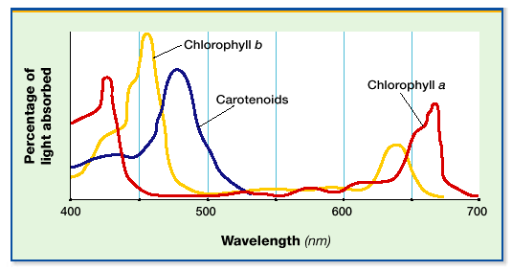

- pigments are located in chloroplasts of leaf cells
- clusters of pigments are embedded in membranes of
thylakoids
- light strikes ________-energy is transferred to electrons in
chlorophyll
-energy causes electron to jump to
higher energy level; “excited”
-excited _____________ jumps to nearby molecules in the
thykaloid membrane
-electron replaced with electron from water molecules
-water split by enzyme
-enzyme stripped from H⁺; Oxygen atoms form _____

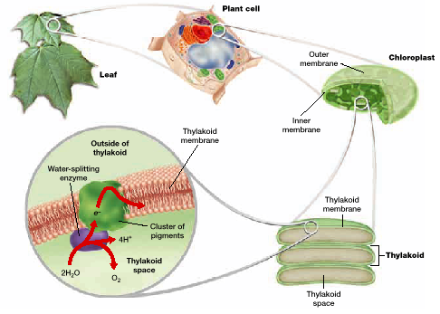

Stage Two:
Conversion of Light Energy

- _______________________- series of molecules through
which excited electrons are passed along;
thylakoid membrane
- 1st electron transport chain
- between _______________ molecules
- electrons must pass through protein
- membrane pump
- electron loses some __________ to protein
- lost energy is used to move H⁺ into cell
- H⁺ being pumped into cell
- concentration gradient across the thylakoid
membrane
- H⁺ __________ down concentration gradient through
specialized carrier protein
- the protein catalyzes the reaction to make _____ into
ATP
*** movement of H⁺ ions across thylakoid membrane
provides energy needed to make ATP for 3 stages of
photosynthesis***

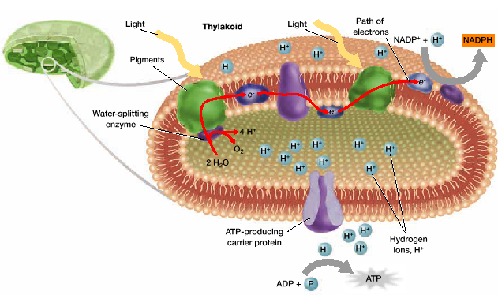

- 2nd electron transport chain
- provides energy to make NADPH
- __________- electron carrier that provides the high
energy electrons needed to make
carbon-hydrogen bond in the 3rd stage of
photosynthesis
- excited electron combines with hydrogen
ions as well as an electron acceptor called
NADP⁺ forming NADPH

Summary of Light Dependent Reactions:
- Pigment molecules in thylakoids of chloroplasts absorb
light energy. Electrons are excited by light energy and
move through electron transport chains in thylakoid
membranes. Electrons are replaced from H₂O molecules,
oxygen forms O₂. Hydrogen ions accumulate inside
thylakoids setting up concentration gradient that provides
energy to make ATP and NADPH.

Stage Three: Storage of Energy

- carbon atoms from CO₂ in atmosphere are used to make
organic compounds in which chemical energy is used
- carbon dioxide __________- transfer of CO₂ to organic
compounds
- dark reactions or light independent reactions…reactions
that fix CO₂

Calvin Cycle
- named for Melvin Calvin
- a series of enzyme assisted chemical reactions that
produces a _______________________; 4 steps
1) CO₂ is added a 5-carbon compound by an enzyme
2) resulting 6-carbon compound splits into 2, 3-carbon
compounds
- phosphate groups from _______ and electrons from
___________ are added forming 3-carbon sugar
3) one of the sugars is used to make organic compounds
- includes _______ and sucrose…stored energy
4) other 3-carbon sugar is used to ____________ the initial
5 carbon compound
- three CO₂ are necessary to produce each 3 carbon sugar
molecule used to make organic compound
- energy is supplied by ATP and NADPH made during
stage 2
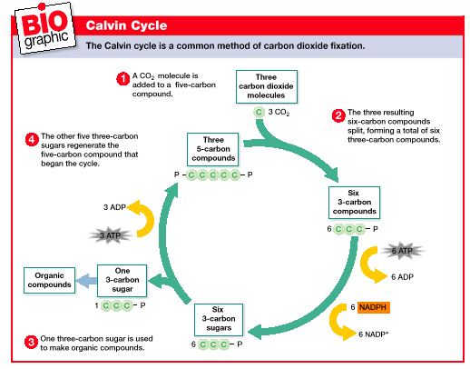
Factors affecting Photosynthesis
- _____________- rate of photosynthesis increases as light
intensity increases
- when all pigments are used, rate of
photosynthesis levels off
- ___ concentration- once a level is reached it cannot occur
any faster
- ______________- most effective in a certain range
- based on enzymes which are very temp.
dependent

CELLULAR RESPIRATION
- __________________- process by which cells transfer the
energy in organic compounds to ATP
- O₂ makes production of ATP more efficient
- some ATP made without O₂
- ______________- metabolic processes that require O₂
- _____________- metabolic process that do not require O₂

C₆H₁₂O₆ + 6 O₂ ^{enzymes} 6 CO₂ + 6 H₂O + energy
(glucose) (ATP)

- occurs in 2 stages
- Stage 1: Glucose is converted to _________ producing a
small amount of ATP and NADPH
- Stage 2: - aerobic respiration- _____ present
- pyruvate and NADH are used to make
large amounts of ATP
- occurs in _____________ of eukaryote
cell and in cell membrane of
prokaryotic cells
- anaerobic respiration- without _____
- pyruvate is converted into either _____ or
ethanol and CO₂
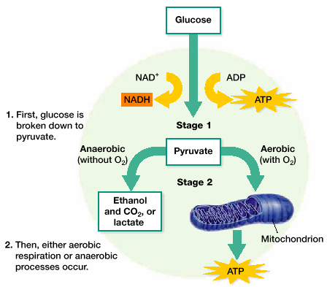

Stage One: Breakdown of Glucose
- glucose is primary fuel for cellular respiration
_________________________
- glycolysis- ___________ is broken down in the cytoplasm
- becomes 2, 3-carbon pyruvate ions
4 steps
1) phosphate groups from 2 ____ molecules are transferred
to a glucose molecule
2) resulting 6-carbon compound is broken down to 2,
3-carbon compounds each with a ____________
3) 2 NADH molecules are produced and one more
phosphate group is transferred to each 3-carbon
compound
4) each 3-carbon compound is converted to a 3-carbon
______________
- produces 4 ATP molecules
- glycolysis uses 2 ATP to make 4 ATP
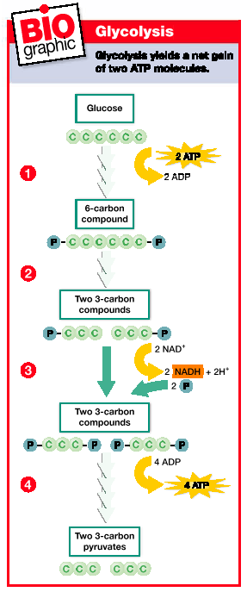

Stage 2: Production of ATP

- when O₂ is present; pyruvate from _____________ enters
mitochondria and made into a 2-carbon compound
- this reaction produces 1 CO₂ molecule, 1 NADH
molecule, and 1, 2-carbon acetyl group
- the _____ group is attached to a molecule (coenzyme A or
CoA) forming acetyl-CoA
_____________ Cycle (5 steps)
1) Acetyl-CoA combines with a 4 carbon compound
forming a 6-carbon compound and releasing CoA
2) CO₂ released
- 6-carbon compound becomes a 5-carbon compound
- electrons are transferred to NAD⁺; makes a molecule
of NADH
3) CO₂ released
- makes 5-carbon compound a 4-carbon compound
- molecule of ____ is made and a molecule of ______ is
produced
4) 4 carbon compound is converted into a new 4-carbon
compound
- electrons are transferred to ____ making a molecule of
FADH₂ (another type of electron carrier)
5) new 4-carbon compound is converted to the 4-carbon
compound that started the cycle
- another molecule of NADH is produced
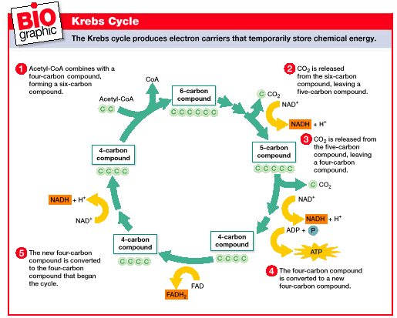

- after Krebs cycle
- most energy from glucose and pyruvate is now in
NADH and FADH₂
- electron transport chain- ____________ respiration
- electron donated by NADH and FADH₂ enter electron
transport chain
- __________ cells (e⁻ transport chain is in mitochondria
inner membrane)
- energy of electron is used to pump H⁺ out of inner
___________________ compartment
- H⁺ in outer membrane has a higher concentration
- H⁺ diffuse through carrier protein that adds a phosphate
group to ______ to make _________
- H⁺ and electron combine with O₂ to make H₂O
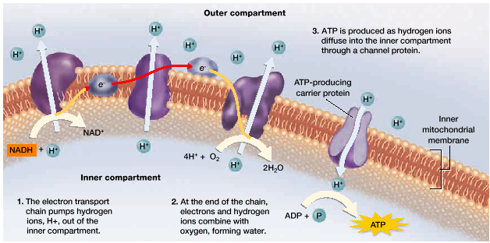

- under anaerobic conditions, electrons carried by NADH
are transferred to pyruvate produced during ___________
- this recycles _________ needed to make more ATP
during glycolysis
- fermentation- recycling of NAD⁺ using an organic
hydrogen acceptor
2 important types (there are several others)
1) ___________________________________
- 3-carbon pyruvate 3-carbon lactate
(ion of lactic acid)
- Ex.- Exercising without enough O₂
- fermentation enables glycolysis to produce ATP as
long as glucose is present
- blood removes lactic acid from muscles
- if not removed quickly will cause soreness
2) _____________________________________
- 3-carbon pyruvate ethanol
(2-carbon compound)
- released CO₂
2 Steps
1) pyruvate is converted to a 2-carbon compound
releasing __________
2) electrons are transferred from ______ to the
2-carbon compound producing ethanol
- NAD⁺ is ________ and glycolysis can contribute to
produce ATP
- Ex.- yeast production of ethanol
- wine, beer
- yeast production of CO₂
- bread rising

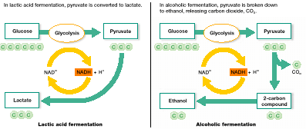

ATP PRODUCTION
__________- 2 ATP total produced; uses 2/makes 4
___________________________- MOST EFFICEINT
- for each molecule of glucose;
- Krebs Cycle makes 2 ATP and up to
34 ATP molecules by the electron
transport chain
_______________________- still makes some ATP
through glycolysis

