Chapter 4 Cells and their Environment
Passive Transport (4 types)
- _______________- movement across the cell membrane
that does not require energy from the
cell
- ___________________- a difference in concentration of a
substance across a space
- ___________- a condition in which the concentration of a
substance is equal throughout a space
1) - _________- movement of a substance from an area of
high concentration to an area of low
concentration caused by the random motion
of particles of the substance
- if allowed to continue, ________________
eventually results
- many substances enter or leave cells by
diffusion
- for most of these substances their
concentration inside and outside and
outside the cell differs
(concentration gradient)
- to go from low to high concentration, a
substance must be able to pass through
the cell membrane
- non-polar, lipid bi-layer will not allow
______ and ______ molecules through
- small molecules and non-polar
molecules may pass through and down
their concentration gradient
********simplest form of passive transport*********

2) – _______- diffusion of water through a semi-permeable
membrane
- water moving down its concentration
gradient
- occurs because substances dissolve in water
- if dissolved ________ have concentration
gradients and can’t move across
membrane…water will move until
equilibrium is reached

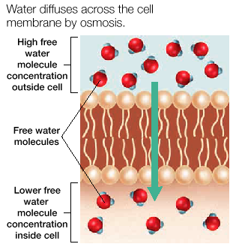

3 possible directions of water movement
1) water moves out…cell _____________
- _______tonic solution- solution that causes cell to
shrink
2) water moves in…cell ___________
- ______tonic solution- solution that causes a cell to
swell because of osmosis

3) no NET water movement...___________ size
- equal amount in as out
- __tonic solution- solution that produces no change
in cell volume because of
osmosis
- swelling can cause cell to burst…lead to adaptations
1) cell _________ in plants
2) ______________ vacuole (collect excess H₂O)
3) remove dissolved particles from cell

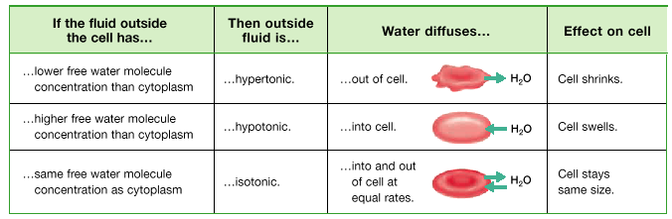

Quick Review
-ions and polar molecules cannot cross cell membrane
because of ______________________ interior
- aided by transport proteins (channels)
- each channel allows only specific substances to pass
through membrane
- ___________ allows cell to control what leaves and
enters

3) - ______________- a transport protein with a polar pore
through which ions can pass
- allows ions to bypass the non-polar
interior of the lipid bi-layer
- some always open, some close by ion
_________________ gates
- closing caused by ____________
- Ex.- stretching cell membrane
- change in electric charge
- binding of specific molecules

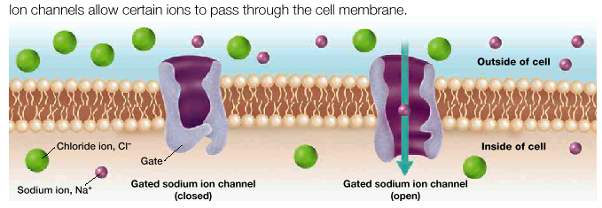

- rate of movement of a substance across the cell membrane
- 2 major factors
1) ____________ ____________________
2) _________________ charge
- inside of cell is typically “-“ charged
- “+” more likely to go in; “-“ more likely to go out
- ion’s charge and concentration gradient may
oppose each other
- affects _____________ rate into and out of cell
- important in animal nerve cells
4) - _________________ _ _________________
- carrier proteins that binds to a specific substance on
one side of cell membrane
- carries the substance across the cell membrane
and releases it on the other side
- substances are carried down their concentration
gradient- uses __________of the cell’s energy

3 steps
1) ______ protein binds a specific molecule on one side
of cell membrane
2) change in shape of carrier protein __________ the
molecule to the other side of the cell membrane
3) carrier protein _______ molecule from inside of lipid
bi-layer
- molecule is released from carrier protein which
returns to its original shape

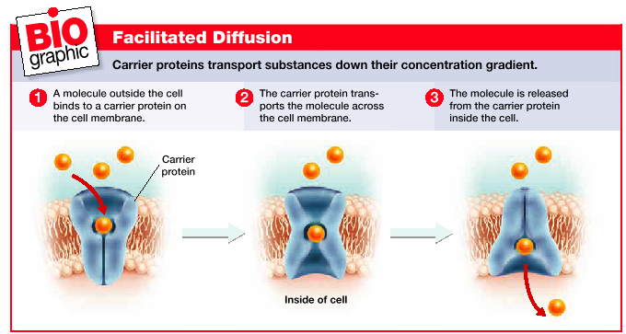

Active Transport
- _____________- a way for cells to move substances from
low concentration to high concentration;
against the concentration gradient
- requires the cell to use ____________
- energy is usually supplied by _____
- many times occurs in carrier proteins
- because the substance moves against
its concentration gradient, carrier
proteins may be referred to as
membrane “___________”
-Ex.- Sodium-Potassium pump
- transports 3 Na⁺ out of cell, 2 K⁺ into cell
- both against their concentration gradient
- energy supplied by ATP
- may account for much of the ATP used by
a cell
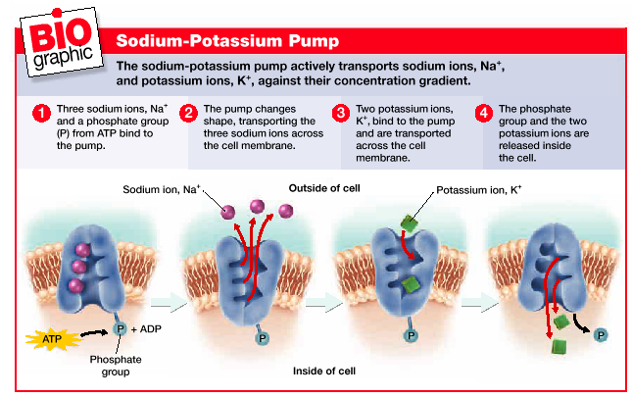
4 steps
1) 3 Na⁺ inside cell bind to ___________
- a ____________ group is removed from ATP and also
binds to the pump
2) pump changes __________
- transporting 3 Na⁺ across the cell membrane and
release outside the cell
3) 2 _____ ions from outside cell bind to pump
- the phosphate group is released changing the shape of
the pump
4) K⁺ ions are moved across cell membrane and released

Na-K pump important- 2 reasons
1) keeps Na⁺ from_____________________ in the cell
- they are always diffusing through ion channels in
lipid bi-layer
- may cause H₂O to enter cell by osmosis and swell
or bust
2) helps maintain the concentration gradient of ___ and
_____ across cell membrane
- useful in transporting other substances across
membrane

- _____________- movement of substances into a cell by a
vesicle
- usually too large for carrier proteins
1) cell membrane forms _______ around a
substance
2) pouch closes up and _________ off to form
vesicle

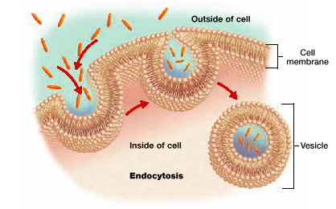

- __________- movement of a substance by a vesicle to the
outside of a cell
- vesicle in cell fuse to export proteins
- vesicle modified by _________________

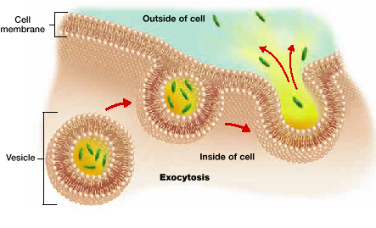

Membrane Receptor Proteins
- ___________________- released by cells
- carry info. to nearby cells and
throughout the body
- Ex.- hormones
- made in one part and released to
rest of body to have effect
- ________________- protein that binds to a specific signal
molecule enabling the cell to respond
- Ex.- muscle contraction

- signal molecules bound by receptor proteins
- causes change in the receiving cell-3 ways
1) change in _____________________
- opens ion channel allowing certain ions to pass
- important in nervous system

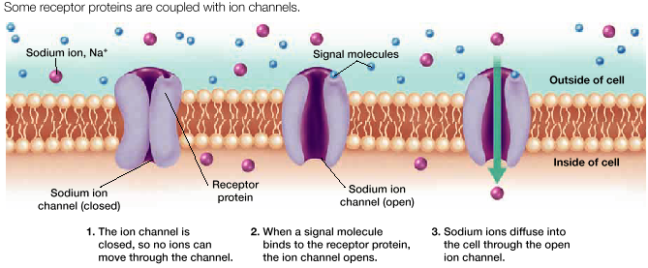

2) second ___________________
- act as a signal molecule in the cytoplasm
- amplifies signal of the first messenger
- may change functioning of the cell
- Ex.- activate enzymes
- trigger biochemical reactions
- open ion channels

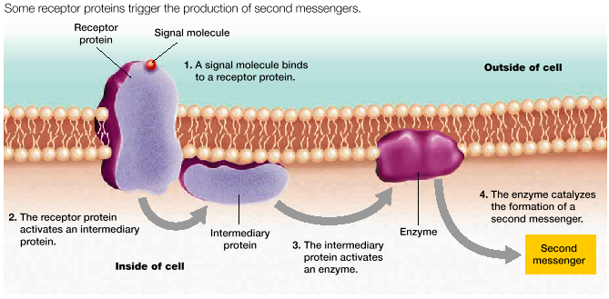
3) _________________ action
- receptor protein acts as an enzyme or may activate
other enzymes
- many drugs affect the binding of the signal molecules
- may bind to the receptor proteins and ______ cell
functions
- Ex.- heroine…illegal
- beta blockers…legal
- prescribed for rapid heart beat
- bind to receptor protein
- keeps signal molecule from binding
- prevents increase in heart rate

