Chapter 3 Cell Structure

-1838- Mattias _________- concluded that cells make all
parts of plants; not just roots and
stems
- 1939- Theodore ________- animals are made of cells
- 1958- Rudolf ________- cells come only from other cells
Cell Theory- 3 Parts
1) All living things are made of 1 or more ________
2) Cells are the basic units of ___________ and function in
organisms
3) All cells arise from existing cells

Cell Size
- 100 trillion cells in the human body
- small cells have higher surface area to volume ratio
- small cells can exchange materials more _________

Common Features
- cell __________- outer boundary; encloses the cells and
separates the cell interior
- regulates what enters and leaves the cell
- cytoplasm- in the interior of the cell
- cyto________- system of microscopic fibers suspended in
cytoplasm
- _________- cellular structure on which proteins are made
- DNA- almost all cells have DNA
- cellular “blue print”
- some, like RBCs, lose their DNA

Prokaryotes vs. Eukaryotes

Prokaryotes
- smallest and simplest cells
- _________- single celled an organism that lacks a nucleus
and other internal organs
- few specialized functions
- EX.- bacteria
- at least 3.5 billion years old

Characteristics
- live in a broad range of environments
- no compartments; ________ is free to move around
- single strand of DNA
- _______ _________ for structure and support
- made of strands of polysaccharides connected by
Amino Acids (AA)
- some are surrounded by capsule cling to
objects
- _________- long threadlike structures used for movement

Eukaryotes
- 1st cells with internal compartments
- ________- organism whose cells have a nucleus
- ______- internal compartment that houses the cell’s DNA
- _________- internal compartment that carries out specific
activities in a cell
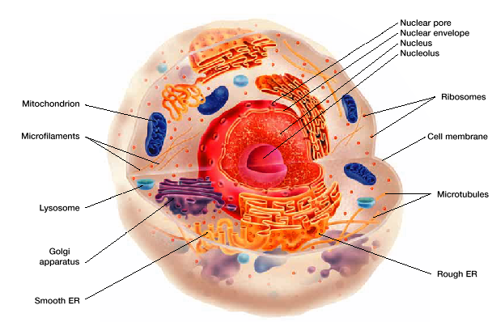
- cytoplasm in eukaryote includes everything within the cell
membrane, but outside the nucleus
- internal membrane connects _______________
- delivers substances
- ________- envelopes in internal membrane that move
proteins and other molecules between
organelles
- some use ________; some use ______
- both may move substances across surface
-Ex.- human mucus in lungs
- cytoskeleton is made of a web of protein __________
- holds cell together and keeps membranes from
collapsing
-__________- fluid surrounding everything in cell
- cytoskeleton fibers
- make up_____________ structure for cell
- hold nucleus and other organelles in their position

3 Types
1) ______ fibers- long, slender microfilaments made of the
protein actin
- form network beneath cell membrane
- contract or expand to change cell shape
2) ____________- hollow; made of the protein tubulin
- transport info. from nucleus to different
parts of cell
- RNA molecules are pulled along by motor
proteins that pull them along the
microtubules
3) ____________ fibers- help confine ribosomes and
enzymes to a particular part of a
cell

Cell Membrane
- _________ permeability- only allow certain substances in
- ____________- lipid made of a phosphate group and two
fatty acids
- has a polar “head” and 2 non-polar “tails”
- phosphate “head” is polar
- _____________ to H₂O
- 2 fatty acid “tails” are non-polar
- __________ by H₂O
- lipid _________- double layer of phospholipids in a cell
membrane
- non-polar tails are on the ____________
- repelled by water on inside and outside
of cell

- ions and most polar molecules are repelled
by the non-polar interior
- lipid bi-layer allows lipids and substances
that ___________ in lipids to pass through

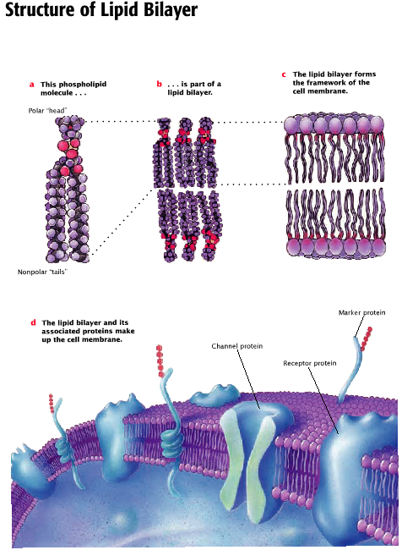

- ________ proteins- a protein found in the lipid bi-layer of
the cell membrane
- membrane protein is attracted to
__________ portion (interior) of the
lipid bi-layer, but repelled by water
on both sides
- polar parts of membrane are attracted
to H₂O
- many different types of proteins in
membranes; variety of functions
- Ex.- marker proteins...ID type of cell
-receptor proteins…bind
molecules outside of cell
- enzymes…biological reactions
- transport proteins… aid in
movement of substances
into and out of cell
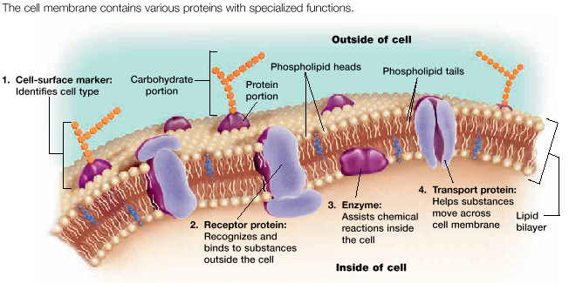

Cell Organelles
- _______- controls cell’s functions
- surrounded by two lipid bi-layers called nuclear
__________ or nuclear ____________
- nuclear _____- small channels on surface of
nuclear envelope
- allow exit and entry of substances
- contains nucleolus which partially produces
ribosomes
- stores DNA hereditary information
- ribosomes produce ______________
- ribosomes found in 2 places
1) free in cytosol
2) attached to rough endoplasmic reticulum
- _____________ _____________ (ER)-
- ribosomes on ER surface produce proteins that are
________________ from cell
- made of lipid bi-layer with embedded proteins
- moves substances throughout cell
- as proteins are made on ER
- enters membrane
- transported
- forms _______- small membrane bound
sac that transports
substances
- smooth ER- lacks ribosomes
- makes ______________
- breaks down __________
- “free” ribosomes are in cytosol
- proteins produced stay in the cell

- _______apparatus- set of flattened, membrane bound sacs
that package and distribute proteins
- contain _______ that modify proteins
that are inside vesicles from ER
- proteins enclosed in new vesicle
- some vesicles include _____________
- special organelles that contain the
cells digestive enzymes
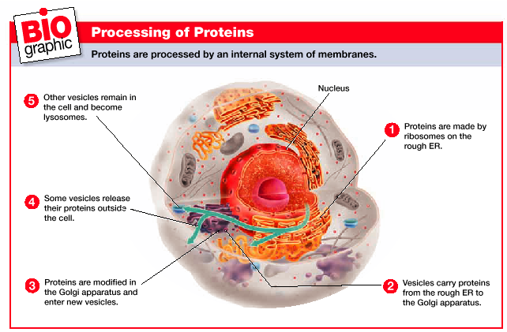

Production of __________________
1) Ribosomes make proteins on the rough ER. Proteins are
packaged into vesicles.
2) The vesicles transport the newly made proteins from the
rough ER to the golgi apparatus.
3) In golgi apparatus, proteins are processed and then
packaged into new vesicles.
4) Many of these vesicles move to the cell membrane and
release their contents outside the cell.
5) The vesicles, including lysosomes, remain within the
cytoplasm. Lysosomes digest and recycle the cell’s
used components by breaking down proteins, nucleic
acids, lipids, and carbohydrates.
- _____________- gets energy from organic compounds to
make __________
- some ATP is made in cytosol; most is
made in mitochondria
- ______ energy cells will have more
mitochondria
- has 2 _________ (makes 2 compartments)
- outer is smooth
- inner is folded
- increases __________ ___________
- where most ATP is made
- contain DNA and ribosomes
- mitochondrial DNA is __________
of nuclear DNA
- supports theory that primitive
prokaryotes are the ancestors
of mitochondria
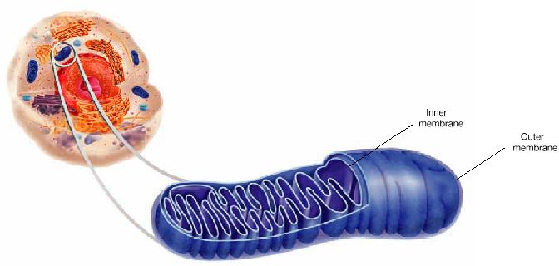

3 Structures found in plant cells
1) _____ _____- surrounds cell membrane
- composed of proteins and carbohydrates
- includes cellulose
- support and maintain shape of cell
- protects cell
- connects with adjacent cells
2) ____________- use light energy to make carbohydrates
from CO₂ and H₂O
- also found in several eukaryotic algae
- produce power along with mitochondria for
cells energy
- surrounded by two membranes
- have their own DNA
- thought to be descendents of ancient
prokaryotic cells
3) central _______- membrane bound sac that stores water,
ions, nutrients, wastes, etc.
- when full makes the cell rigid
- keeps plant upright

