Unit 2 The Cell/ Bio. Chem.

Chapter 2: Chemistry of Life

- Matter consists of __________
-atom- smallest unit of matter that cannot be broken
down by ______________ means
- made of _____ particles
__________ nucleus +
___________ nucleus o
___________ e⁻ cloud -

-e⁻ cloud “____“ charged
-nucleus “____” charged
-___________- pure substance made of only 1 kind of atom
- over 100 known elements
- each has its own ______________
- differ in number of ___________
- varying number of neutrons is an ___________
-Ex.- C-12, C-13, C-14
- each has 6 protons, but different number
of neutrons
- C-12 has 6, C-13 has 7, C-14 has 8
-____________-substance made of the joined atoms of 2 or
more different elements
-force joining them is called a chemical ______
-there is a ______________ for each compound
-tells number of each ________ that
make it up

3 types of bonds
1) ________________bonds
-form when 2 or more atoms _______ e⁻ makes a
___________
-_______- a group of atoms held together by covalent
bonds
* e⁻ arrangement determines ___________________
- e⁻ closest to the nucleus have ____ energy than those
that are further away
- atom is stable when its outer energy level is _______
-small atoms only need _____ e⁻, most need ____ e⁻
- atoms react until there ________ energy level is full
2) __________________bonds
-a weak chemical attraction between _____ molecules
-shared e⁻ are attracted more _________ to the oxygen
nucleus (more ________, more “+” charges)
-gives some molecules slightly “___” and “___“ ends
-“+” and “-“ _____________ molecules
- each “+” and “-“ is attracted to other ends of
molecules ”+” and “-“
- _________ is a polar molecule
- stays as a stream because of ____________
bonding
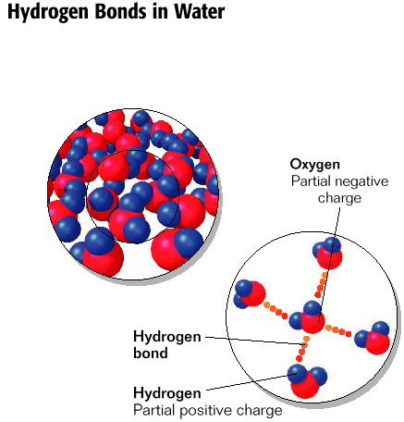

3) ______________bonds
- __- atom has gained or lost e⁻ electrically charged
- lose e⁻ ”___” charge; gain e⁻ ”__“charge
- opposite charges _____________
- Ex: salt- NaCl
Na⁺ + Cl⁻ NaCl
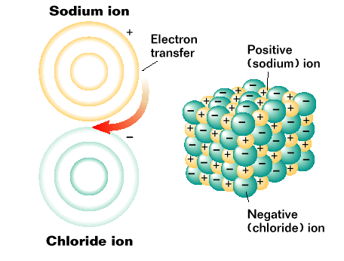
- ___% of body is ____________
- water heats more _____ and retains heat _____ than most
substances
- organisms use water to maintain _______________
-Ex. - sweating
- ________________ of water cools body
- _________- an attraction between substances of the ____
kind
- Ex. - water molecules
- held to each other by hydrogen bonds
- responsible for ________ __________
- ___________- an attraction between ________ substances
- Ex.- ___________ _________
- _______moves upward through a narrow
tube (stem of plant)
- attraction of water to _____ of plant is greater
than ________…water moves _________
- ________- a ______ in which one or more substances are
evenly distributed in ______________substance
- Ex.- lots of substances dissolved in __________
- allows material to be transported to and
away from ________
- water’s ____________ dissolves many substances
- ionic and polar __________ dissolve best
- ______ become surrounded by _____ molecules
- attracted to _____ ___________
-________molecules don’t dissolve as well in water
- ________ molecules are more attracted to
each other
*****non-polar molecules not dissolving in water is
important in Biology*****
-Ex.- _____ ____________
- depend on interaction of _____ water and ________
membrane molecules
H₂O → H⁺ + OH
H⁺ → ___________ ion→_______
OH → __________ ion→ __________
- pure __________ always has some H⁺ and OH
- acids have more ___ ions in water
- bases have less ___ ions in water (extra OH bond
with H⁺ to make ______)

- ____ ___________
0-14; measures acids and bases
- below 7 is an ________; 0 is the strongest acid
- above 7 is a _______; 14 is the strongest base
- 7 is __________
- a change by one number on pH scale represents
__________ change
-Ex.- pH of 6 has ten times as many H⁺ ions as
something with a pH of 7
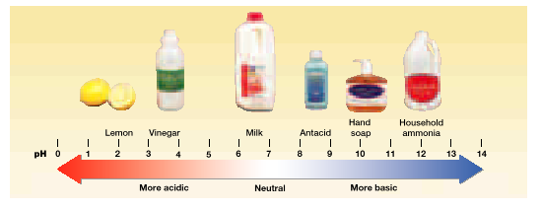
4 main classes of organic compounds
1) __________________
- organic compounds made of C, H, O in a ratio of 1:2:1
- key source of ___________
- made of ____________________ (simple sugars)
- main _______ source for _________
- ____saccharides- two monosaccharides
- ______saccharides- three or more
monosaccharides
- 2 main store houses for energy
1) _______- made by plants
2) __________- made by animals

2) _______________
- ____________molecules that are not _______ in water
- includes ____, ____________, ________, and ______
- important in _______ and ________ of cell membrane
- ________ store energy
- fats contain three ______ _______ bonded to a
____________ (3 carbon molecule)
- fatty acid- long chain of _______ atoms with
_____________
- ______________ fatty acids
- all carbon atoms are bonded to 2 or 3 __________
- straight
- includes most _________ fats
- usually ______ at room temperature
- _____________ fatty acids
- some carbon atoms are linked by _______ bonds
- produces “______” in molecule
- includes most ________ oils
- _______ at room temperature (except artificially
saturated material…margarine and vegetable
shortening)

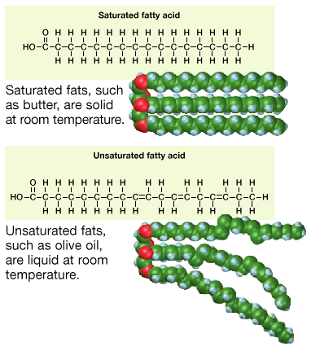
3) ______________
- large molecules formed by linked __________ ______
- _______ _______- building blocks of _____________
- ____ different amino acids
- some polar; some non-polar
- some electrically charged; some not
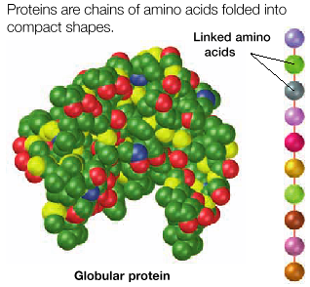

- ____________ have several functions
- hemoglobin, muscle contraction,
_______ (chemical reactions), structural functions
fight infections
4) ____________ ____________
- ________ ______- long chain of smaller molecules
-nucleotides
- _____________- 3 parts; sugar, base, phosphate group
- 2 types of nucleic acids
1) ____- ________________ acid
- store heredity info.
- 2 strands (________ __________)
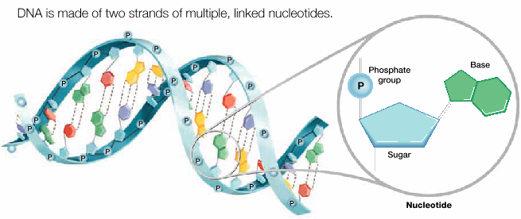
2) _____- ______________ acid
- 1 strand
- makes ______ and __________
- _____- adenosine triphosphate
- ____________ storage of energy for cells
-_________- ability to move or change matter
- many forms
- may be stored or released by a ________ reaction

- _________ ________- process by which chemical
bonds _____ and new ones are
_______ resulting in different
________________
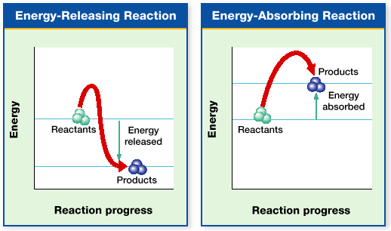
-__________- starting materials for reaction
-___________- newly formed substances from
reaction
REACTANTS→PRODUCTS
- ______ is absorbed or released when chemical
bonds are broken and new ones are formed
-___________- chemical reactions that occur
within an organism
- process by which cells get most of
their _____________
-_________ ________- energy needed to start a chemical
______________
-_________- substances that increase the speed of chemical
reactions
- they are _________ that lower the __________
energy
- help to maintain ______________
-Ex.- O₂ + CO₂ in blood
CO₂ + H₂O ^{carbonic anhydrase} H₂CO₃
- CO₂ reacts with H₂O to form carbonic acid
-__________ reaction
- Carbonic acid breaks down to form CO₂ and
H₂O…….___________
- carbonic anhydrase- ________ that ______ ___
reaction
- without carbonic anhydrase blood couldn’t
_______ and ______ CO₂ and O₂ quick enough
for us to _________
- ________ times more efficient with the enzyme
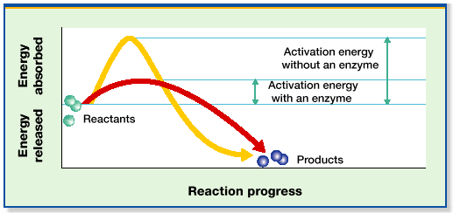
-________- substance on which an enzyme ____ during a
chemical reaction
- enzymes act only on _________ substrates
-Ex.- starch ^{amylase} glucose
-Ex.- 2H₂O _{catalase} 2H₂O + O₂
- _________ determines __________
- ________- ____ found on surface of enzyme
- determines which substances an
enzyme will ____ upon
3 steps
1) substrate attaches to an enzyme’s _________ ______
2) enzyme reduces the activation _________ of the reaction
3) ______________ is not changed by the reaction
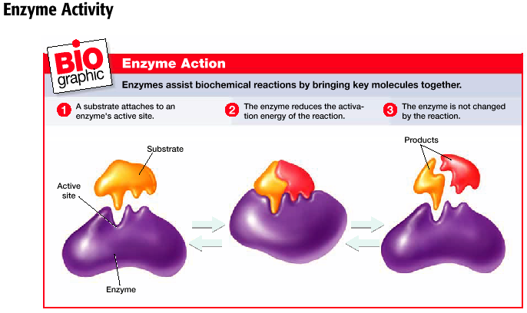
- enzymes work best in _________________ environments
- ______________
- ____
- each type of cell has different enzymes that ________ the
reactions that occur in that cell
-Ex.- nerve cell and red blood cell

