Chapter 9
DNA: The Genetic Material

The Structure of DNA
- James Watson and Francis Crick
- determined the shape of DNA
***shape determines ____________***
- allowed researchers to understand how DNA
served as _________ ___________
- shape was as a double _________
- 2 strands wrapped around each other
-similar to a winding staircase or a twisted ladder
- strands are made of linked nucleotides
- __________________- subunits of DNA
3 parts to a nucleotide
1) _____________ group
2) ____________ molecule
- deoxyribose, a 5 carbon sugar
3) nitrogen _________; 4 types
1) Adenine (A)
2) Guanine (G)
3) Thymine (T)
4) Cytosine (C)
- adenine and guanine are ___________
- 2 rings of C and N
- thymine and cytosine are ______________
- 1 ring of C and N
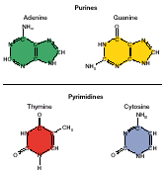

- if double helix is thought of as a twisted _________:
- sugar and phosphate make up the _________ of ladder
- nitrogen bases make-up _________ of ladder
- hydrogen bond holds base pairs together

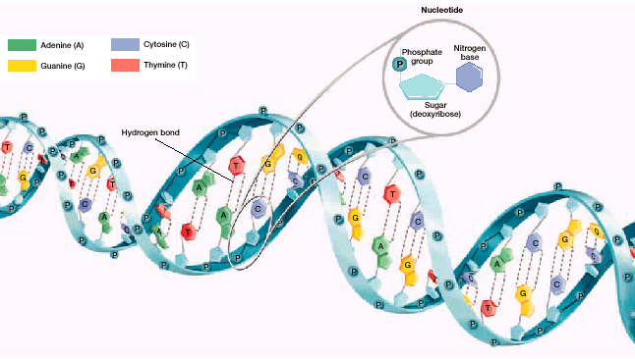

- Erwin __________ discovered that:
- amount of ___ and T equal
- amount of ___ and G equal
- amounts of each pair varied between organisms
- Wilkins and Franklin developed _____ diffraction photos
of DNA strands
- DNA resembles a tightly coiled helix and was
composed of 2 or 3 chains of nucleotides
- _____-and______ used Chargoff, Wilkins, and Franklin’s
discoveries and their knowledge of chemical bonding to
discover double helix
- determined base pair rules
- A always bonds to T
- C always bonds to G
- based on structure and size of molecules
- _______________ base pairs- sequence of bases on one
strand determines the
sequence of bases on the other
strand

DNA REPLICATION
- DNA replication- process of making a copy of DNA
- occurs during the _______ (S) phase of
cell cycle
3 steps
1) double helix unwinds
- DNA _________- enzyme that breaks hydrogen bonds
between nitrogen bases
- “unzips” double helix
- replication _______- proteins that attach to each strand
and hold them apart
- keep them from becoming a
double helix shape

2) nucleotides added
- DNA _________- enzymes that add nucleotides to the
exposed nitrogen bases
- follows base pairing rules
- ___ new double helixes are formed
- occurs at replication fork
3) continues until 2 new strands are formed
- each has an ________ strand and a _____ strand
- nucleotide sequence is identical

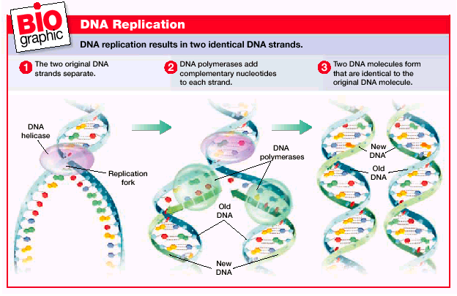

***DNA polymerases may back up and exchange
nucleotides if a mistake is made***
- errors occur once/billion nucleotides
- 50 nucleotides/second in ___________
- 500 nucleotides/second in ____________

- length of chromosome would take ____ days if the DNA
polymerase started at one end and went straight through
to the other end
- each chromosome is replicated in about _____ sections
approximately 100,000 nucleotides each with its own
starting point
- takes about ____ hours to replicate

