Chapter 8: Mendel and Heredity

- ___________- passing of traits from parents to offspring
- Gregor Johann _______- Austrian monk, studied science
and math
- bred different varieties of peas
- experiments had been done before
- T.A.____________, British farmer
- Mendel developed rules to predict
patterns of heredity
- ___________- branch of biology that focuses on heredity
- ___________- mating or breeding of individuals
Knight’s experiments:
- crossed purple flowering peas with white flowering
peas
- all offspring had _________ flowers
- when two offspring were crossed, the white flowers
reappeared
- Mendel imitated Knight’s experiments only he kept track
of the ___________ of each type of offspring
Why pea plant’s?????
1) several traits exist in 2 clearly different ________
- Ex.- flower color; purple or white…no intermediates
- 7 traits Mendel looked at
1) flower color
2) seed color
3) seed shape
4) pod color
5) pod shape
6) flower position
7) plant height
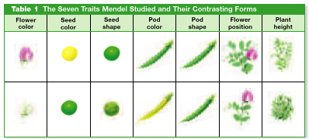

2) all plants have ______ (♂) and ________ (♀) parts
- may fertilize itself (_________________) or fertilize a
different plant (__________________)
- to cross-fertilize; he would cut off stamen (♂) and
dust pistil (♀) of another plant
3) peas are small grow easily, mature quickly, and
produce lots of offspring
- lots of subjects to count, _________ results

- _____________cross- cross that involves one pair of
contrasting traits
- Ex.- purple flower vs. white flower
Step1: allowed peas to self-pollinate for several
generations
- __________- makes sure only that trait is present
- Ex.- purple flower produces only purple
offspring
- if it produces white it wasn’t pure
- true bred plants served as the first generation
- _____generation- parental generation
- 1st two individuals crossed in a
breeding experiment

Step 2: Mendel _____ pollinated two P generation plants
that had contrasting traits
- F₁ generation- offspring of P generation (filial)
- counted F₁ generation that expressed each trait
Step 3: allowed F₁ generation to self-pollinate
- ____generation- offspring of F₁ generation
- counted F₂ generation that expressed each trait
RESULTS
F₁ plants- only 1 form of the trait was _____________
F₂ plants- missing trait from F₁ ________________
- ratio worked out as
- F₁ 4:0
- F₂ 3:1
- ratio held true for all 7 traits
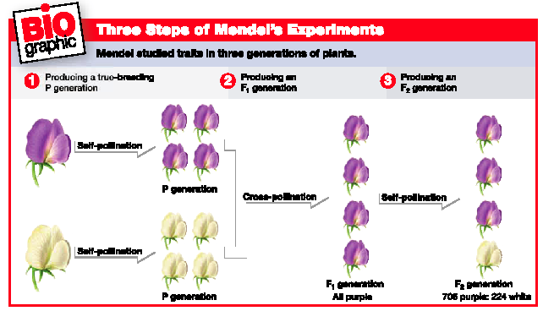
Mendel’s Theory
- before Mendel, people believed in ____________ of traits
- Ex.- tall parent X short parent = medium child
- Mendel explained each parent gives one of the offspring’s
__________ factors (genes) for each trait
Mendel’s 4 Hypotheses
a.k.a. ____________ Theory of Heredity
1) for each inherited trait, an individual has _____ copies of
the gene (one from each parent)
2) there are alternative versions of genes
- _________- different versions of a gene
- Ex.- purple vs. white

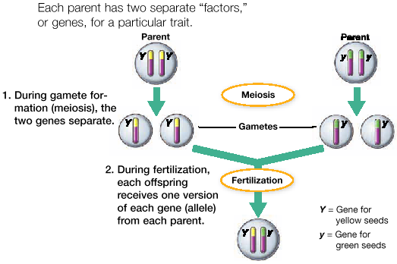
3) when two different alleles occur together, one of them
may be completely expressed, while the other may have
no observable affect on the organism’s appearance
- ________- expressed form of a trait when both alleles
are present
- ________- trait not expressed when dominant form is
present
- Ex.- purple X white
- purple showed up
- purple dominant; white recessive
4) When gametes are formed, the alleles for each gene in
all individuals separate ______________ of one another.
Thus, gametes carry only _____ allele for each inherited
trait. When gametes unite during fertilization, each
gamete contributes one allele.
- use letters to represent alleles
- capital letter represents _________ trait
- ____________ letter represents recessive trait
- Ex.- P = purple
p = white
3 combinations
PP _______zygous dominant = purple
Pp =_______zygous = purple
pp =_______zygous recessive = white
- homozygous- 2 alleles of a particular gene present in an
individual are the same
- heterozygous- alleles of a particular gene present in an
individual are different
- only dominant trait is expressed
- recessive trait is present, but not
expressed
- Ex.- freckles and cleft chin are dominant
- __________- an individual set of alleles
- Ex.- Pp, PP, or pp
- always write dominant trait first
- ___________- physical appearance of a trait
- Ex.- purple, white

The Laws of Heredity- 2 main ones
1) Law of ___________________
- first law of heredity
- describes behavior of chromosomes during ________
- state that the 2 alleles for a trait segregate when the
gametes are formed
2) Law of _________________ __________________
- second law of heredity
- states that the alleles of different genes separate
independently of one another during ______ formation
- the inheritance of one trait does not influence the
inheritance of another trait
- Ex.- plant height does not affect flower color
- _________ cross- cross that considers 2 pairs of
contrasting traits
- this law applies only to genes that are located on
_______chromosomes or that are far apart on the same
chromosome
- ________ _____- a diagram that predicts the outcome of a
genetic cross by considering all possible
combinations of gametes in the cross
- possible gametes for one parent are
written at the top
- possible gametes for other parent are
written on the side
- each box has __letters in it; take the letter
from the side and the top and combine
- letters in the boxes represent possible
________________

- _______________cross- a cross that considers 1 pair of
contrasting traits between 2 individuals
- Ex.- homozygous purple X homozygous white

P P
p
Pp | Pp
Pp | Pp

p
4/4 Pp heterozygous; all purple

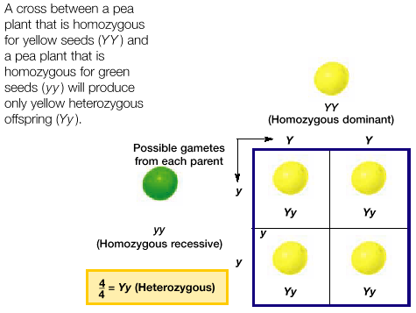

- Ex.- heterozygous X heterozygous
P p
P
PP | Pp
Pp | pp

p

1 PP purple ¼
2 Pp purple ½
1 pp white ¼
3 Purple: 1 White

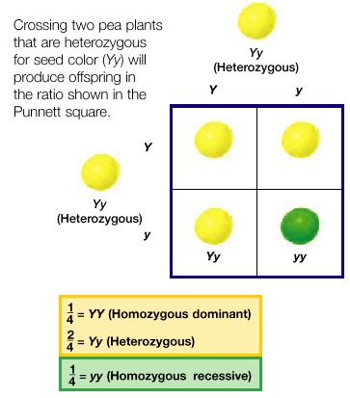
- important to know if an individual who exhibits a
dominant trait is homozygous or heterozygous
- ____cross- individual with the dominant phenotype,
but unknown genotype is crossed with a
homozygous ____________ individual
- if offspring are ½ dominant phenotype
and ½ recessive phenotype, then parent
in question was a _______________
- reality: don’t need ½ and ½; if one
offspring shows recessive phenotype,
then parent had to be heterozygote
- if all offspring show dominant
phenotype, doesn’t necessarily mean
parent was homozygous
- heredity is ________, may have just
not had any kids that expressed the
recessive phenotype
Probability
- probability- likelihood that a specific _______ will occur
- if event definitely will occur = ___
- if event definitely will not occur = ____
Probability = number of ____type possible outcome
______ number of all possible outcomes
- Ex.- flipping a coin; landing on heads
- 2 possible outcomes; 1 possible type of outcome
= ½
- Ex.- probability of a purple flower in which
both parents are heterozygous
Pp X Pp
- 50:50 chance each parent will give a P PP ½ X ½ = ¼
- 50:50 chance 1 parent will P and other Pp ¼ +¼ = ½
will give p; or vise versa
- 50:50 chance each parent will give a p pp ½ X ½ = ¼
- __________- a family history that shows how a trait is
inherited over several generations
- useful for determining genetic disorders
- carriers or not
- _______- heterozygous for a trait, but do not
show symptoms
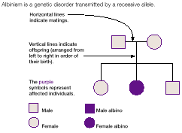

- pedigree helps scientists in 3 ways:
1) determine if a trait is _________ or sex linked
- autosomal- on a chromosome other than X or Y
- ___ _________- trait whose allele is located on the X
chromosome; most recessive
- males only have 1 X chromosome
- nothing to mask the sex-linked
recessive trait
- females who carry a recessive trait on X
has a _________ X to mask it
- she will only expressed trait if she is
______________ for the recessive trait
2) dominant or recessive
- if trait is _________ dominant; every individual with
the trait will have a parent with the trait
- if trait is recessive; an individual can have 1, 2, or
neither parent ___________ the trait

3) _______________ or ________________
- for autosomal traits, if individual is homozygous
dominant or heterozygous, they will show dominant
trait
- if homozygous recessive, show recessive
characteristics
- two heterozygous carriers won’t show recessive trait,
but may have children who do
- ____________trait- when several genes influence a trait
- genes may be scattered along the same
chromosome or located on a different
chromosome
- many combinations appear in offspring
- Ex.- eye, hair, skin color, height, weight
- __________ dominance- an individual displays a trait that
is ___________ between the two
parents
- Ex.- red snapdragon X white snapdragon
- ________snapdragon offspring
- neither red nor white is dominant
- Ex.- Caucasians curly X straight
- wavy in offspring
- ___________alleles- genes with 3 or more alleles
- Ex.- blood types; A, B, O
- alleles I^{A}, I^{B}, i
- I^{A} and I^{B} are dominant; i is recessive
- I^{A} and I^{B}; co-dominant
- blood types; ____, ____, _____, ____

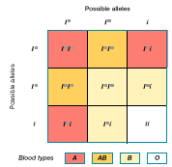

- ______________- 2 dominant alleles are expressed at the
same time
- different from incomplete dominance
because both traits are __________
- phenotype may depend on environment
- Ex.- hydrangea
- flowers are different colors depending on pH of
soil
- Ex.- arctic fox
- color depends on temperature
- white - cold, brown – warm
- Ex.- humans
- height; nutrition
- skin color; exposure to sun
- behavior
- study identical twins to study environmental effect
- genetically _____________
Genetic Disorders
- ________ ______- effect produced by inherited mutations
- many are carried by ________ alleles in
heterozygotes
- 2 heterozygotes cross
- homozygous children

_________________________
- recessive
- defective form of protein; hemoglobin (binds O₂ to RBC)
- causes RBC to take sickle shape; ruptures easy
- less O₂ in blood
- gets stuck in blood vessels, cuts off blood supply
- allele that causes sickle cell also causes heterozygotes to
be protected from malaria

________________________
- fatal recessive
- defective gene that makes a protein necessary to pump
chloride into and out of cells
- mucus clogs airways of lungs and ducts of liver and
pancreas

__________________________
- recessive; sex-linked
- gene that codes for blood clotting in located on the X
chromosome (♂ have only one X)
- impairs the blood’s ability to clot

____________________ Disease
- dominant allele
- mild forgetfulness and irritability
- people in 30’s and 40’s
- eventually causes loss of muscle control, uncontrolled
spasms, mental illness, death
- don’t know you have it until you have had kids because of
late onset
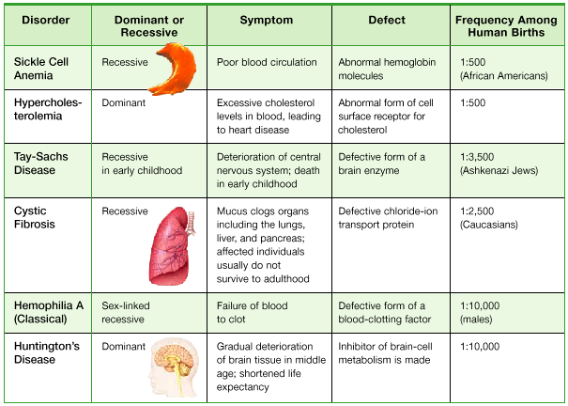
- _______________- medical guidance that informs people
about genetic problems that could
affect them or their offspring
- phenolketonuria (_____)- lack an amino acid that
breaks down ____________
- phenylalanine builds up in body- retardation
- gene _________- replacing defective genes with copies of
healthy one
- isolate gene
- piggyback good DNA via a virus
- DNA replicates
- good cell _____________ defective one
- has worked on cystic fibrosis in lung tissue
in lab, but not in human body
- used cold virus, body had built up
immunity to cold virus
- still working on _____________ virus

