Chapter 7: Meiosis

- some organisms reproduce by joining gametes
- gametes are haploid…2 join to make diploid offspring
- ________- form of cell division that halves the number of
chromosomes when forming reproductive cells
- involves two divisions of nucleus
- meiosis ___ and ___
8 steps
1) ___________ I:
- chromosomes condense
- nuclear envelope breaks down
- homologous chromosomes pair up
- _____________________ occurs
- portions of chromatid on one homologous
chromosome are broken and ___________ with
corresponding portion of other homologous
chromosome
2) ____________ I:
- pairs of homologous chromosomes are moved by the
spindle to equator of the cell
- homologous chromosomes remain together
3) ____________ I:
- homologous chromosomes separate
- chromosomes are pulled to opposite poles
***chromatids do not separate at centromere***
4) _______________ I:
- most cells; cytokinesis occurs forming two new cells
***no replication between meiosis I and meiosis II***
5) _________________ II:
- new spindle forms around the chromosomes
6) __________________ II:
- chromosomes line up along the equator and are
attached at their centromeres to the spindle fibers
7) ____________________ II:
- centromeres divide
- chromatids (chromosomes) move to opposite poles
8) ____________________ II:
- nuclear envelope forms around chromosomes
- spindle breaks down
- cell undergoes cytokinesis

***RESULTS IN 4 HAPLOID CELLS***
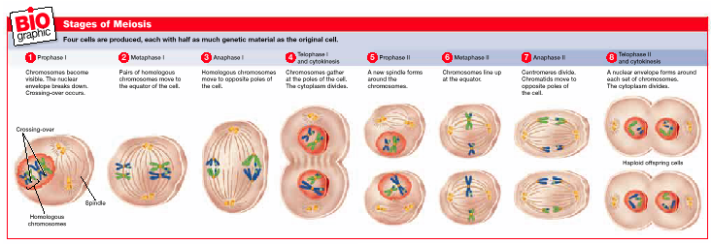

- meiosis allows for rapid genetic variation
3 mechanisms
1) _________________ _________________:
- random distribution of homologous chromosomes
during meiosis
- each of 23 pairs of chromosomes separate
independently
- allows for about __ million gamete combinations
from 1 cell
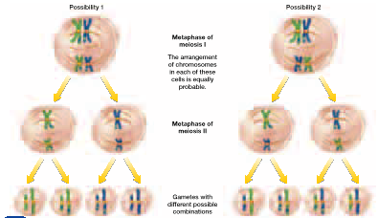

2) _______________________
3) ____________ _____________:
- zygote is random joining of 2 gametes
- 64 trillion possible combinations
**genetic variation produces variations very quickly**
- increases rate of __________

- combination of genes of genes from 2 organisms results in
a third type
- ____________________- formation of gametes
- _______genesis- process by which sperm are produced in
male animals
- occurs in testes
- diploid cell increases in size (germ cell)
- undergoes meiosis I
- produces 2 cells
- each cell undergoes meiosis II
- produces ___ haploid cells
- cells change shape and grow tail
- sperm
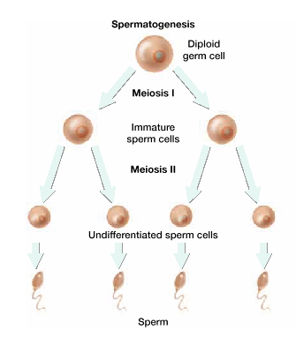
- ____genesis- process by which gametes are produced in
females
- occurs in _______
- cytokinesis after meiosis I distributes
cytoplasm _______________
- one cell gets most; other very little
- cell with most of the cytoplasm will
eventually become the egg cell
- cell without cytoplasm is called _____
body
- polar body may divide; but offspring
will not survive
- larger cell undergoes meiosis II
- cytokinesis; uneven distribution of
cytoplasm again
- larger cell develops into gamete called
_____ or _____
- polar body ________
- egg contains _______ to nourish zygote in
case egg is fertilized
