Unit 3: Genetics

Chapter 6:

Chromosomes and Cell Reproduction

-2 trillion cells produced by an adult human every day
- 25 million every second
- older cells divide via cellular __________ or
_______________
- many types of cell division
- ____________- an organism’s reproductive cells
- sperm or egg cell
- copy of ________ must be present in each cell
- before cell divides, DNA copies itself

____________________ Cell Reproduction
-____________fission- asexual reproduction that produces
identical offspring
- a single parent passes exact copies of
DNA to offspring

2 Stages
1) DNA is copied
2) Cell divides
- Cell adds a new cell membrane between 2 copies of
DNA
- pinches in middle; 2 independent cells

___________________ Cell Reproduction
- ______- segment of DNA that codes for a protein of RNA
molecule
- single DNA has 1,000’s of genes lined-up
- play role in determining how a body functions and
develops
- when genes are used, DNA is stretched out
- directs protein in photosynthesis
- preparing to divide → DNA coil into a chromosome
- _____________- DNA is copied before it coils
- ____________- 2 exact copies of DNA that make up each
chromosome
- attached at a _______________
-separate during division
- one chromatid in each new cell
- same genetic material
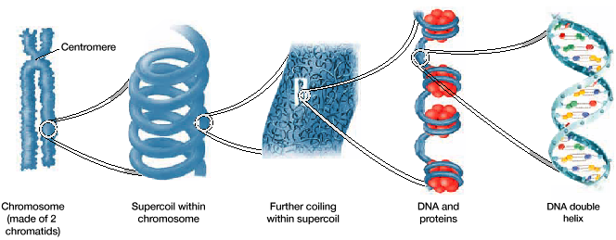

- __________ cell- any cell other than sperm or egg
-2 copies of 23 different chromosomes
- total = 46 chromosomes
- each chromosome differs in size, shape, and
set of genes
- __________ chromosomes- chromosomes that are similar
in size, shape, and genetic
content
- ____ pairs of 2 homologous chromosomes
- 1 homologous chromosome from each parent
- ________- when a cell contains two sets of chromosomes
- _________- when a cell contains 1 set of chromosomes
- “n” represents 1 set of chromosomes
- haploid human cell→ n=____
- diploid human cell→ 2n=____
- ______________- fusion of 2 haploid gametes
- produces a diploid zygote
-_____________- fertilized egg cell

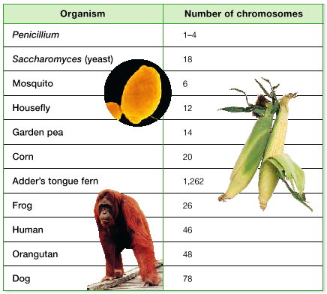

- number of chromosomes in cells is constant within a
species
- ________- chromosomes that are not directly involved in
determining the sex of an individual
- 22 of 23 pairs

- ____chromosomes- contains genes that will determine the
sex of an individual
- ____ of 23 pairs
- ____ and ____ chromosomes
- Y causes male to develop
- no Y causes female
- in humans
- ______ = male
- ______ = female
- sex is determined by ___________
- female can only give X
- male can give X or Y
- different organisms have different
combinations of sex chromosomes
- must have all 46 chromosomes for normal
development (humans)
- missing a chromosome…do not survive
- extra chromosomes…___________
- do not develop properly
- caused by non-_______________
- an egg or sperm with both homologous
chromosomes fuses with the other gamete
with one set of chromosomes
- total of ___ sets
- usually a cell will divide homologous
chromosomes
- 2n cell results vs. 2n+1
- Ex.- trisomy 21/Down syndrome
- short stature
- round face; upper eyelids cover inner
corner of eyes
- varying degrees of mental retardation
* more common in older mothers
- egg ages; more damage
- ______________- changes in a chromosomes structure
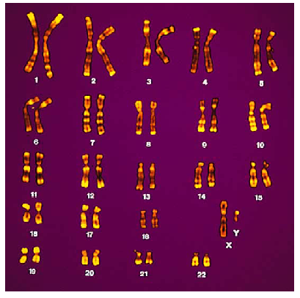
- 4 types from break of chromosome
1) ___________- piece of chromosome breaks off
- after cell division
- new cell lacks certain genes
- fatal to zygote
2) _____________- chromosome fragment attaches to its
homologous chromosome
- will carry 2 copies of a certain gene
3) _________- chromosome piece reattaches to the original
chromosome, but in a reverse orientation
4) ______________- piece reattaches to a non-homologous
chromosome

The ________ ____________
- repeating sequence of growth and division during the life
of an organism
- 90% of life spent in first 3 phases (_______________)
- will enter last two phases when ready to divide
5 phases
1) 1st __________ phase (____):
- cell grows; routine functions
- occupies a majority of cell’s life
- some cells don’t divide
- never leave G₁
- Ex.- most muscle and nerve cells
2) ______________ phase (___):
- cell’s DNA is copied
- each chromosome consists of two chromatids attached
at the centromere
3) 2nd _____________ phase (____):
- prepare for cell division
- microtubules are assembled to move chromosomes
during mitosis
4) ____________:
- process during cell division in which the nucleus of a
cell is divided into two nuclei
- each nucleus ends up with same number and kinds of
chromosomes as original
5) ______________:
- process during cell division in which the cytoplasm
divides
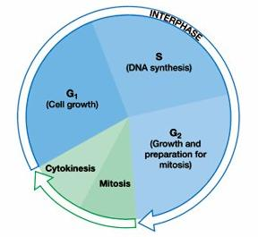
3 checkpoints during cell cycle
1) _______ ________ (_____) checkpoint:
- decides if cell will divide
- if conditions are favorable
- certain proteins will stimulate the cell to begin
synthesis (S) phase
2) ________ __________ (_____) checkpoint:
- DNA replication is checked by DNA repair enzyme
- if passed; proteins trigger mitosis
3) ___________ checkpoint:
- triggers exit from mitosis
- signals beginning of G₁
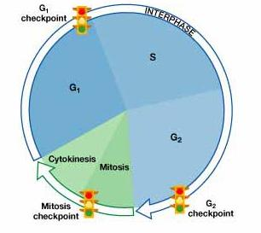
- genes that contain the proteins make proteins may mutate
result: _____________- uncontrolled growth of cells
- cancer is a disorder of cell division
- mutation may cause:
1) over production of growth promoting molecules
- speeds up cell cycle
2) inactivate control proteins that slow or stop
cycle

Mitosis and Cytokinesis
- _________- cell structures made up of both centrioles and
microtubules fibers that chromosomes during
cell division
- cell copies its pair of centrioles during G₂ before mitosis
- at beginning of mitosis, centriole pairs separate
- move to opposite poles of cell
- centrioles and spindle fibers are made of microtubules
- each centriole is made on ___ triplets of microtubules
arranged in a ________
- ________ cells do not have centrioles
- microtubules attach to the side of centromere and extend
in______________ direction
- other end attaches to centromere
- _________________ can be separated
- spindle fibers are broken down little by little at poles
- makes fibers shorter and pulls chromatids to poles
- once chromatids are separated they are called
chromosomes
- each pole has ______ set of chromosomes

Mitosis- 4 steps

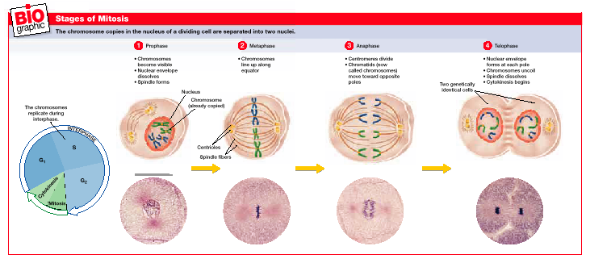
1) ______________:
- chromosomes coil up and become visible during
prophase
- nuclear envelope dissolves
- spindle fibers
2) _____________:
- chromosomes move to the center of the cell and line up
on equator
- spindle fibers link the chromatids to opposite poles
3) _______________:
- centromeres divide
- 2 chromatids (chromosomes) move towards opposite
poles
4) ____________:
- nuclear envelope forms around chromosomes at each
pole
- chromosomes uncoil and spindle dissolves

- at end of mitosis, cytokinesis begins
- cytoplasm divides in half
- cell membrane encloses each cell

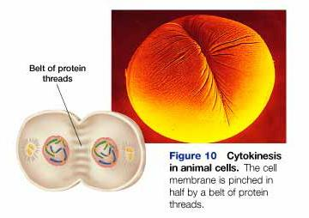

- produces two genetically identical cells-____________
- cell is pinched in half by a _______ ____ (cells with no
cell wall)
- cells with cell ________ divide by:
- vesicles fuse at midline and form cell plate
- cell wall forms on either side of cell plate
- cell plate then separate the 2 cells

