Chapter 10: How Proteins are Made

- ________- ribonucleic acid
- 3 differences between RNA and DNA
1) RNA is a single strand of nucleotides
2) RNA nucleotides contain 5 carbon sugar, ribose
- ribose contains one more oxygen than
deoxyribose
3) RNA has no thymine, replaced with ______ (U)
- RNA bases = A,G,C,U
- DNA bases = A,G,C,T
- uracil combines with _____________
- ___________- process by which instructions for making a
protein are transferred from a gene to an
RNA molecule
- ______________- process by which RNA molecules read
instructions on an RNA molecule and put
amino acids together to make a protein
- gene expression or protein _____________-
- process by which proteins are made based on
information in the DNA

Transcription (3 steps)
- RNA ______________- enzyme that adds and links
complementary RNA nucleotides
during transcription
1) RNA polymerase binds gene’s promoter…start sequence
2) RNA polymerase unwinds and separates the double helix
- exposes DNA nucleotides
3) RNA polymerase adds and links _______ nucleotides
- 60 nucleotides/sec.
- follows base pairing rules except U replaces T
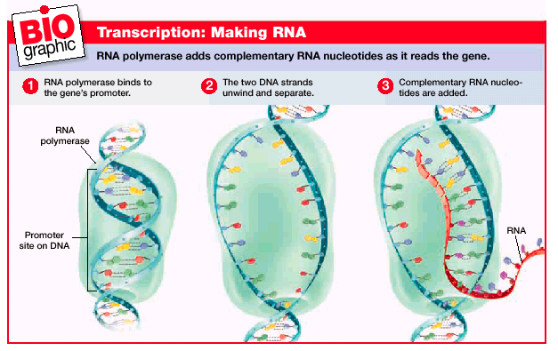

- RNA polymerase reaches a STOP signal...end of gene
- as RNA polymerase moves down strand DNA zips back
up into double helix
- nucleotides link together with ____________bonds

DNA replication vs. transcription
- DNA replication- 2 new DNA strands
- both strands serve as templates
- transcription- new molecule is a single strand of RNA
- in transcription, only 1 part of 1 strand
(gene) is used as a template

- ____________- transcription occurs in cytoplasm
- ____________- transcription occurs in nucleus
- many RNA molecules are made
simultaneously

- ___________________ RNA (mRNA)-
- form of RNA that carries the instructions for making a
protein from a gene and delivers it to the site of
__________________
- RNA is translated to proteins
- nucleotides to amino acids

- ___________- series of 3 nucleotide sequences on mRNA
- each codon stands for an amino acids or start or
stop signal
- ____________- amino acids, start, and stop signals coded
for by each of the possible 64 mRNA
codons
- 1961, Marshall Nirenberg deciphered 1st
codon…_____________

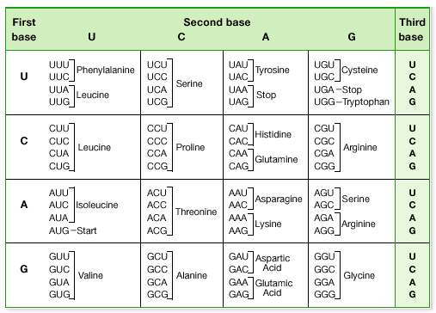

- translocation occurs in cytoplasm
- _____________RNA (tRNA)- single strands of RNA that
temporarily carry a specific amino
acid on one end
- has an anti-codon
- _____________- 3 nucleotide sequence on a tRNA that is
complementary to a mRNA codon
- the amino acid that a tRNA molecule carries corresponds
to a particular mRNA ________________
- ________________RNA (rRNA)-
- RNA molecules that are part of the structure of
ribosomes
- each ribosome temporarily holds one RNA and 2 tRNA
molecules
_____________________ (7 steps)
1) mRNA leaves the nucleus and enters the cytoplasm
- mRNA, 2 ribosomal subunits, and a tRNA carrying the
amino acid methionine form a functional ribosome
- the mRNA “start” codon ______ is oriented in a region
of the ribosome called the __ site where the tRNA
molecule carrying methionine can bind to the start
codon
2) codon in area of ribosome called the ___ site receives
the next tRNA
- the tRNA molecule with the _________________
anticodon arrives and binds to the codon
- the tRNA is carrying its specific amino acid
3) both A and P sites are holding tRNA
molecules…each holding a specific amino acid
- enzyme form peptide bond between the adjacent amino
acids
4) the tRNA in the ___ site detaches
- leaves behind its amino acid and moves away from the
ribosome
5) tRna in the ___ site moves over to fill empty ___ site
- because anticodon and codon are attached, the tRNA
and mRNA move as a unit
- a new codon is present on the A site ready to receive
the next tRNA and its amino acid
- an amino acid is carried to the A site by a tRNA and
then bonded to the growing protein chain
6) tRNA in the P site detaches and leaves its _____ ____
7) steps 2 through 6 are repeated until a “stop” codon is
reached (UAG, UAA, UGA)
- no tRNA to fit stop codon
- ribosome protein synthesis stops
- new protein released into the cell
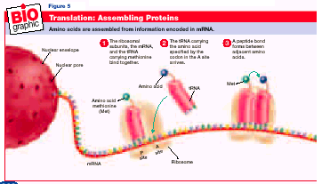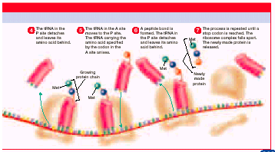
- genetic code appears to be universal
- Ex.- GUC codes for amino acid valine in all life forms
we know of
***leads scientists to think that all life forms have a
common evolutionary ancestor with a single genetic
code***

- changes in an organism’s heredity information are rare,
they can occur
- ___________- change in the DNA of a gene
- in gametes, can be passed to offspring
- in body cells, affect only the individual
- gene _____________- mutations that move an entire gene
to a new location
- 2 types
1) move as part of a _____________…”jumping gene”
2) rearranged during ________________
- gene alterations- mutations that change a gene
- results in wrong amino acid arrangement
3 types
1) _________ __________- a single nucleotide changes
2) ___________- sizable length of DNA is inserted
- usually occur from transposons
3) ________- segments of DNA are lost, usually during
meiosis
- __________ mutation- mutation that causes a gene to
be read in the wrong
3-nucleotide sequence
- Ex.- insertion or deletion
