Chapter 38
The Circulatory and Respiratory Systems

The Circulatory System
- _____________ system – extensive system of vessels that
transport blood, a mixture of
specialized cells, and fluid

5 things move through cardiovascular system
1. _______________
- from digested food to all cells

2. _____________
- from lungs to all cells

3. ___________ ___________ (CO2)
- from cells to organs for excretion

4. _______________
- help coordinate body activities

5. __________
- to maintain a body temperature
- Ex. - blood vessels in skin relax
- heat leaves body
- blood vessels constrict
- conserves heat
- blood to deeper tissues

- _______ – blood vessels that carry blood away from the
heart
- __________ – connects arteries to capillaries

- ________ – tiny blood vessels that allow the exchange of
gases, nutrients, hormones, and other
molecules in blood
- __________ – small vessels that connect
capillaries with veins

- _________ – blood vessels that carry blood back to heart

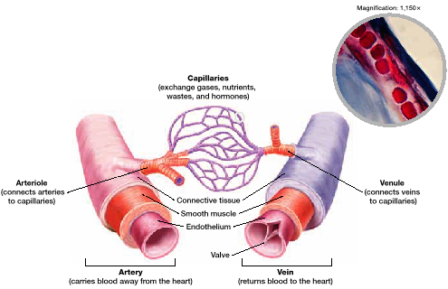

Arteries
- 3 layers make up wall
1. __________________
- innermost
- single layer of epithelial tissue

2. ______________ ____________
- surrounds endothelium
- contains elastic fibers

3. ____________ ______________
- outermost layer
- protects

- heart pumps blood into arteries
- arteries _____ nature expands then returns to original size
- much like air into a balloon

Capillaries
- gases, nutrients, hormones, and other molecules are
transferred from the blood to cells
- CO2 and other wastes from cells to blood
* only 1 cell _________ *
- easy passage of materials
* inner __________ is just big enough for width of cell *
- easy for O2 and CO2 to diffuse

Veins
- located further from heart
- less ________________
- thinner layer of smooth muscle
- larger in diameter than artery
- less resistance
- most have 1 way valve
- _____ – flap of tissue that ensures that blood or fluid
does not flow backwards
- skeletal muscles contract – _________ valve
- skeletal muscles relax – __________ valve
- weak valves – vein dilates (becomes larger)
- varicose veins
- in anal area - ______________________
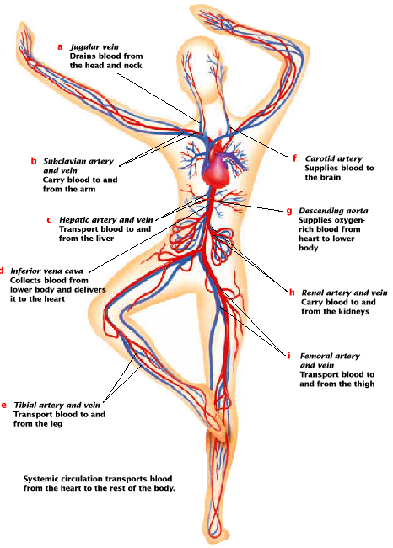

- __________ system – collects and recycles fluids leaked
from the cardio vascular system and
helps fight infections
- every time heart pumps, some fluids are forced out of
capillaries
- collects in spaces around the body’s cell
- lymphatic vessels and ______ located throughout body
- includes thymus, tonsils, spleen, bone marrow
- vessels and nodes collect leaked fluids (_______)
- back to neck
- lymph vessels contain valves, like veins
- lymph moves as _________ muscles contract
- lymphatic system involved in immune system
- nodes concentrated in armpits, neck, and groin
- get tender and swell when fighting infections

Blood Components (7 major parts)
- made of water, with lots of dissolved and suspended
molecules and three kinds of cells

Plasma
1. _____________
- acts as solvent
- carries other substances

2. _________ ________ ___________
- glucose , nutrients, vitamins, hormones, gases,
nitrogen-containing wastes

3. __________ (ions)
- sodium, chloride, bicarbonate
- maintain osmotic balance
- regulate pH of blood and permeability of cell
membrane

4. ______________
- most abundant solutes in plasma
- maintain osmotic balance
- amount of protein in cell and vessels is equal
- isotonic
- keeps water from flowing into cells
- some help thicken blood, anti-bodies, clotting

Blood Cells and Fragments
- accounts for 40% of total volume of blood
3 types of cells
1. _______ _______ ______ (RBC)
- carry oxygen
- a.k.a. erythrocytes
- most of interior is hemoglobin
- iron containing protein that binds O₂ in lungs
- mature RBCs don’t have _________
- no repairing or making protein
- biconcave shape
- life span is 4 months
- made by stem cells in bone ___________
- ________ – condition in which the oxygen carrying
capacity is reduced
- results from blood loss or nutrient
deficiencies

2. __________ _______ _______ (WBC)
- a.k.a. leukocytes
- ≈ 1 or 2 WBC for each RBC
- primary job is ___________
- larger than RBC and have nuclei
- several types
- each has different functions
- Ex: destroy bacteria and viruses
- produce ________________
- markers of foreign substances
- get destroyed

3. ___________________
- bits of cytoplasm that get pinched off
- important in ___________
- hole appears
- platelet arrives
- enlarges
- gets _____________
- attach to blood vessel wall fibers
- plug hole
- may release clotting agent for big cuts/holes
- produces ______________
- forms net
- catches blood and platelets (clot)
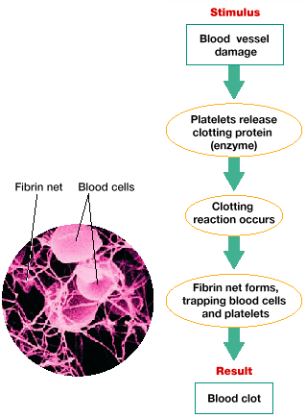

Blood type
- determined ________________
- ABO blood group system
- 4 types (A,B,AB,O)
- A and B refer to _____________ on surface of RBC
that act as antigens (provoke immune response)
- AB have both antigens (universal recipients)
- O has ______ antigens (universal donor)

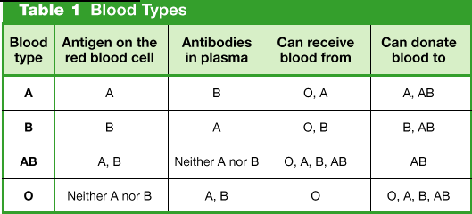

Rh factor
- another __________ on surface of RBC
- Rh⁺ = have antigen; Rh־ = no antigen
- problem:
- Rh־ mother goes gives birth to Rh⁺ baby
- mother begins to make anti-Rh anti-bodies
- may be passed to _____ _______ – later on – death
- RhoGAM
- stops production of anti-bodies

The Heart
- 2 separate ______________ loops
- right side drives pulmonary loop
- pumps oxygen-poor blood through ______________
arteries to lungs
- gas exchange
- RBCs release CO2 , take in O2
- oxygenated blood returns left side of heart through
pulmonary veins
- left side of heart pumps __________ circulation loop
- oxygen rich blood to body tissues
- oxygen poor blood to right side
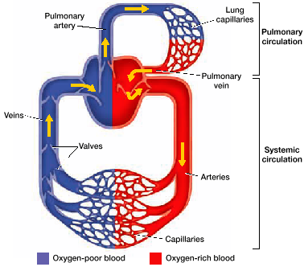

- _______ – chambers that receive blood returning to heart
- ________ – thick walled chambers that pump blood away
from heart
- series of one-way valve in heart prevent blood from
moving ______________

Path of blood through heart
1. inferior and superior vena cava (2 large veins) collect
oxygen poor blood from body
- _______ _________ empties blood into right atrium

2. blood from right atrium moves into right __________

3. right ventricle contracts, send blood into pulmonary
arteries

4. pulmonary arties carry blood the right and left _______
- O2 and CO2 exchanged

5. oxygenated blood returns from lungs to left side of heart
through pulmonary _________
- blood dumped into left _________

6. blood then pumped into left __________

7. after delay to permit left atrium to completely empty, left
ventricle contracts

8. blood enters the aorta
- ____________ – one of the largest arteries

- _______ ________ – first arteries to branch from aorta
- carry oxygenated blood to heart muscle
- other arteries branch from aorta to rest of body
- from body to superior and inferior vena cava

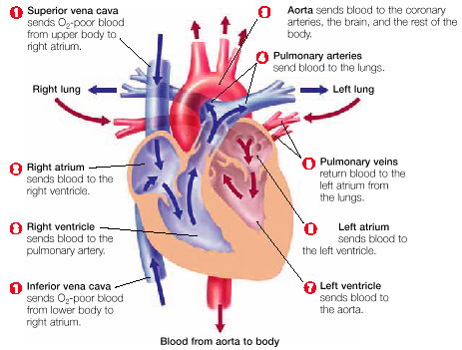

- ____________ node – (SA node) small cluster of cardiac
muscle responsible for initiating heart
_______________
- located in upper wall of right atrium
- fire electrical stimulus
- followed by contraction that travels in
wave and causes atria to contract __________________
- wave hits ventricles
- 1/10 of a second delay to contract
- allows complete ____ emptying
- ventricles contract simultaneously

- blood ________ – force exerted by blood as it moves
through blood vessels
- provide information about condition of
arteries

systolic pressure
diastolic pressure

- ________ – pressure exerted when the heart contracts and
blood flows through the arteries
- _________ – pressure exerted when the heart relaxes

normal: 100 to 130/70 to 90 mm Hg (millimeters Mercury)
- Ex: 120 as heart contracts
80 as heart relaxes

- ____________ – high blood pressure
- strain on walls of arteries (burst)
- control by diet, exercise, and medicine

- _____ – electrocardiogram
- electrical impulses from heart reach surface of body
- EKG senses impulses
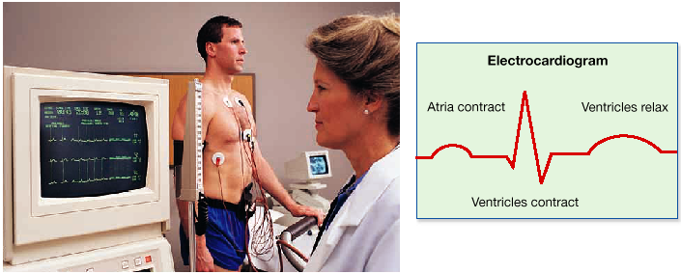

- ______ – series of pressure waves within an artery caused
by the contractions of the left ventricle
- indicator of heart rate
- blood surges – elastic walls expand
- radial artery – thumb side of wrist
- average 70 to 90 b.p.m.
- heart _______ – occurs when an area of the heart muscle
stops working and dies
- __________ – when an area of the brain dies
- both are result of not getting enough blood

Respiratory System
- oxygen needed to oxidize glucose and make ATP
- without oxygen not enough ATP is produced
- carbon dioxide is _______ and must be removed

The Process
- air enters respiratory system via mouth or nose
- hair filters dust and particles
- tissues lining nose moisten and warm air
- ________ – muscular tube in upper throat
- serves as passage for air from nose to larynx
- _________ – voice box
- epiglottis covers larynx
- prevents food and water from entering
- from larynx air enters trachea
- _________ – long, straight tube in chest cavity
- wind pipe
- divides into two bronchi
- _________ – small tubes that connect trachea to lungs
- bronchi divide into smaller and smaller tubes called
bronchioles
- _________ – smallest bronchioles clustered into air sacs
- where gases are exchanged
- increases surface area
- 300 million alveoli
- cells that line bronchi and trachea secrete _______ to trap
foreign particles
- directed upward by cilia
- swallowed and digested
- lungs in chest cavity
- bound on sides by ribs
- bound on bottom by diaphragm
- ________ – powerful muscle spanning the rib cage under
the lungs
- aids in respiration
- double membrane surrounds both lungs
- outermost membrane attached to ________ cavity
- innermost membrane attached to surface of ______
- space between membranes filled with fluid
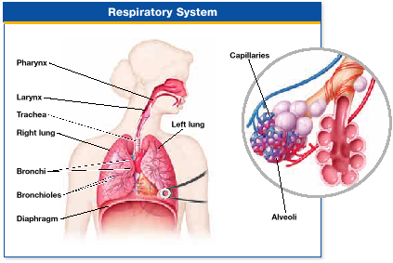

- breathing occurs because of ________ difference between
lungs and atmosphere

- ______________
- rib muscles contract
- rib cage moves up and out
- diaphragm contracts – most ___________
- volume of chest increases
- air pressure _____________
- air flows from high to low pressure
- air drawn into lungs

- ______________
- rib cage and diaphragm muscles relax
- decreases volume in chest cavity and _________ the
air pressure in the lungs
- air forced out (high pressure to low pressure)
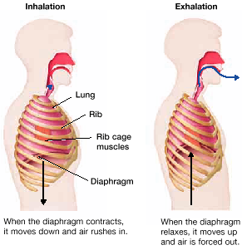
- _________ in brain and in cardiovascular system monitor
levels of oxygen and carbon dioxide in the blood
- receptors send nerve signals to the brain
- brain sends signals to diaphragm and rib muscles to
control breathing rate
- breathing is ________________
- may hold breath
- after being unconscious, respiratory control
center takes over

Gas Transport
- oxygen leaves alveoli and enters plasma
- gets picked up by RBC’s with iron containing
protein called ______________________
- each hemoglobin contains ______ iron atoms
- iron bonds reversibly with oxygen
- able to release oxygen when appropriate
- can be picked up by body cells

1. oxygen from outside reaches __________
2. oxygen diffuses from alveoli to pulmonary ___________
- hemoglobin carries full load of oxygen
3. blood travels to ______ then pumped to body tissues
4. oxygen diffuses into cells for aerobic ______________
* in tissues, oxygen levels are lower, hemoglobin
releases its oxygen *
5. carbon dioxide from respiration makes blood ________
- changes shape of hemoglobin
- gives up oxygen easier
- carbon dioxide diffuses out of tissues into blood
6. carbon dioxide travels to heart as _________ ions.HCO₃⁻
7. heart pumps blood to lungs
- carbon dioxide releases as gas
8. carbon dioxide is _____________

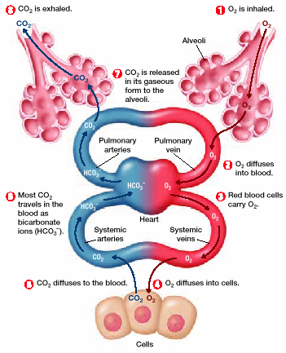

Carbon Dioxide transport
CO2 in blood in 3 forms:
1. 7% of CO2 is dissolved in ____________
2. 23% of CO2 is attached to hemoglobin in RBC’s
3. 70% is carried as bicarbonate ions

H2O + CO2 H2CO3 HCO3־ + H⁺

- water + carbon dioxide makes carbonic acid which breaks
into bicarbonate ions and a hydrogen ion
- reaction reverses in ___________

Respiratory Diseases
_____________
- chronic condition in which bronchioles become inflamed
- sensitive to certain stimuli
- bronchial walls tighter, more mucus released
- airway narrows
- medicine expands bronchioles

______________
- chronic pulmonary disease resulting from chemical
imbalance that destroys elastic fibers in lungs
- fibers allow contraction and expansion
- starts with destruction of alveoli
- irreversible
- fatigue and breathlessness
- ___________ causes 90% of cases

_______ ______________
- one of the leading causes of death world wide
- caused by abnormal cell growth
- once detected, lung may be removed
- usually not curable
- _________ live more than 5 years after diagnosis

