Chapter 37
Introduction to Body Structure

- human body has over 100 trillion cells with over 100
types of cells
- 4 levels of organization
1. cells
2. ______________
3. organs
4. organ ______________

4 types of tissues
1. _______________ tissue
- lines most body surfaces and protects other tissues
from dehydration and physical damage
- usually a few cells thick
- cells are flat and thin, constantly being replaced

2. _______________ tissue
- makes up nervous system
- made of nerve cells and supporting cells

3. ________________ tissue
- support, protect, and insulate body
- includes fat, cartilage, bony tendons, and blood

4. ___________________ tissue
3 types
1. skeletal muscle (_____________ muscle)
- control it consciously
- move bones in trunk and limbs
2. ______________ muscle (___________ muscle)
- cannot consciously control it
- some contract by signal molecules
- blood vessel walls
- some contract spontaneously

3. ______________ muscle
- found in heart
- neighboring cardiac cells contract at once;
stimulating ______ groups of cells to contract

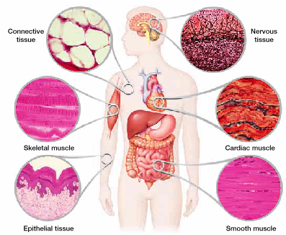

__________ cell
- undifferentiated cells
- able to become any type of tissue
- able to divide ___________________
- embryonic stem cells
- controversial
- repair tissues
- destroys embryo
- adult stem cells
- in bone marrow
- produce blood cells
- stop dividing after ≈_________ divisions

Organ Systems
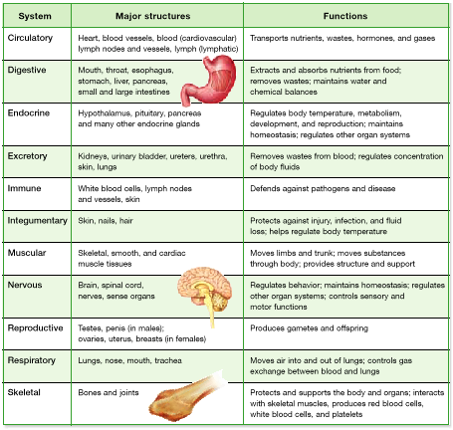

- organs made of two or more types of tissues
- housed in body _____________ (4 total)
- organs are suspended in fluid to support and protect
- ____________ cavity; brain, protected by skull
- ________ cavity; spinal cord, protected by vertebrae
- _________ cavity; heart and lungs, protected by ribs
and sternum
- ____________ cavity; digestive organs; protected by
pelvis and abdominal muscle

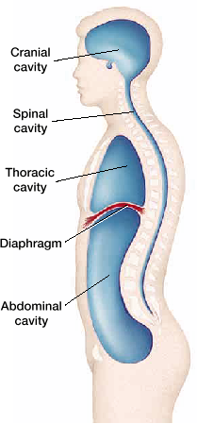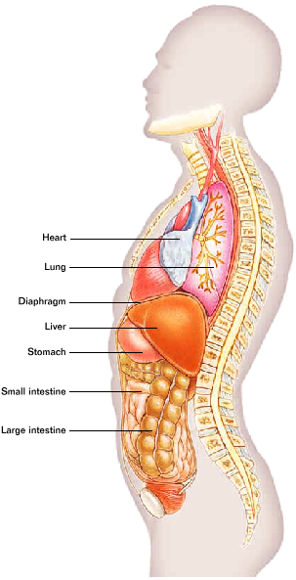

Skeletal System
- supports body
- ________________________
- allows movement
- ____________ bones
- 80 bones form axial skeleton
- skull
- 29 bones, 8 form cranium, 14 facial,
6 middle ear, base of tongue
- spine (26 vertebrae)
- ribs (12 pairs)
- _________________

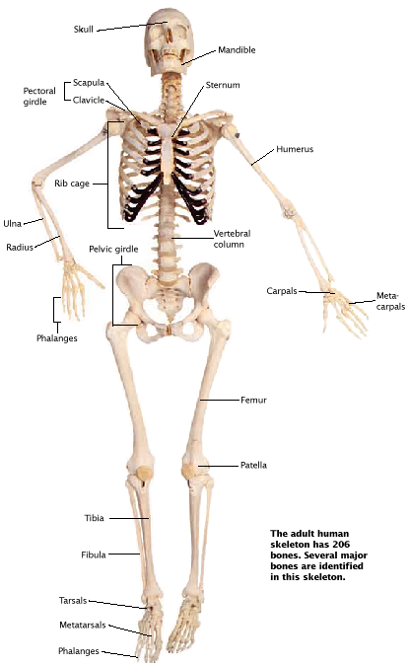
- 126 bones form _____________________ skeleton
- arms
- legs
- pelvis
- shoulder
- attached to axial skeleton at shoulders and hips
shoulder (_____________ girdle)
- 2 shoulder blades (scapulas)
- 2 collar bones (clavicles)
- clavicles connect scapulas to sternum
- hold shoulders apart
- allows full rotation
hips (___________ girdle)
- 2 large pelvic bones – distribute weight evenly
down legs

Bone Structure
- _____________ – though exterior membrane
- contains lots of blood vessels
- _______________ bone – very dense
- provides support
- ___________ bone – loose connective tissue
- may be filled with marrow
- ____ marrow – produces all red blood cells
and platelets
- ____________ marrow – fat in long bones

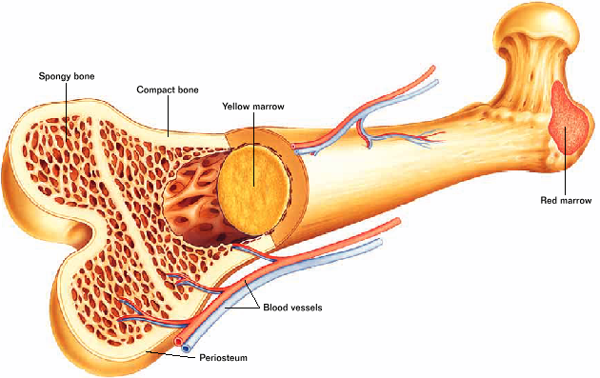

Bone Growth
- early skeleton is mostly __________________
- gradually replaced by bone as calcium and other
minerals are deposited

- compact bone
- new bone cells added in layers around ___________
canals
- narrow channels that extend the length of the
bone
- contain blood vessels
- form rings around canals
- allow for tremendous stress on bones
- _______________ – bone cells
- become embedded in bone tissue
- maintain mineral content
- bones thicken and elongate through adolescence
- elongation occurs at ________ of long bones

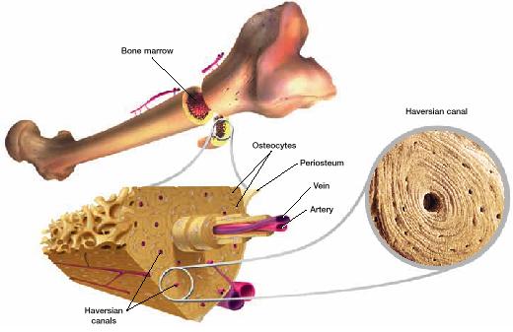

- ________________ – severe bone loss
- become brittle and break easily
- less bone tissue as you get older
- women more affected (2 reasons)
- less bone __________ to start with
- decreased production of sex hormones
after ______________________

Joints
- where two _________________ meet
- padded by cartilage
- held together by _________ – strong bands of connective
tissue
- stabilize joints
- keep bones from moving too far
3 main types
1. __________________ joints
- permit little or no movement
- Ex: cranial bones joined by sutures

2. ______________ movable joints
- permit little movement
- Ex: vertebrae
- between bones of rib cage

3. __________ movable joints (5 main types)
- permit the most movement

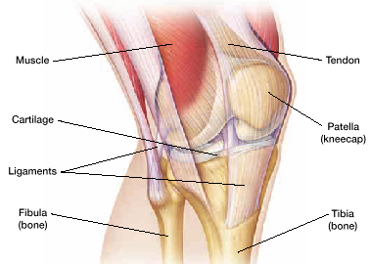

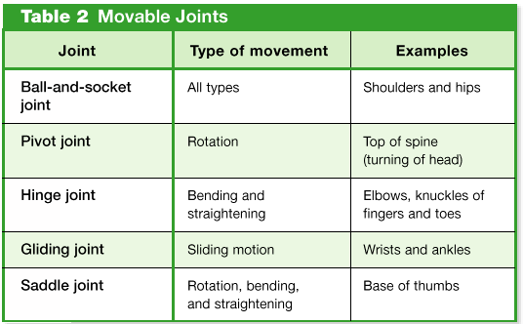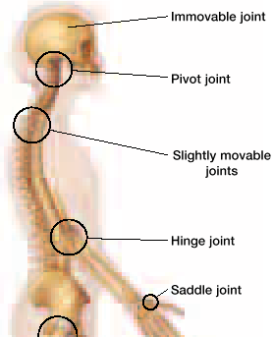
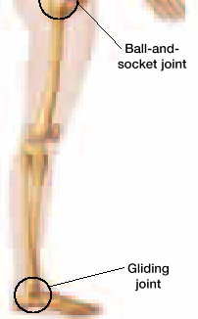

- ________ – painful inflammation of freely movable joints
- immune system cells attack tissues around joints

Muscular System
- movement requires muscle ___________________
- no movement requires muscles to maintain balance
- able to move because muscles attach to bones
- most skeletal muscles attach with a tendon
- ________ – point of muscle attachment that remains
stationary during muscle contraction
- _____________ – bone that moves when the muscle
contracts
- skeletal muscles usually attach in pairs
- 1 pulls in one direction, 1 in the other direction
- _____________ – causes joint to bend
- _____________ – causes joint to straighten
- Ex: bicep (flexor) and triceps (extensor)
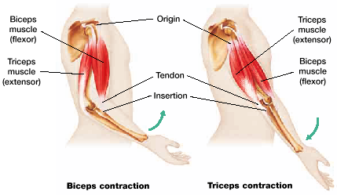

Structure
- ________________ – protein filaments enable muscles to
contract
- actin – thin filaments in sarcomere
- myosin – thick filaments in sarcomere
- actin and myosin run parallel to each other
- __________ – anchors actin filaments
- ____________ – area between two z lines
- ____________ – several sarcomeres together end to end
- alternate light and dark bands (striated)
- _______ ____________ – made of several myofibrils
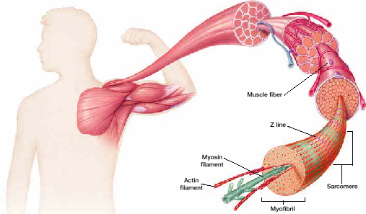
Muscle contraction (3 steps)

Step 1: prior to contraction, ______________ is relaxed
- myosin and actin fibers partially overlap

Step 2: contraction begins when fiber is stimulated by
_____________ molecules released by nerve cell
- causes myosin and actin fibers to slide and overlap
more
- sarcomere becomes _________________

Step 3: sarcomere is ______________ contracted
- myosin and actin completely ________________
- occurs down entire length of muscle fiber

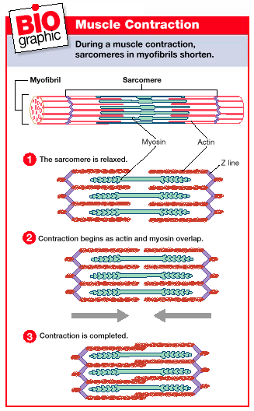

- amount of force exerted depends on 2 things
1. how ___________ the muscle fibers are stimulated
2. how ____________ are stimulated

- _____ unit – set of muscle fibers activated by a nerve cell
- each time a motor unit is activated all of the
fibers contract
- motor units have varying amounts of muscle
fibers
- Ex: fingers – only a few
- hamstrings – several hundred

Myosin & Actin
- actin contains many sites where ___________ can bind to
- myosin “head” seeks out _____________ binding sites
3 steps
1. contraction begins as myosin head ______ to an exposed
binding site on an actin filament
2. myosin head rotates, pulling myosin ________ and actin
passed it – overlapping
3. _____ used as myosin head detaches and snaps back to
original position
- myosin __________ to actin at a binding site further
along filament

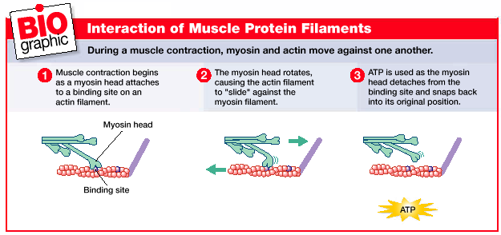

- ____________ – no ATP, myosin head can’t release
- always contracting
- ATP also used to move ______ into muscle cells
- calcium needed for binding sites to be exposed on
actin filaments
- ATP usually supplied by __________ respiration
- during brief, intense exercise – anaerobic respiration
- most anaerobic ATP by ____________
- when ATP consumption exceeds ATP production
- muscle fatigue and _______________
- fibers can’t recover from contraction

Skin
- largest organ of body
- part of ___________________ system
- several functions
- protection from injury
- 1st line of defense against disease
- regulate body temperature
- prevents drying out
- mostly connective tissue (3 layers)
1. __________________
- outermost layer
- several layers of epithelial cells
- ________ – protein that makes skin though and
water proof
- damaged cells ____________ not repaired
- new cells at base of epidermis
- inner layer of epidermis has cells that produce
melanin
- __________ – pigment that ranges in color
from yellow to reddish brown to
black
- determines skin color
- move melanin; darker skin
- absorbs UV rays, protects skin
- move UV, move melanin

2. _____________________
- functional layer below epidermis
- connective tissue makes skin ________
- contains:
- nerve cells
- blood vessels
- hair follicles
- specialized skin cells
- touch, temp, pain originate in __________
- muscles that straighten hair when cold and
goose bumps
- temperature regulation
- controlled by blood vessels
- if body is hot
- blood vessels near skin surface _____
- release heat to environment
- if body is cold; vessels ____________
- reduce heat loss
- sweat glands
- evaporation of sweat from skin
surface
- 99% water, 1% salt
- may also release proteins and fatty
acids
- offensive odor is _______ waste
products
3. ___________________ tissue
- connective tissue made mostly of fat
- shock absorber
- insulation
- stores energy
- anchors skin
- thickness varies
- Ex- eyelids, soles of feet – up to 6 mm
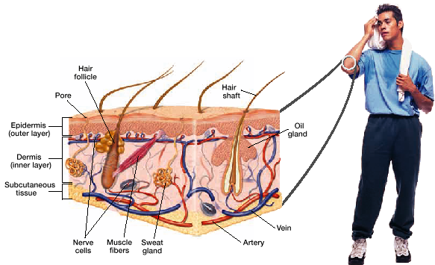

Hair & Nails
- both come from epidermis
- hair follicle produces individual hairs
- __________ and ____________
- hair is dead, keratin filled cells
- hair on head grows for years and then enters ______
phase
- _______________ determines color
- blond/red – _________ melanin
- brown/black – ___________ of melanin
- nails produced by cells in light, semicircular area at
base of each nail
- filled with keratin as they move outward
- protect _________________________

Skin disorders
1. ____________
- oil glands in skin release sebum
- ______ – oily secretion that lubricates skin
- released through pores into hair follicles
- very active during ________________
- acne caused by excessive sebum blocking ____ with
oil, dirt, and bacteria
- surrounding tissues become _________ and inflamed
- accumulate pus
- can’t be prevented, usually managed with proper
skin care
2. Skin _____________
- caused by genetic mutation from UV rays

