The Microscope
Ch. 3 Sec. 1
* See P. 1028, 1029*
- 1665- __________________ looked at cork through a
microscope
- saw “boxes” – cells
- 1675- _______________________ – looked at pond
water
- saw many living things
- Scientists use metric system (SI) – based on powers of 1O
- stuff under microscope is measured in meters
- use prefixes
- Ex. kilo= 1000
micro = 10⁻⁶ or .000001
2 main types of microscopes
- - light passes through 1 or more lenses
to produce on enlarged image
- __________________- forms an image of a specimen
using a beam of electrons rather
than lights
- micrograph- image produced by a microscope
- ___________-quality of making an image appear
larger than its actual size
-Ex. 200x=200 times larger than actual
size
- ______________- measure of the clarity of an image
- both increased magnification and good resolution are
needed to view small objects clearly

Types of Microscopes
- vary in magnification and resolution
- different limitations
- electron microscopes- ↑magnification, can’t look at
living cells
- light microscopes- ↓magnification, can look at living
cells
- Compound ____________ Microscopes (LM)
- light microscopes with 2 lenses
- light bulb in base shines upward through specimen
- _______ lens (closest to the specimen) – collects the
light
- light is sent to _______ lens (closest to viewers eyes)
- both lenses magnify
- multiply both lenses to figure magnification
Ex. 40x objective; 10x ocular = 400x mag.
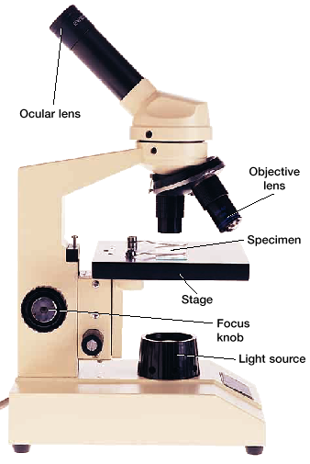

- __________________ Microscopes (2 types)
1. __________________ electron microscopes (TEM)
- electron beam directed at the slice of specimen
stained with metal ions
- some parts become more heavily stained
- absorb more electrons
- lightly stained parts let electrons pass through
- electrons passing through specimen strike a
screen – form image
- shows a cell’s internal structure in fine detail
- always in black and white
- scientists add artificial colors
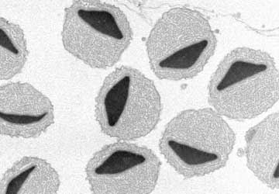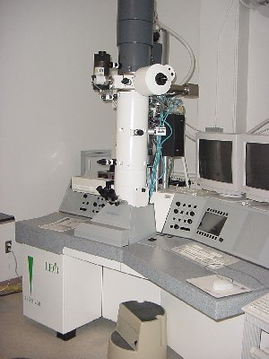
2. _________________ electron microscopes (SEM)]
- only electrons that bounce off of metal ions
coated specimen form images
- 3-D images of surface; black and white
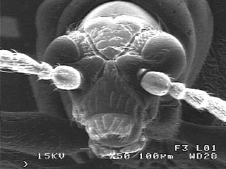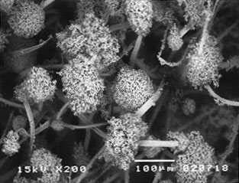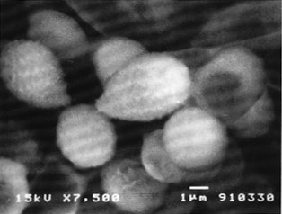

3. Scanning _________________ Microscope
– uses a needle like probe to measure differences
in voltage caused by electrons that leak, or
tunnel, from the surface of the objects being
viewed
- computer tracks measurements – view objects
as small as atom
- 3-D image of specimen’s surface; can be used
for living organs,color
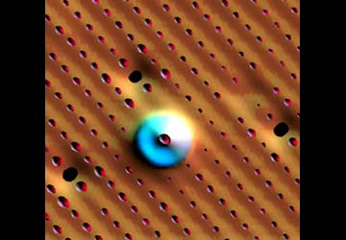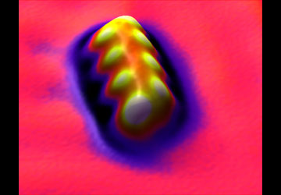
Xenon on Nickel
This image shows xenon on a nickel surface. Cesium & Iodine on Copper
The image describes a molecule assembled
from 8 cesium and 8 iodine atoms. Color is
assigned to the surface not only by lights but
by local curvature of the surface. This helps
to delineate the shape of the object.

