Chapter 17: Biological Communities

-species interact as a result of a long __________ history in
which many participants adjust to one another over time
Ex.- flowering plants that allowed for easy, efficient
dispersal of its pollen by insects flourished, as they
flourished so did the insects that fed on the nectar
and transported the pollen
- __________- act of one organism killing another for food
- ___________- one organism feeds on another and usually
lives on or in another, typically larger
organism
- usually don’t kill the host
-________parasites-lice, ticks, mosquitoes, fleas
-_______parasites-more specialized;hookworms
-plant defenses
- plants protect themselves with thorns, spines, chemical
compounds
- most plants contain defensive chemicals called ______
compounds
- chemical signals the presence of a______ to insects
-Ex.- mustard oils
- pungent aroma and taste (mustard, radish, etc.)
-________________ have evolved to feed on certain plants
- not all, but some insects will be able to_______each
plant family

-Ex.- cabbage butterfly larvae eat plants with mustard
oil
- larvae limit that plants___________; decreasing
competition for nutrients
- plant limits which insects will feed on it with
toxin
-___________- two or more species live together in a close,
long term association
- beneficial to both organisms or benefits one
organisms and leaves the other unharmed or
unaffected
___ types of relationships
1)_____________- symbiotic relationship in which both
participating species benefits
- Ex.- ants and aphids
- aphids take sucrose from plants and
excrete it (honey dew)
- ants use honey dew as food and protect
aphids from predation
2) _____________- a symbiotic relationship in which one
species benefits and the other is neither
harmed nor helped
- Ex.- clown fish and sea anemone
- clown fish are protected by
anemone’s sting
3)______________- mentioned earlier
- detrimental to the host organism
- __________- occurs when two species use the same
resource
- supplies in short supply
- Ex.- lions vs. hyenas
- ________- the functional role of a particular species in an
ecosystem
- how an organisms lives; the “_____” it performs
within an ecosystem
- niche describes (some examples)
- space utilization
- food consumption
- temperature range
- requirements for mating
- don’t confuse with __________________
- habitat is ______________
- niche is _____________________________
- niche can be described as how the organism affects
____________ flow within the ecosystem
- overlapping of niches leads to ________________
- ___________niche- entire range of resource opportunities
an organism is potentially able to
occupy within an ecosystem
- Ex.- Cape May Warbler
- summers in NE United States
- nests in mid-summer
- eats small insects
- searches for food high on spruce
trees at tips of branches
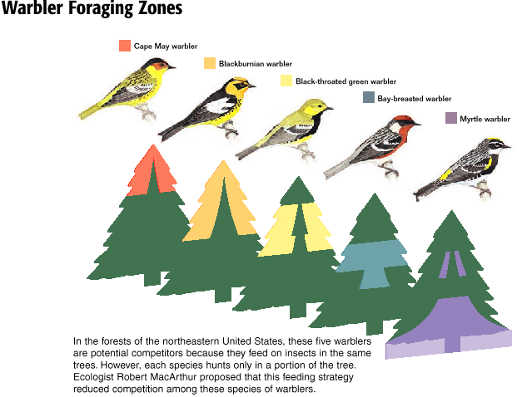

- __________niche- the part of its fundamental niche that a
species occupies
- Cape May Warbler only uses tops of
spruce trees
- other warbler species use various
parts of the same tree
- reduces competition
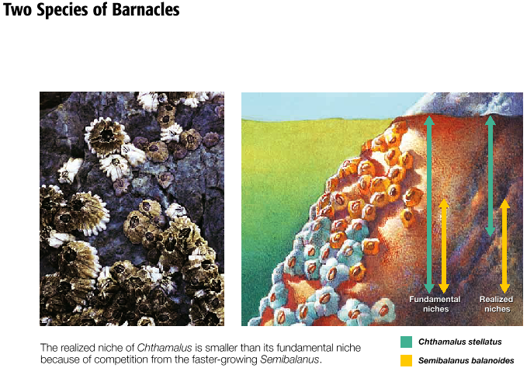

-__________________- elimination of a competing species
- if ____ species are competing, the
species that uses the resource
more __________ will eventually
eliminate the other one
-Ex.- PART ONE
- two species of _________________
- in same culture tube; compete for food..bacteria
- one was more resistant to bacteria _________
products
- drove the___________ species to extinction
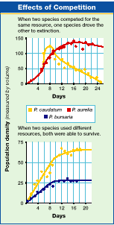

-Ex.- PART TWO
- extinct bacteria from part 1 vs. 3rd Paramecium
- compete for same _________________
- both survive ???
- upper part of culture tube; high concentrations of __
and bacteria density- extinct bacteria was ________
- lower portion; low concentration of O₂ levels- new
food source- _________________
- 3rd Paramecium fed best on yeast
- fundamental niche for both species is _______ tube,
but realized niche of each species was only a
________________of the tube

- the niches didn’t overlap too much, both were able
to survive
- ______________ can reduce effect of competition
- Ex.- sea stars in intertidal pools
- stars are fierce predators of clams and mussels
- when stars were kept out of pools their prey
species fell from 15 to 7
- stars controlled mussel population; increased
__________________
- ______________- variety of living organisms present in a
community
- measures: 1) number of different species
(species _____________)
2) relative number of each species
( species _____________)
- biologically diverse ecosystems are more
___________ than plots with few species
- _______- prevailing weather conditions in any given area
- determines what organisms can live in a given
environment
two most important factors in determining climate:
- _______________- animals are adapted to live in a
particular temperature range
- ______________- all organisms require water
- may be scarce; rainfall determines an areas
life forms
- moisture holding ability of air increases
when it is warmed and decreases when it
is cooled
***very similar communities occur in many different places that have similar climates and geography***
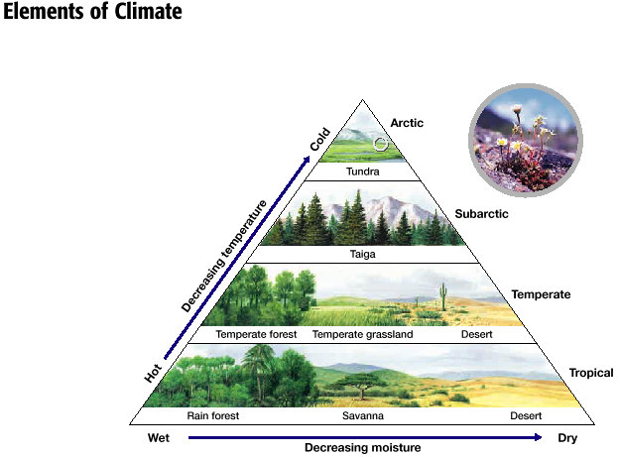

- _______- major biological communities that occur over a
large area of land
7 widely recognized biomes
1) ________________
2) _________________
3) _______________
4) ______________
5) ___________________
6) ____________________________
7) ________________________________________
- in general; temperature and available moisture decrease as
latitude __________________
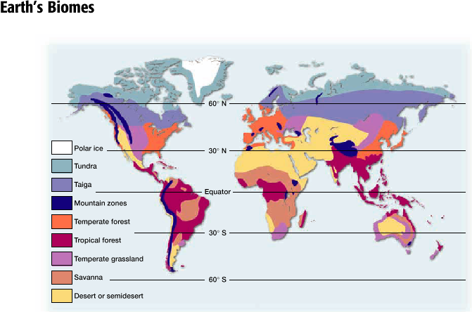

Terrestrial Biomes
1) Tropical Rain Forests
- rainfall 80 to 180 inches/year
- greatest number of ____________
- contain ½ of the_______________species
- high 1⁰ productivity
- very little _____________ in soil
- most within plants
2) Savannahs
- rainfall 30 to 60 inches/year
- wider temp. range than tropical rain forests with
________________
- open landscape with widely spaced ____________
- many animals are active only during the rainy season
- large herds of grazing_______________ in east Africa

3) Taiga
- long, cold _____________
- most precipitation in summer
- cold, wet climate…______________ forest
4) Tundra
- between ________ and permanent ice surrounding the
north pole
- low precipitation…10 inches/year
- water unavailable most of the year…___________
- permafrost/permanent ice
- within 3 ___________ of surface
5) Deserts
- 10 inches of rainfall/year
- scarcity of water determines biological ____________
- vegetation is sparse
- most extensive in _________________ of continents
6) Temperate Grasslands
- moderate climates halfway between equator and poles
- highly productive for agriculture
- large herds of _____________ animals
- deep, fertile ______________
7) Temperate Deciduous Forests
- mild climates and plentiful rain
- deciduous trees...shed leaves in fall
- warm summers/cold winters
- precipitation 30 to 100 inches/year
- eastern U.S.
- trees…hickory, oak, beech

8) Temperate Evergreen Forests
- drier weather and different __________________
- pine forests of southeastern and western U.S.
- when it gets drier…dry shrubs…chaparral areas of
California
Aquatic Communities (3)
1) ___________________________
- lakes. ponds, streams, and rivers
- 3 zones
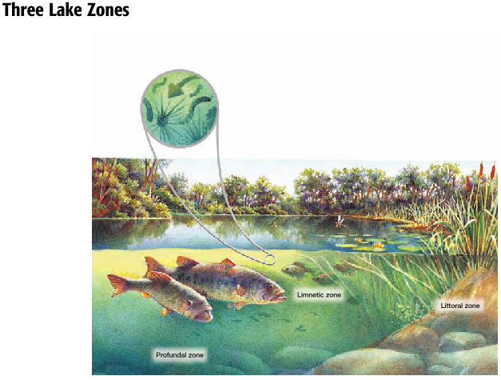
1) ______________________________
- shallow zone near shore
- aquatic plants live with predatory insects,
amphibians, and small fish

2) _________________________
- further from shore, but close to surface
- inhabited by floating algae, zooplankton, and
fish
3) ________________________
- deep water zone that is below the limits of
effective light penetration
- bacteria and wormlike organisms that eat debris
- debris breakdown releases lots of nutrients
- not all freshwater systems are deep enough to
include a profundal zone
2) __________________________
- swamps, marshes, bogs
- community covered with a layer of water
- water tolerant plants (hydrophytes)
- Ex.- marsh grasses and cattails
- moderate flooding
- lots are being disrupted by humans
- see them as useless
3) ______________________________
- ¾ of Earth’s surface
1) __________________________
- small in area; large number of species
- ______________- seashore between high and low
tide
- home to many invertebrates

2) __________________________
- _________- bacteria, algae, fish larvae, and many
invertebrates
- fish, whales, invertebrates feed on plankton
- birds, larger fish feed on these animals
- plankton responsible for about 40% of world’s
photosynthesis
- must be in light penetrable depth of ocean
3) _________________________
- total darkness, cold, great pressure
- bizarre invertebrates and fishes
- very diverse number of species

