Chapter 16: Ecosystems

1866- Ernst Haekel coined the term ecology
- “oinkos” meaning ______, “logos” meaning study of
- ecology- study of the interactions of living organisms
with one another and with their physical
____________________
- _______- place where a particular population of a species
lives
- __________- many different species that live together in a
habitat
- __________- consists of a community and all the physical
aspects of its habitat (soil, water, etc.)
- __________ factors- physical aspects of a habitat
- ___________ factors- the organisms in a habitat
- biodiversity- number of species living within an
ecosystem
- size of ecosystem depends on what is being studied
- may be large (earth)
- may be small (rotting log in forest)
- species- the first organisms to live in a new
habitat
- usually small, fast growing plants
- make ground more hospitable for other
species
- succession- a somewhat regular progression of species
replacement
- ________ succession- succession that occurs where plants
have not grown before

- ____________ succession- succession that occurs in areas
where there has been previous
growth

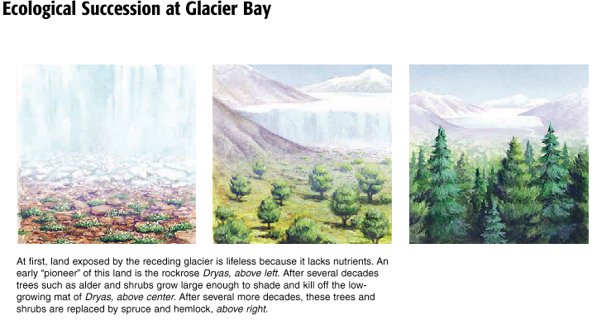

- primary __________- rate at which organic material is
produced by photosynthetic
organisms in an ecosystem
- determines the amount of _____ in
a system
- producers- organisms that first capture energy
- includes plants, some bacteria, and algae
- producers make _______ _______ _________
- ___________- all organisms that consume plants or other
organisms to obtain the energy necessary to
build their molecules
- food chain- path of energy through the trophic levels of an
ecosystem

- _______ level- graphic organizer based on the organism’s
source of energy
- first level- lowest level of all ecosystems is occupied by
producers
- produce energy rich _____________________
- second level- _________- animals that eat plants or other
primary producers
- primary consumers
- herbivores must be able to
break down a plant’s molecules
into usable compounds
- most rely on _____________ to
help digest cellulose

- third level- _________________ consumers
- _______vores- animals that eat herbivores
- _________vores- herbivore and carnivore
- use simple sugars and starches
stored in plants as food, but
cannot digest cellulose
-all levels contain ____________________
- organisms that obtain their energy
from organic wastes and dead bodies
- decomposers- organisms that cause decay
- bacteria and fungi
- release _______ back into the environment
- fourth level- not in all ecosystems
- carnivores that consume _____ __________
(tertiary carnivores)

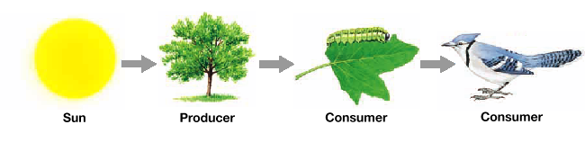
-__________- diagram that shows the feeding relationships
between organisms in an ecosystem
- more realistic than a ___________________
- individual animals may feed at several
trophic levels
- food chain is just one path in a food
web
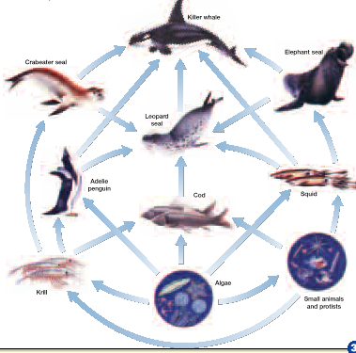
Loss of Energy in a Food Chain
-almost____ of energy is lost to the environment as heat
- during every transfer of energy within an ecosystem,
energy is lost as heat
- amount of energy ____________ as it passes through an
ecosystem
***at each trophic level, the energy stored by the organisms in a level is about _______ of that stored by
the organisms in the level below***
- energy ________- illustrates the flow of energy through
ecosystems
- made of blocks (trophic levels) stacked
on top of each other with the _________
trophic level on the bottom
- _________ of block is determined by the
amount of energy stored in each
organism of the level
- gets smaller as you go up because each
trophic level loses 1/10 of its energy
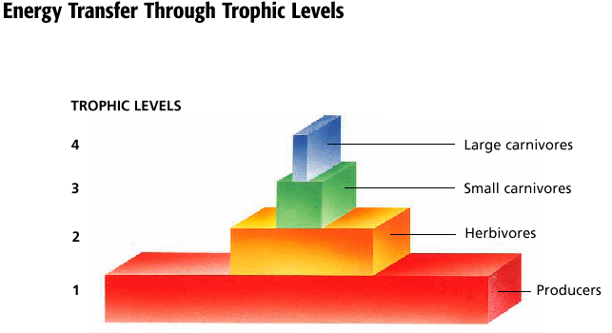
***the number of trophic levels that can be maintained in an ecosystem is limited by the loss of potential energy***
- Ex.- if people only ate lions
- we would die because there is not enough zebras
to feed the lions
- for there to be enough zebras there would have to
be more grass to feed them

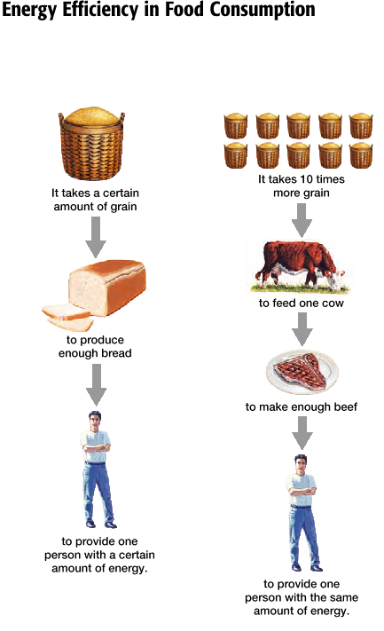
- ______- the dry weight of tissue and other organic matter
found in a specific ecosystem
Biochemical Cycles—4 major cycles

- pathway formed when a substance enters living organisms
then returns to the non-living environment

1) ____________________________
- water vapor condenses and falls to the Earth’s surface
- some seeps into the soil and becomes ground water
- ________ water- water retained beneath the earth’s
surface
- most remaining water re-enters the atmosphere by
evaporation
- some water is taken up by a _____________ ________
- water evaporates from plant leaves (______________)
- wind draws moisture from openings in leaves
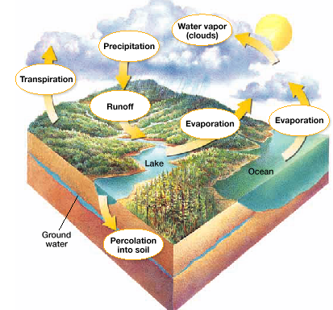

2) Carbon Cycle
- cycles between living and non-living organisms
- CO₂ in air or in water is used by
photosynthesizers to build organic molecules
- carbon returns to air and water in 3 ways
1) ___________- organisms using oxygen to oxidize
organic molecules … CO₂
is released
2) combustion- burning releases CO₂
- fossil fuels
3) __________- marine organisms make shells with
CO₂
- shells become limestone
- carbon is released as limestone erodes
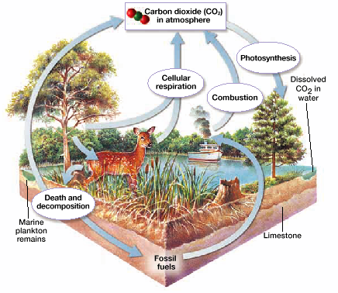

3) ____________ _______________
- phosphate is present in soil and rock as calcium
phosphate which dissolves in H₂O
- phosphate ions are absorbed by plant roots and used to
make ATP
- animals eat the plants; reuse the organic phosphorus
4) ________________ _________________
- nitrogen _______- process of combining nitrogen with
hydrogen to form ammonia (NH₃)
- certain bacteria take N₂ from atmosphere and break the
strong triple bond to form ammonia
4 important stages
1) ____________- the absorption of nitrogen into plant
and animal compounds
2) _____________- production of ammonia by bacteria
during the decay of nitrogen
containing urea
3) _____________- production of nitrate from ammonia
4) _____________- conversion of nitrate to nitrate gas
- scientists are trying to develop plants that can fix their
own nitrate… won’t need to add nitrogen fertilizer
