Chapter 13: The Theory of Evolution
The Theory of Evolution by Natural Selection

- 1st theory of evolution by Roman philosopher _________
who lived 2,000 years before modern theory
- 1859 – Enlgish naturalist ________ ____________
- published evidence that species evolve
- proposed a reasonable _____________ of how it
occurs
- theory of evolution has developed through _________ of
scientific observation and experimentation
- took shape because of Darwin
- almost all scientists ______ evolution as basis for
_____________ of life on earth
- Darwin was supposed to be one a doctor or a __________
- was repelled by surgery-no anesthetics
- collected biological specimens instead
- completed degree in _________ from Cambridge
- spent most free time __________ natural science
-1831- set a sail on HMS Beagle as a naturalist

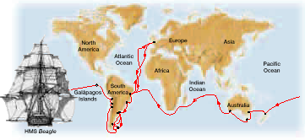

- before Darwin- most people and scientists believed each
species was a devine creation existing
____________ from its original creation
- some wondered about ______________
- Darwin’s grand father, among others, proposed
mechanisms to explain how living things changed
over time
- 1809 - Jean Baptist _________ proposed how organisms
change over generations
- Lamarck believed that over a lifetime of an individual,
physical features increase in size because of ______ or
decrease in size because of _________
- these changes are then passed to offspring
- this part is incorrect

***Change in species is linked to the “physical conditions of life” or environmental conditions***

- Darwin found evidence that challenged belief that species
are unchanging
- read _____________ book “Principles of Geology”
- book said surface of Earth changed slowly over
many years
- as Darwin traveled he found the same amongst animal
species
- fossils that _________, but weren’t exactly the same as
living specimens in the area
- Darwin visited the Galapagos Islands
- noticed many plants and animals on Galapagos
resembled those on nearby South American coast
- ________ miles away
- suggested that ancestors of Galapagos migrated from
South America long ago and ____________ after they
arrived
- called this “descent with modification”
-evolution
- didn’t report his ideas about evolution until
many years later- time to ____________ data
- didn’t know how it occurred
- 1798 -essay by Thomas _______________
- essay described how human populations increase
faster than the food supply
- Darwin realized that Malthus’s hypothesis applied to all
_________________ not just humans
- every organism has potential to produce many
offspring
- only a limited number of offspring ____________ to
_______________
- ________ ______ – Darwin’s term for differential rate of
reproduction
- individuals that have physical or
behavioral traits better suited to
their environment are more likely to
_________ and will reproduce more
successfully than those that do not
have such traits
- in time the number of individuals that
carry these favorable characteristics
will increase in population causing the
population to change..called evolution
- Darwin also explained how organisms differ from place to
place because their ______________ are _____________

- each species has evolved and adapted in response to
its particular environment
- _____________ – a feature that has become common in a
population because the feature provides a
selective advantage
- Ex- moths dark vs. light
- 1844 – Darwin wrote down ideas of evolution and natural
selection
- lots of controversy about evolution & Lamarck’s
hypothesis kept Darwin from publishing work
- 1858 – Alfred Wallace asked Darwin to help him publish
his essay about evolution by _________ _______
- Darwin’s manuscript & Wallace’s essay were presented at
a public scientific meeting
- Nov. 1859 – Darwins book “On the Origin of Species by
Means of Natural Selection” appeared
- many readers were disturbed by his assertion
that humans and apes are ______
- slowly gained _____________ by biologists
around the world

4 major parts
1. variation exists within the genus of every
population or species
- random ____________ and translocation
2. some individuals of a population or species are better
suited to ________ and have more ___________
3. over time, the traits that make certain individuals of a
population able to survive and reproduce tend to
______________ in that population

4. there is ___________ evidence from _______ and many
other sources that living species evolved from organisms
that are extinct

- genetics changes how we look at Darwins theory of
Natural Selection causing evolution
- scientists now know that genes are ______________ for
inherited traits
- forms of a trait become more common because more
individuals in a population _____ the alleles for those
forms
- natural selection causes the ____________ of certain
alleles to increase or decrease over ________
- mutations & recombination of alleles provides
______ source of new variation for natural selection
at act upon

- ________________ isolation –
- condition in which 2 populations of the same
species do not breed with one another because
of their geographic separation
- they both evolve differently over time due to
their differing _______________
- eventually they may not be able to _________
together
- become different species

- Ex.- Kaibab squirrel vs. Abert squirrel
- Kaibab lives on North rim of Grand Canyon
- Abert lives on South rim of Grand Canyon
- characteristics vary – can no longer breed
together
- now are different species
- took over 10,000 yrs.
-__________– model of evolution in which gradual change
occurs continuously over long periods of
time
- ____________ equilibrium – model of evolution in which
periods of rapid change in a
species separated by periods of
little or no change
- suggests environmental changes
caused evolution to occur in
_________ then the species stay
unchanged for a while
Evidence of Evolution
3 major sources of evidence
1) ___________ _____________
2) _________ and development
3) biological ______________

1) the fossil record
- although incomplete, fossils provide most direct
evidence that evolution takes place
- provide actual record of Earth’s past ______ forms
- fossilized species found in older rocks differ from
those found in newer rocks
- Darwin predicted _____________ forms between the
great groups of organisms would be found
- _________, but not all, have been found
- Ex.-intermediaries between fish & amphibians
- between reptiles & birds
- between reptiles & mammals
- most scientists accept Darwin’s theory based
on 3 points
1) Earth is about ____ billion years old
2) organisms have ________ Earth for most of its
history
3) all organisms living today _________ common
ancestry with earlier, simpler life-forms
- many species live in environments where fossils do
not form
- most fossils form when buried rapidly in sediment
- most are formed in wet lowlands, slow streams,
lakes, shallow seas, near volcanoes
- chances for ___________ are still low in these areas
- fossil record will never be complete
- it still provides strong evidence
- when paleontologists arrange fossils from oldest to
youngest…evolution can be seen
- Ex.- whale evolution
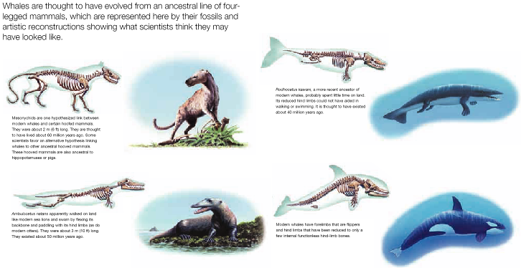

2) anatomy and development
- anatomy often shows basic similarities in body
structure even though their function may differ
- __________ structures- structures that are reduced in
size and function that are part of
an organisms evolutionary part
- Ex.- whale hind limbs
- humans appendix
- ________________ structures- structures that share a
common ancestry or similar
structures in 2 organisms can
be found in the common
ancestor of the organism
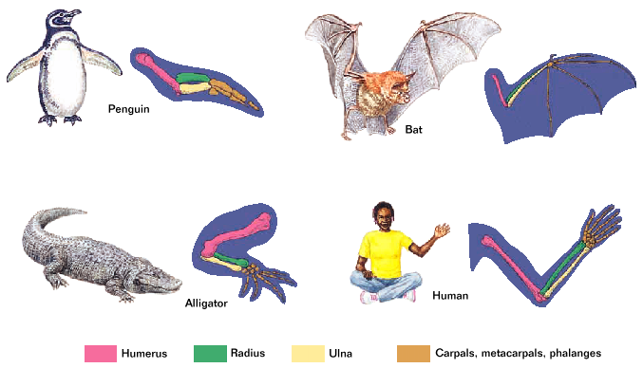

- evolutionary history can be seen in development of
__________________
- Ex.- at some point in development all vertebrate
embryos have a tail, buds that became limbs,
and pharyngeal pouches (became gills)
- humans – tail disappears and pharyngeal
pouches develop into structures in the
throat

3. biological _______________
- if species have changed over time, then the genes
that determine these characteristics should also
change by ___________ and ____________
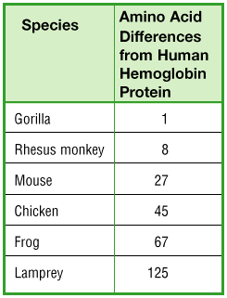

- more and more changes in a genes nucleotide
sequence should build up over time
- 1st tested by analyzing ______ _______ differences
- if evolution has taken place, then species who
descended from a ______ ancestor should have ____
amino acid differences than species whose common
ancestor is older

Examples of Evolution
- environment dictates the direction and amount of change
- Ex.- polar bear
- white fur is beneficial in its current environment
- if snow & ice melted – no longer a benefit

4 factors for Natural Selection
1) _____________________________________________
- individuals in a population differ genetically
2) _____________________________________________
____________________
- the environment will prevent some individuals from
reproducing
3) _____________________________________________
_______________________
- forces individuals to compete to survive
4) individuals that are ________ able to cope with the
challenges presented by their environment tend to
leave move ___________ then those individuals less
suited to the environment do
- Ex.- Tuberculosis (TB)
- caused by bacteria Mycobacterium tuberculosis
- 1950’s 2 antibiotics were available
- isoniazid & rifampin
- 1980’s new strains of M. tuberculosis appeared that were resistant to both antibiotics
- new strands evolved through natural selection
- doctors compared DNA of rifampin- resistance bacteria to DNA samples of normal, rimampin sensitive M. tuberculosis
- only one difference – a single base changes from cytosine to ____________
- new strands couldn’t divide as rapidly as original, but it could still divide
- new strands could reproduce better in presence of antibiotics than old strains, so it survived

- another example – _____________ ___________
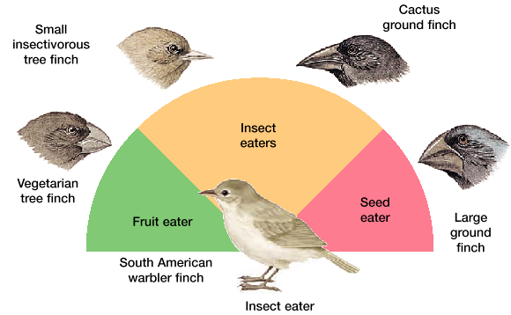

- Darwin collected ____ species of finches from the Galapogos
- 9 distinct species
- all similar except their beaks
- 2 ground finches had _____ bills to crush seeds
- 2 had narrow bills to eat ___________
- another had sharp beaks to feed on ______ of sea birds
- 1 ate __________
- 1 ate insects out of cacti
- Darwin claimed each came from a common _____________
- tested in 1938 by David Lack – 5 month study
- found nothing to support Darwin
- 2nd study started in 1973 – went for ____ years
- supported Darwin’s theory
- Lack’s study was done during a _____ year with food
plentiful
- beak ______ didn’t matter in that case
- during dry years seeds were much harder
– not soft
- stronger beaks allowed a bird to feed on tougher seeds that were passed by other birds
- these birds produced more offspring with big beaks
- during a period of wet seasons
-more smaller beaked offspring
- _________ – accumulation of differences between groups
- leads to formation of new species
- ______________ – process by which new species form
- ___________ – populations of the same species that differ
genetically because of adaptations to
different living conditions
- 1st step towards speciation
- eventually species become so different they
can no longer interbreed
- Ex.- geographic isolation prevents
breeding
- reproduce at different times
- physical differences
- not attracted to each other
- hybrid may not be fertile
