Chapter 27: Introduction to Animals

Characteristics of Animals
8 Features
1. _______________
2. ________________
3. ______________________
4. ___________
5. ___________ _____________
6. blastula formation
7. cells organized into tissues
8. absence of a cell wall
- features were inherited from a common ancestor
1. heterotrophy
- cannot make their own food
2. mobility
- able to perform rapid, complex movements
- move with __________ cells
- specialized cells that contract with considerable
force
3. multi-cellularity
- all are multicellular
- most cells are similar inside
4. diploidy
- adults have ____ copies of each chromosome
- 1 from mom, 1 from dad
- only gametes are haploid
- allows for creation of new combinations of genes
5. sexual reproduction
- almost all reproduce sexually
- sperm have a ____________ and are highly mobile
6. absence of a ________ ___________
- allows cells to move about in body
7. ____________ formation
- all animals except sponges
- blastula – hallow ball of ____________
- forms from zygote as its cells divide

- forms 3 layers
- called primary tissues layers
1. ___________
2. ___________
3. ___________
- give rise to all body tissues

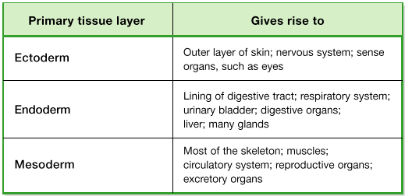

8. __________________-
- all animals except sponges are organized into tissues
- group of cells with common structure and work for a
specific function

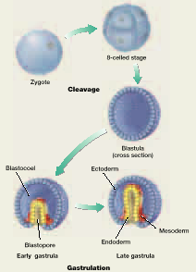

Body Symmetry
- body _______ – used to describe an animal’s shape,
symmetry, and internal organization
- determined by an animals genes
3 basic types of symmetry
1._______________________
- irregular shape (no pattern)
- ______________ body plan
- sponges are about only asymmetrical animal
2. __________________
- body parts arranged around a central axis
- a plane passing through central axis divides the
organism into about equal ____________
- aquatic – most move slowly or drift in ocean
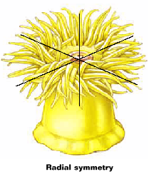
3. _________________
- body design in which there are distinct right and left
halves
- plane passing through animal’s midline divides into
mirror images
- dorsal – _______________
- ventral – ______________
- anterior – ______________
- posterior – ______________
- allows different parts of the body to specialize
- Ex: - ____________ – anterior concentration of
sensory structures

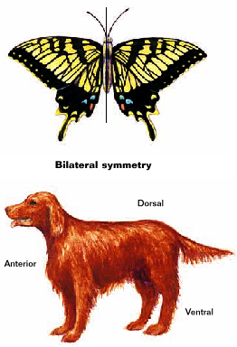

Internal Body Cavity
- applies to animals with bilateral symmetry
3 types of internal body plans
1. ______ – a fluid filled space between body wall and
digestive tract (gut)
2. ______________ – animals with no body cavity
- space is full of __________
3. _______coelomates – body cavity located between
the mesoderm and endoderm

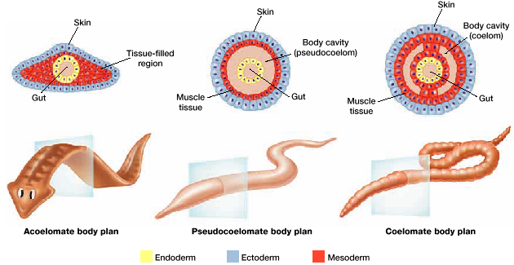

__________ – true coelom located entirely in
mesoderm
- gut and internal organs are suspended within
coelom
- allows space for mesoderm and endoderm to
have contact during embryonic development
- aided evolution of complex organs with
more than 1 type of tissue
- organs are protected from surrounding _______
- allows movement without damaging
organs or interfering with their function

Body Segmentation
- ___________ – series of similar repeating units
- underlies organization of all advanced animals

- _________ – segmentation not visible externally; visible
in embryo
- _______ – vertebrate muscles develop from
these repeated blocks of tissue

- segmented worms – each segment moves _____________
- flexibility and mobility
- allows complex movement
- highly segmented animals – may repeat organs in each
segment
- materials able to pass from 1
segment to another via a
circulatory system
- nerves- send messages from
1 segment to another
- allows modification for a
____________ function
- Ex: may evolve into a structure for feeding,
moving, reproduction

Kinds of Animals
- about 35 different phyla
- ____________ tree – branching diagram that shows how
animals are related evolutionarily
- 2 groups of animals
1. __________________
- lacking a backbone
2. ____________________
- animals having a backbone

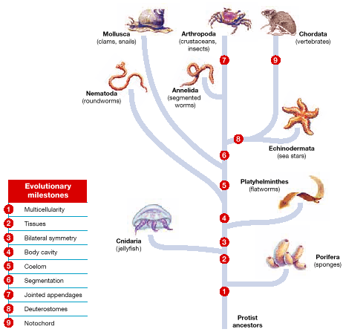

Animal Body Systems
6 important systems & reproduction
1. _________________
- single celled organisms and sponges digest food in
cells
- food must be ___________ than cells
- all others digest food extra cellular, but within a
__________________ cavity
- digestive ________________ break down food
- allows food to be larger than cells
- ______________ cavity – digestive cavity with only
one opening
- no specialization within cavity because
every cell is exposed to all steps of
digestion
- others have a digestive ______ (gut) with 2 openings
- mouth and anus
- food moves in one direction mouth to anus
- allows for __________________

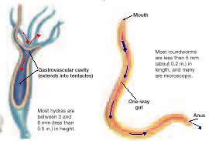

2) _________________
- simple animals – O₂ and CO₂ are exchanged directly
in environment by ____________

- respiration – uptake of O₂ and release of CO₂
- must take place along a moist surface
- _________ animals – simple diffusion not adequate
- have specialized respiratory
structures

- ___ – thin projections of tissue rich in blood vessels that
some aquatic animals use for respiration
- not good for terrestrial animals
– must be kept moist
3) __________________
- simple animals – body cells are near environment
and can exchange O₂, CO₂, and
nourishment directly
- complex animals – cells are not near surface so they
cannot exchange directly
- O₂ and nutrients must be transported to cells by
a ________________system
2 types
1. _____________ circulatory system
- heart pumps fluid with O₂ and nutrients through a
vessel and into cavity
- fluid contacts cells; fluid collects in open ______ and
flows back to heart
2. _____________ circulatory system
- heart pumps blood through a system of blood vessels
- allows blood to flow from heart to all cells and back
to heart
- blood remains in _________ – no contact with cells
- materials pass in and out of blood by ____________
through blood vessel walls

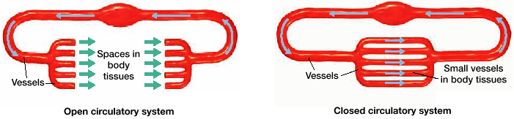
3. conduction of ____________ impulses
- nerve cells (__________) are specialized for carrying
messages in form of _______ impulses (conduction)
- coordinate activities in body
- all phyla except sponges have nerve cells
- simplest arrangement
- all nerve cells are similar and linked to each
other…nerve _________
- little coordination
- bilaterally symmetrical animals
- ___________ – clusters of neurons
- at anterior end they became larger and
more complex
- brain-like structure
- more complex invertebrates
- have ___________ with sensory structures

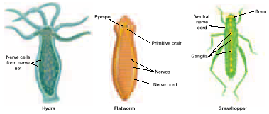

4. _____________
- skeleton provides support and movement
3 types of skeletons
1. _________________ skeleton
- consists of water that is contained under
_____________ in a closed cavity
- like a balloon with water
- water puts pressure on balloon
- if something presses on balloon
- water will _______; altering shape of
balloon

2. ____________________
- rigid external skeleton that encases the body of
an animal
- muscles are attached to inside of ___________
- provides __________ to pull against
- also protect organism’s soft internal parts

3. ____________________
- composed of a hard material embedded within
an animal
- muscles attach to endoskeleton and __________
contracting and relaxing

4. _________________
- removal of wastes produced by cellular
metabolism
- may be toxic if not removed
- ________________ – most toxic
- aquatic animals dissolve ammonia in body
fluids
- less toxic
- aquatic animals excrete ammonia
through skin or gills
- loss of ______________
- other animals need to minimize water loss
- some convert ammonia to less toxic substances
- Ex: ____________
- urea is excreted; water is returned to
body
- in humans – kidneys
- keep track of water content of
body and dilute urine based in
water levels

Reproduction
2 types
1.___________________
- reproduction that does not involve the ________ of 2
gametes
- Ex: sponge
- fragments itself – each part becomes a new
sponge
- Ex: ________________________
- new individual develops from an unfertilized
egg
- common in ___________
- Ex: bees
- queen stores sperm
- lays eggs
- if fertilized female bees
- if unfertilized – males or drones
- most Asexual animals also reproduce sexually

2. __________________
- new individual is formed by union of a male and
female gamete
- gametes produced in sex organs
- _______________ produce sperm
- _______________ produce eggs
- __________________ – have both testes and ovaries
- usually sperm and egg are
produced at different times
- self-fertilization does not occur
- other hermaphrodites are able to
self fertilize
- advantage if an individual has
_______ contact with other
species
- Ex: slugs, earthworms
- sperm are released – flagella propel them to egg
- ________ fertilization – egg is fertilized outside
of females body
- Ex: fish...eggs laid, sperm released into water
- usually lots of sperm to increase
chances of fertilization
- _______ fertilization – union of sperm and egg
occurs within the ♀ body
- sperm placed in females body
- must be a moist environment
- terrestrial animals
- keep gametes from ___________ out
- fertilized eggs must be kept moist
- terrestrial animals may have a shell to
prevent drying out
- some animals stay to protect eggs,
some don’t
- some animas have embryo develop
________________ of mother

