Chapter 25: Plant Structure and Function

The Vascular Plant Body
Tissues

3 Types
1. ______________ tissue – forms protective outer layer
2. ______ tissue – makes up much of inside of non-woody
plants
- includes roots, stems, and leaves
3. ____________ tissue – xylem and phloem

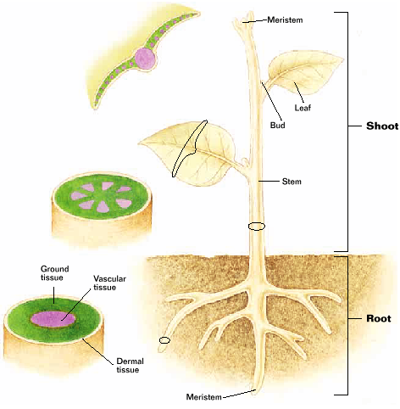

Dermal Tissue
- outside of plant’s body
- ___________ – outer single layer of cells
- coated by waxy layer to prevent water loss
- epidermal cells have extensions to help slow
water loss
- in roots:
- extensions help take in more ________
- ______ – layers of dead cells in woody stems
and roots
- contain water proof chemicals
- no waxy cuticle
- functions in ______ exchange and absorption of _______

Ground Tissue
- make up much of inside of plants
- in leaves: specialized for ___________________
- in stems and roots: store water, sugar, and starch
- surrounds and supports _____________ tissue

Vascular Tissue
2 types
1) xylem
2) phloem

_______________
- thick walled cells that conduct water and mineral nutrients
from a plant’s roots through its stem’s to it’s leaves
- must lose membrane, nucleus, and cytoplasm to
conduct water
- think of them as pipes to carry material
- 1st type are ____________________
- water flows through pits
- 2nd type which make up vessels
- vessels are wider then tracheids
- allow for quicker water ___________
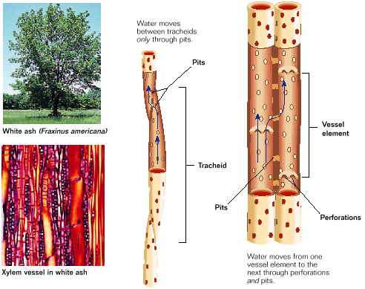

__________________-
- conduct sugars and other nutrients throughout a plant’s
body
- lack organelles or are modified organelles
- _________ tubes – conducting the strands in phloem
- pores in adjoining cells share cytoplasm will allow
substances to pass freely between cells
- companion cells carry out ______________, protein
synthesis, and other metabolic functions for sieve
tubes

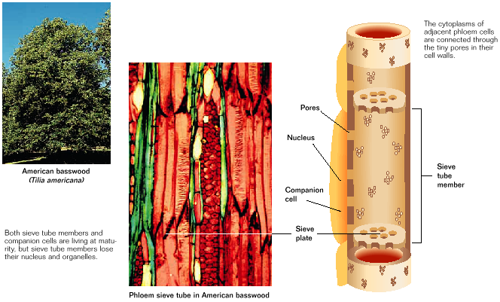

Roots
- serve to anchor plants and to absorb water and minerals
- may also serve to store sugar and starch
- _______ – large central root with many smaller branching
roots
- dicots
- Ex: - carrot, radish
- ________________ roots (prop roots)
- grow above ground
- Ex: corn and orchids
- _______________ roots
- monocots
- branched fibrous root system
- ___________ – ground tissue surrounding vascular tissue
- roots are covered by dermal tissue
- ________hairs – slender projections of cell membranes
- increases surface are of a root
- increases ability to absorb water and minerals
- root _________ – covers and protects the root tip

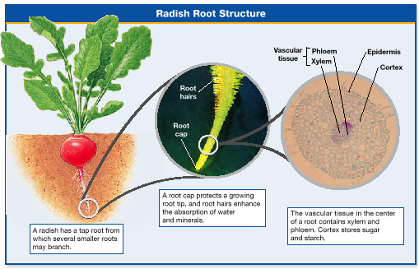

Stems
- support leaves and houses vascular _________
- some specialized for storage and asexual
reproduction
- leaves attach at nodes
- _________________ – space between two nodes
- buds that grow into new branches are located at
nodes

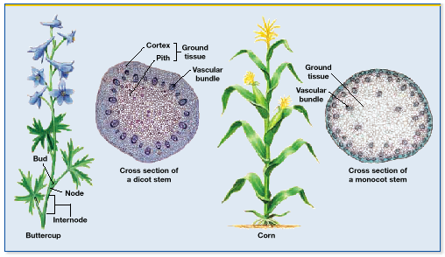

WOODY vs. NON-WOODY

Non-woody
- ___________stem – plant with stems that are flexible and
usually green
- Ex: violets, clovers, and grasses
- ______________bundles – xylem and phloem in bundles
surrounded by ground tissue
- in monocots – vascular bundles are
_________ throughout
stem
- in dicots – vascular bundles arranged
in _________
- ________ – ground tissue outside ring of vascular bundles
- ________ – ground tissue inside ring
- stomata in epidermis enables the stem to exchange _____

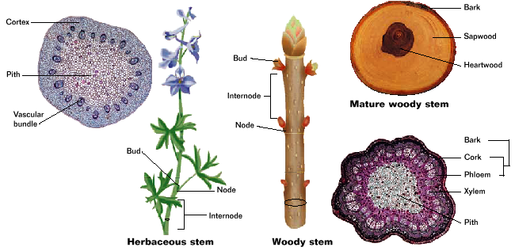

Woody Stems
- buds found at tips and at ends of nodes of woody stems
- exchange gases through _____________
- has central core of pith and ring of vascular __________
- layers of xylem form inner most cylinder
- woody stems are covered by cork – protection and
prevents water loss
- layers of cork and phloem make up bark
-____________ – wood in center of a mature stem or trunk
- _______ - lies outside the heartwood contains vessels that
conduct water

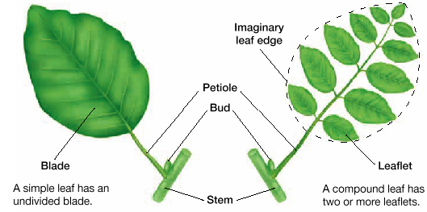

Leaves
- primary photosynthetic organ of plants
- ________ – flattened portion
- ________ – attaches blade to stem
- _________ leaves – leaves with undivided blades
- __________ leaves – leaves with 2 or more leaflets
- _________ – reduce surface area of blade
- leaf is ground tissue and vascular tissue covered by
epidermis
- cuticle covers upper and lower epidermis
- xylem and phloem are in veins of leaf
- _____________ – ground tissue
- packed with chloroplasts for photosynthesis
2 layers of mesophyll
1) ____________ layer – lies underneath epidermis
2) spongy layer – lies between palisade and lower
epidermis
- spongy layer has many air spaces to allow passage of
air
- __________ – connect air spaces to outside air

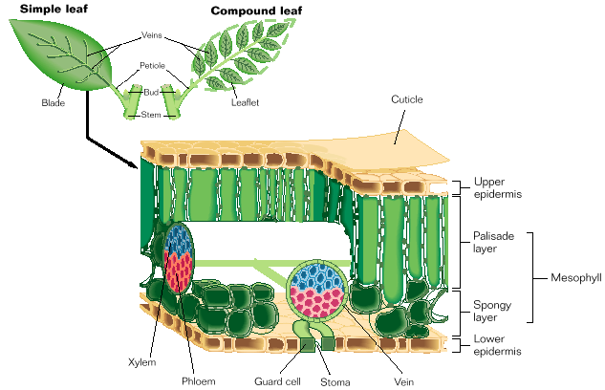

Transportation in Plants
Movement of Water
1) stomata open – water diffuses out of leaf
- _______________ – loss of water vapor from a plant
- cause of loss of over 90% of water
2) cohesion of water molecules causes water being lost by a
plant to pull on water still in the xylem
- pull extends through water in xylem
- water will continue upward as long as the column is
not broken
3) roots take in water by ______________
- water enters xylem and replaces water lost through
transpiration

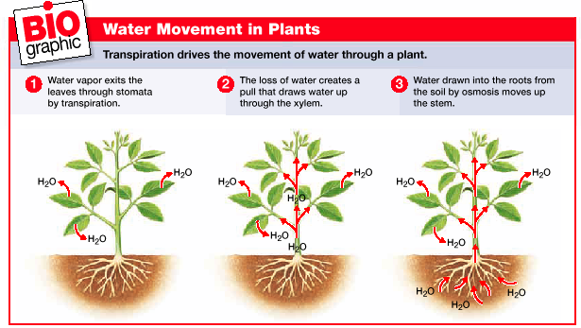

- changes in water pressure change shape of guard cells
- cause the stomata to open or close
- guard cells take in water – __________
- opens stomata - transpiration
- guard cells lose water – _____________
- closes stomata – stops transpiration

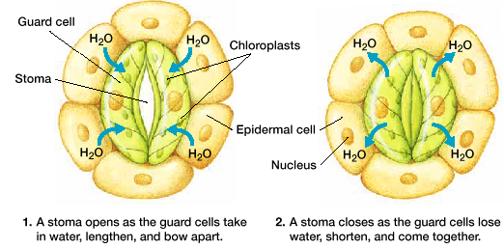

Moving Organic Compounds
- more in phloem
- _______ – refers to a part of a plant that provides organic
compounds for other parts of the plant
- _____ – refers to a part of a plant that organic compounds
are delivered to
- ___________ – movement of organic compounds within a
plant from a source to a sink
- 3 reasons why organic compounds are harder to move
than water
1. organic compounds must pass through __________
2. organic compounds move in all directions through
____________
3. organic compounds cannot diffuse through cell
_________________
- pressure – flow model
- Ernst Münch
1. sugar from a source enters phloem cells by ___________
transport
2. when sugar concentration in phloem increases, water
enters the sieve tubes in phloem from xylem by _______

3. pressure builds up inside the sieve tube cells and pushes
____________ through the sieve tube
- sugar moves at a rate as high as 100 cm/h
4. sugar moves from phloem cells into a _______ by active
transport

