Chapter 24: Plant Reproduction
Sexual Reproduction in Seedless Plants

- non-vascular plants have alternation of generations
- gametophyte – gamete producing
- sperm and eggs
- ______________ – structure that produces eggs
- _____________ – structure that produces sperm
- more pronounced than sporophyte
- sporophyte – spore producing stage
- spores produced in ________________

Life Cycle of Moss
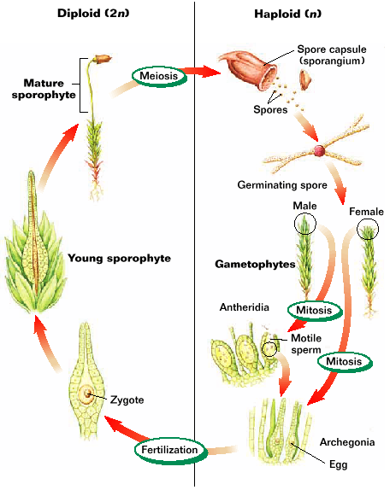

- egg fertilized (_____________)
- diploid zygote grows to diploid sporophyte
- grows from gametophyte – stays attached
- bare stalk with spore _______________
- spores are haploid
- spores dispersed by wind or water
- spore ___________________ and becomes gametophyte
- archegonia and antheridia form
- egg and sperm form by ________________
- ________________ carries sperm to egg
- seedless vascular plant reproduction - Ex. ferns
- must have water for sexual reproduction
- egg and sperm are usually produced by some individual
- ____________ – cluster of sporangia on fern frond

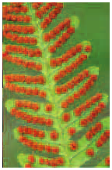

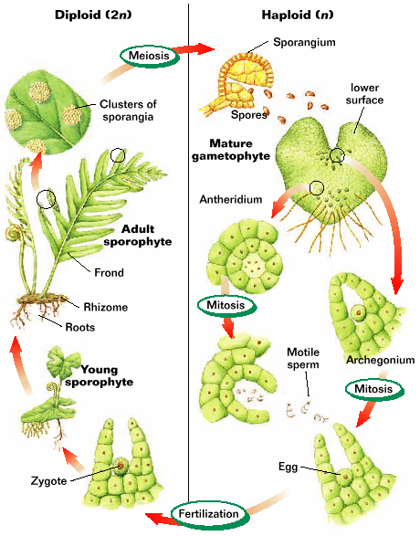

Sexual Reproduction in Seed Plants
- ________ _________ – male gametophyte of seed plants
- _____ - multi-cellular structure inside of which the female
gametophyte develops
- after fertilization; ovule develops into the seed
- sexual reproduction occurs without water
- wind and animals transport pollen to ovules
- _________________ – transfer of pollen to female
reproductive structures
- ________ ____ – a tube that emerges from the pollen
grain to reach ovule
- tube enables sperm to go
directly to ____________

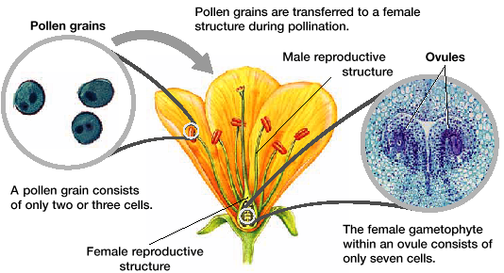

Seeds
- contains embryos of seed plants
- ________________ – hardened outer cell layers
- protection
- keeps out H₂O and O₂
- allows seed to wait for favorable
conditions before beginning growth
- contains _________________ for embryo
- ___________sperms – nutritious tissue is part of ♀
gametophyte
- ___________sperms – endosperm (nutritious tissue)
- __________ – leaf like structures that function in transfer
of nutrients to the embryo
- gymnosperms – 2 or more cotyledons
- monocots – 1 cotyledon
- dicots – 2 cotyledons
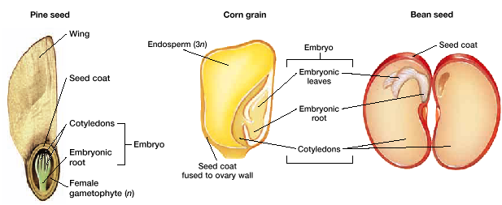

Cones
- gametophytes of gymnosperms develop in cones
2 types
1) ____________ cones (pollen cones)
- produce pollen
2) ____________ cones (seed cones)
- produce ovules on surface of scales
- some plants have both types on an individual
- some have separate male and female parts
- male cones produce lots of pollen to be carried by
_______________ to female cones
- seed cones close up after sperm travels up pollen
tubes to eggs
- stay closed until seed is mature
- may be a few ______________

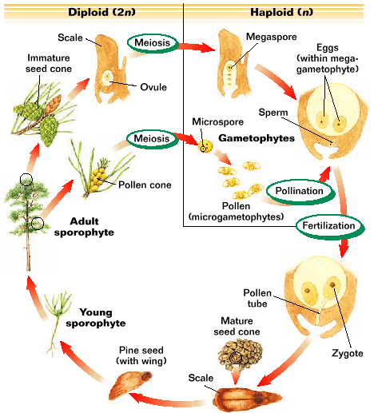

Flowers
- in angiosperms, ______________ develop within flowers
- ______________ – protect flower when it is a bud
- ______________ – attract pollinators
- stamens – produce pollen
- 2 parts
1) ________________ – pollen producing sac
2) ____________________ – anther sits a top filament

- ___________________ – produce ovules
- ovules develop in lower portion of pistil (ovary)
- style rises from ovary
- top of style (stigma) catches pollen
- ___________________ flower
- flower which has a 4 basic structures
- sepals, petals, stamens, pistils
- incomplete flower
- flower lacking 1 of 4 basic structures
-__________________ flower
- flower with both stamen and pistol
- imperfect flower
- flowers that lack either a _________or a __________

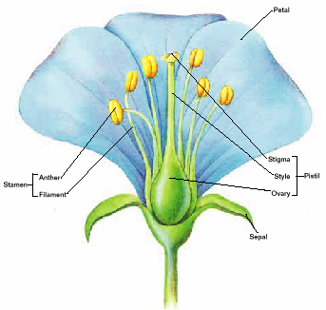

Pollinators
- flowers are source of _____ for pollinators (birds, insects)
- as pollinator eats _________ – pollen sticks to its body
- carries pollen to next flower
- flowers use scent, color, nectar to attract pollinators
- some flowers use the wind
- most times ____ ____ have bright color, odor, or nectar

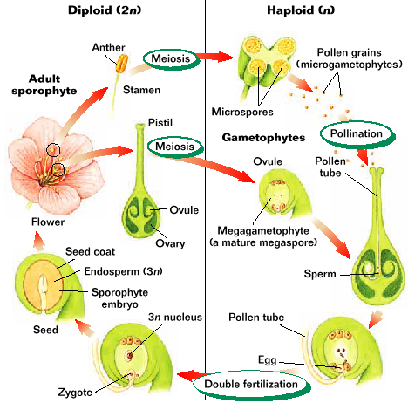

- _______________fertilization –
- 2 ____________ in each pollen grain
- 1 fertilizes egg, other fuses with haploid nuclei
making a _______ cell that develops into endosperm

