Chapter 23: Introduction to Plants
- dominant group on land; based on weight
- very __________________
- most photosynthetic, some parasitic
- probably evolved from multicellular aquatic green ______
- could not survive on land
- 3 things to move on land
1. get ____________ from environment
2. keep from ____________ out
3. reproduce without ____________

1. absorbing nutrients
- ___________ – symbiotic relationship between
plants and fungi
- fungi supplied nutrients

2. preventing water loss
- _____ – waxy layer that covers the non-woody,
above ground parts of most plants
- _______ – pores that permit plants to exchange
O2 and CO2
- _____ cells – specialized cells that border each
stoma
- stomata open and close as guard
cells change shape
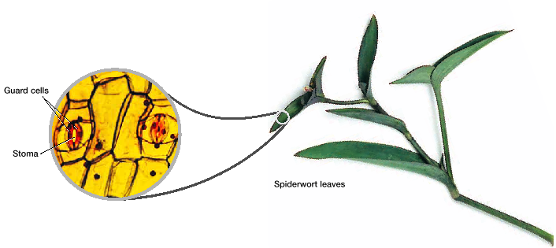
3. ___________________ on land
- sperm in structures that keep it from drying out
- makes up pollen

Conducting Tissues
- tissues that move _______ and other materials through the
plant body
- 1st plants transported materials by ___________ and
diffusion
- today: specialized cells that run from end to end
- some carry water and minerals from root to leaf
- some carry organic nutrients from leaves to
other parts

- ____________ plants – plants with a vascular system
- __________ system – system of well developed
vascular tissue that distributes
materials efficiently
- vascular _______ – contain the specialized cells
that transport water and other
materials
- _________________ plants – no vascular system
- 3 groups

Seeds
- seed – structure that contains the embryo of a plant
- _______ – an early stage in the development of plants and
animals
- seed plants – vascular plants that produce seeds
- 380 myo

Advantages
1. _____________________ – covered by seed coat
- prevent drying out
- disease
- breakage

2. ______________________
- most seeds have stored nutrients
- nutrients for embryo

3. __________ __________________
- seeds disperse offspring
- structure aids wind, water, or animals to carry
- dispersal prevents ___________ between parent and
offspring

4. ___________ _____________
- embryo is suspended waiting for favorable
conditions
- wet and warm

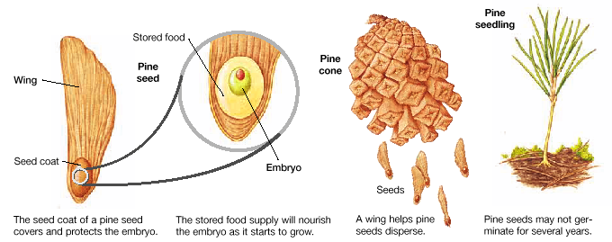

Flowers
- ________ - reproductive structure that produces pollen &
seeds
- ___________ of 1st seed plant carried by wind
- lots of pollen; not _____________
- today; most are flowering plants
- 130 myo
- attract animals
- pollen grains ____________ to animals
- animals carry directly from 1 flower to another
- flowering plants make __________ pollen
- cross-pollination can occur from far away

Life Cycles
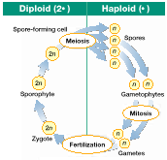

- alternation of ______________________
– plants’ ____________ and __________ look different
- size
- nonvascular plants
- __________ generation is dominant (most noticeable)
- vascular plants
- ___________________ generation is dominant

- increase in size, enables specialized structures
1. vascular system
- 2 types of vascular tissue
1. _____________ – tissue responsible for
transporting organic nutrients
2. _____________ – tissue responsible for
transporting water and minerals
2. distinctive _____________ forms
- _________ – part of body that grows upward
- _________ – part of body that grows downward
- ____________- zones of actively dividing cells
- produce growth
- vertical body forms as new cells form at tip of
plant body
- plants later developed roots, stems, and leaves

Kinds of Plants
1) non vascular plant
- plants without a vascular system
- Ex: moss
Key Features
- lack true roots, stems, and leaves
1. _________________ size
- small and simple
- water and nutrients travel by osmosis & diffusion
- limits size of plant body
2. larger _____________________
- gametophyte is larger than sporophyte
- ___________ – hair like projections that anchor
gametophyte to the surfaces on which
they grow
- smaller, non green sporophyte grows on
gametophytes and counts on it for nutrients

3. require water for _______________ reproduction
- must be covered by water to reproduce
- sperm must swim to eggs

KINDS
- Mosses
- Liverworts
- Hornworts

2) seedless vascular plants
- _____________ – horizontal underground stems

Key Features
1. ___________________ system
- xylem and phloem – xylem reinforced with
________________
- able to grow much larger
- develop true roots, stems, and leaves
2. larger _______________________
- larger size makes it easier for wind to carry
spores
- smaller gametophyte-on or below surface of soil
- must have water to reproduce sexually
3. drought resistant _____________________
- spores have thick walls

Kinds
- ferns
- leaves called __________________
- spores are produce on underside of fronds

- club mosses
- stems branch from underground rhizome
- _________ – structure formed from non-green spore
bearing leaves
- not present in all species

- horsetails
- vertical stems are hollow and have joints
- ____________ of scale like leaves grow at joints
- spores form in cones

- whisk ferns
- very similar to earliest vascular plants
- no leaves or roots
- spores in sporangia on tip of short branches

3) Gymnosperms
- _______________ – seed plants whose seeds do not
develop within a sealed container
- fruit

Key Features
- Seeds
- all produce seeds

- Greatly Reduced Gametophytes
- 2 types of Gametophytes – male & female
- pollen – _________ gametophyte
- female – in structure that becomes ______
- usually each develops in its own ______

- Wind Pollination
- pollen carried by wind

Kinds
- Conifers-
- leaves are either __________ or tiny scales
- limit water loss
- Cycads
- short stems and palm like leaves
- ♂ and ♀ ___________ on different plants
- Ginkgo
- _____________ shaped leaves
- ♂ and ♀ gametophytes on different trees
- do not develop within a line

- Gnetophytes
- very diverse
- pollen and seeds in cones that look like
_____________

4) Angiosperms
- _______________ – seed plants with flowers
- seeds develop enclosed within a fruit
- most recent plant to ___________

Features
_________________ –
- ♂ and ♀ gametophytes in flowers – efficient
- have color or scent to attract pollinators
- some self-pollinate
- some pollinate with wind
- sperm don’t need to swim in water
____________ –
- 1º purpose – seed _______________
- animal eats fruit
- don’t digest – get dispersed
- some fruits float on wind and water
- some eject seed from parent
Endosperm –
- ______________ – stored food in a seed
- gets absorbed by ________ as it
develops
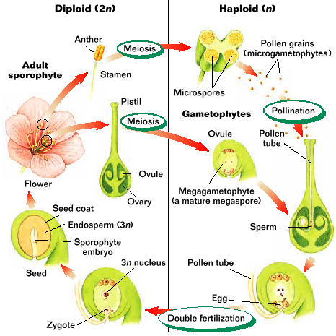

Kinds
- 2 sub groups
1. monocots
2. dicots
- ________ – flowering plants that produce seeds with
one seed leaf (________________)
- usually also multiples of 3, long narrow
leaves, with parallel veins

- ____ – flowering plants that produce seeds with two
seed leaves
- usually flowers with parts in multiples of 2,
4, or 5 and have leaves with ________ veins
