Chapter 19: Introduction to the Kingdoms of Life

- look at a few fundamental characteristics makes it easier
to see the relatedness within the 6 kingdoms
1. __________ ____________
- prokaryotes vs. eukaryotes
- 2 kingdoms of prokaryotes
- 4 kingdoms of eukaryotes
2. ___________ ________________
- cells of organisms in 4 kingdoms have cell walls
- cells of organisms in 1 kingdom do not have cell
walls
3. __________ ___________
- unicellular or multi-cellular
- 2 kingdoms are entirely unicellular
- 2 kingdoms have both
- 2 kingdoms are entirely multi-cellular
4. _____________
- autotrophs or heterotrophs
- 3 kingdoms have both
- 1 kingdom is entirely autotrophic
- 2 kingdoms are entirely heterotrophic
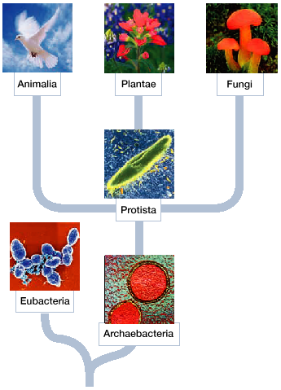

The 6 Kingdoms
1. ________________ 4. Fungi
2. ________________ 5. Plantae
3. ________________ 6. Animalia
- 1 & 2 used to be 1 kingdom (Monera)
- DNA & RNA separated them

3 Domains
1. ______________
- 1 kingdom – Eubacteria or Bacteria
- common name bacteria
- prokaryotes that have same lipid in cell membrane as
do eukaryotes
- sizes from .1 to 15 μm
- found in almost all environments

Characteristics
1. cell wall
- bacteria have strong exterior cell walls of
_________________

2. __________ structure
- no introns – entire gene is transcribed as a
single mRNA transcript

3. gene ________________ apparatus
- evolutionary relationship is determined by
amino acid sequence
- bacteria sequences differ from eukaryotes and
archaebacteria

Types
- most _______________ organisms on Earth
- some cause disease
- some are used to process foods, control pests,
produce chemicals, perform genetic engineering
- usually classified by shape, cell wall, and type of
metabolism
- some get energy from hydrogen sulfide, ammonia,
methane, photosynthesis in ocean and fresh water,
_______________ - some in presence of O2 , some
without (decomposers)

2. _________________
- 1 kingdom – Archaebacteria
- prokaryotes diverged early from the bacteria
- more closely related to eukaryotes then to bacteria
- diverse group with some common features

Characteristics

1. cell wall and membrane
- do not contain _______________
- contain _______ different than other 2 domains

2. gene structure and translation
- contain introns
- ribosomal proteins are similar to ____________, but
different than _______________

Types
- more common than originally thought
3 basic types
1. _______________________
- get energy by combining H2 + CO2 → CH4
- live deep in mud of swamps and are
poisoned by 02

2. ________________________
- thermophiles live in hot places – up to 106°C
- ________________ live in very salty lakes
- some live in acidic places (pH below 1)
- some live under enormous pressure

3. ______________ __________________
- grow in same environments that bacteria do

3. _______________
- 4 kingdoms – Protista, Fungi, Plantae, Animalia
- eukaryotes
- became larger and led to multi-cellular life

Characteristics
1. highly organized cell interior
- have cells with a nuclear and internal
_________________
- allows for specialization of functions

2. multi-cellularity
- occurs only in _________________

3. ________________ reproduction
- also occurs in bacteria; genetic exchange in
eukaryotes is a more regular process
- form haploid cells by ________ which produces
diploid cell fertilization
- allows for wide variation
- raw materials for evolution

Types
- some unicellular; most are ____________
- Protists contain both unicellular and
multi-cellular; most aquatic
- grouped together because they don’t fit any
where else
- ____________ are mostly multi-cellular
- Fungi have cell walls of chitin
- yeast are unicellular Fungi
- may live on or decompose dead organisms
- many are parasitic
- plants and animals are all multi-cellular
- almost all plants are ___________with cell
walls of cellulose
- all animals are ____________ with no cell walls
- most plants and animals have tissues and organs
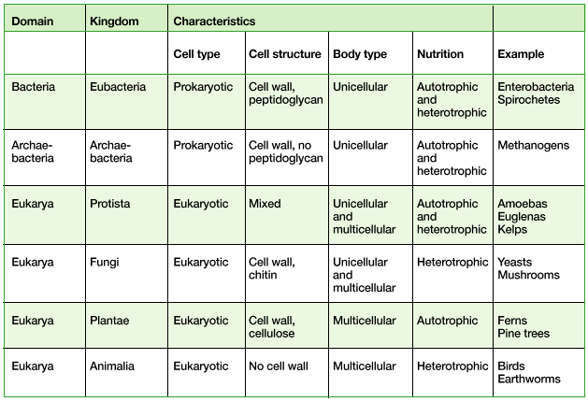

Advent of Multicellularity
- ________ organism – group of cells that are permanently
associated by that do not
communicate with one another
- not considered multi-cellular

- _____________ – temporary collection of cells that come
together for a period of time and then
separate
- Ex.- slime mold (___________)
- usually alone, come together when
starved and release spores which
grows into food
- separate and eat
- not considered true multi-cellularity

- _______________ – an organism composed of many cells
that are permanently associated with
one another
- occur only in eukaryotes
- may be very large
- occurs when individual cells are in
contact with each other and activities
are coordinated
- allows specialization

- _________________ – process by which cells develop a
specialized form and function

- _______ – a distinct group of cells with singular structure
and function

- ________ – different tissues organized with a specialized
structure with a specific function
- Ex.- heart
- muscle, nerve, & other tissues

- organ _____ – various organs that carry out a major body
function
- Ex.- circulatory system

- rest of chapter quickly covers the kingdoms
- we will cover each of these in future chapters

