Chapter 14: Classification of Organisms

Categories of Biological Classification
- too many organisms to try to _____________ every name
- 10 to 30 million
- biologists group organisms into categories that start _____
then get smaller and smaller
- like your address
- Aristotle – 2,000 yrs. ago grouped plants and animals
based on their structural similarities
- Greeks & Romans grouped plants & animals into basic
categories
- eventually became known as ________ or groups
- middle ages – names were in Latin
- _________ – scientific naming and classifying organisms
- used to use descriptive terms to classify
– some got to 11 or 12 words long – _______________
- were changed often
- very hard to keep track of
- Carl ___________________
- used a 2 word Latin name for each species he studied
- called – ___________________ ______________
- genus name followed by a single descriptive term
- universally adopted
- 2 part name is now called the scientific name
- _______ - taxonomic category containing similar species
- share important characteristics
- second word is descriptive
- identifies one particular kind of organism within the
genus

- 1st letter of genus is always __________ and first letter of
second word is always lowercase
- scientific names are ___________ or _______________
- after first use the genus can be abbreviated with the first
letter
Ex: red oak – common name
- Quercus rubra
- Q. rubra
- gives scientists a common way to communicate
- common names refer to different organisms
- Ex.- steamburger, BBQ, loose meat sandwich,
tavern
- all refer to the same sandwich
- same thing happened with plants ad animals

Rules for naming
1. 2 Latin words according to rules of Latin grammar
2. 2 organisms _________ have the same scientific name
- ___________ name must be different
- Linnaeus’s system now consists of 8 levels from broadest
to most specific
1. domain – 3 domains: Archae, Bacteria & Eukarya
2. kingdom- 6 kingdoms
3. phylum
4. __________
5. _____________
6. ___________
7. genus
8. species
Do Kindly Pay Cash Or Furnish Good Security
- to help remember order of nomenclature
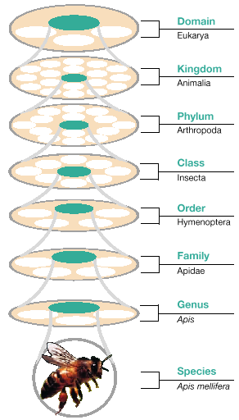

How biologists classify organisms
- usually use appearance and structure to group organisms
- sometimes cannot be used
- Ex.- hybrids- wolves x dogs
- biological_______ – group of natural populations that are
interbreeding, or that could
interbreed, and that are
reproductively isolated from other
such groups

- reproductive isolation occurs when a barrier separates 2 or
more groups from _______________________
- may not always be complete
- species are closely related
- problem with biological species are organisms that
reproduce ___________________
- modern biologists recognize species by studying an
organism’s features
- 1.5 ________________ species have been described
- estimate that 5-10 million more species my exist in
the tropic alone
- only have named 500,000 tropical species
- knowledge is limited
- _____________ – classification based on its evolutionary
history
- in lieu of basing classification on similarity
- Ex. - birds vs. insects
- both have wings but evolved
independently
- _________ evolution- similarities evolve in organisms not
closely related to one another
because they live in similar
habitats
- _____________ characters- similarities that arise through
convergent evolution
- ________________ – method of analysis that reconstructs
phylogenies by inferring relationships based
on shared characters
- sequence of evolution

2 types of characters
1. __________ character – it has evolved in a common
ancestor of both groups
- Ex.- birds vs. mammals
– backbone is ancestral character
2. _________character – evolved in an ancestor of one
group but not of another
- Ex.- feathers were character of bird ancestors
not mammals
- cladistics is based upon the idea that derived characters
provide evidence that 2 groups are ____________ related
- shared ancestoral characters do not
- Ex.- dogs vs. whales vs. lizards
- dogs and lizards have limbs; whales used
to have limbs
- limbs are shared ancestoral character
of all three
- dogs and whales have mammary glands;
reptiles do not
- shared ___________ character of dog
and whale
- more closely related than either is
with lizard
- ________ - branching diagram which shows evolutionary
relationships among organisms
- organisms are grouped together to show
shared derived characters
- changes as organisms evolve
- advantage of cladistics is objectivity
- always get same cladogram
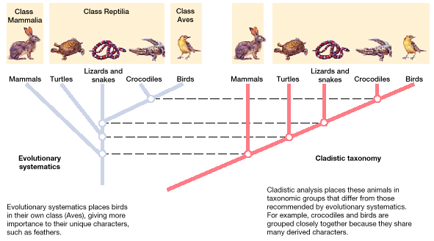

- disadvantage is degree of ________________________
- characters either exist or don’t exist
- Ex.- can’t take into account size, location or
effectiveness of character
- Ex.- feathers…ignored
- some modern cladistics attempt to weigh evolutionary
significance of characters being studied
- evolutionary ______________ - taxonomists give varying
degrees of importance to
characters
- subjective analysis
- _____________ tree - branching diagram representing
evolutionary systematics
- bad because it involves bias of scientists
- may differ on importance of a character
- includes evolutionary history
- must be ________ because it was not
________________

